**BSc (Hons)**

**in Information Technology**



**IT3021 – Data Warehousing & Business Intelligence**

**Assignment 01**

Submitted By:

Botheju W.M.N

IT20139230

**Step 1: Data set selection**

I have selected a dataset which tracks the fictional telco company's customer churn based on a variety of possible factors including customer details, dependents, monthly charges, and many with information about the types of services each customer has.

Data Set: Telco customer churn (11.1.3+) - <https://www.kaggle.com/datasets/ylchang/telco-customer-churn-1113>

There were five files which including customer details, customer churn status, customer location, population details of the area which pertinent to the zip code and customer service details. Modifications and extendedness were done in order to come up with a proper dataset.

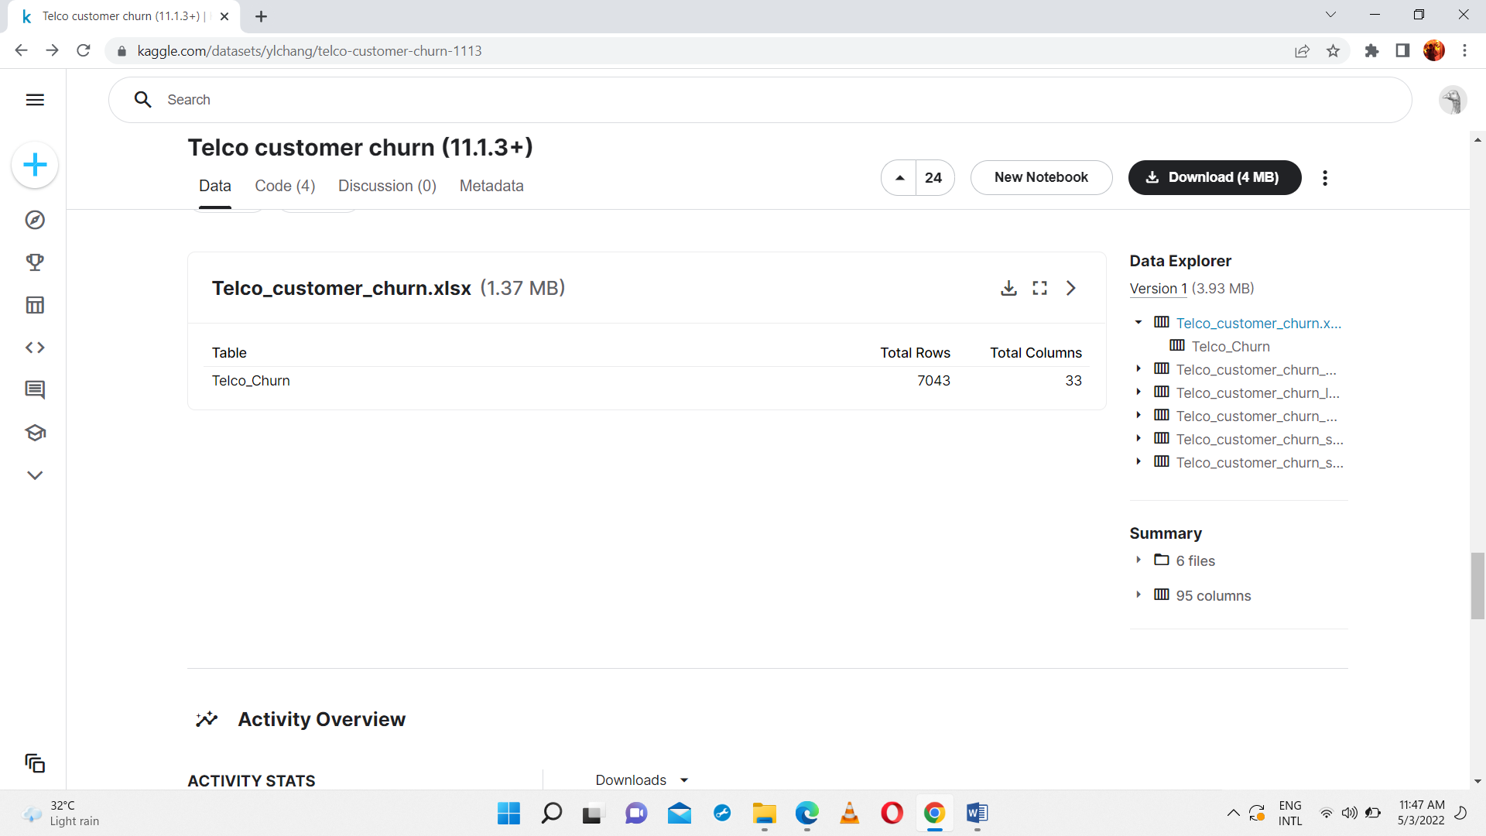

ER Diagram:

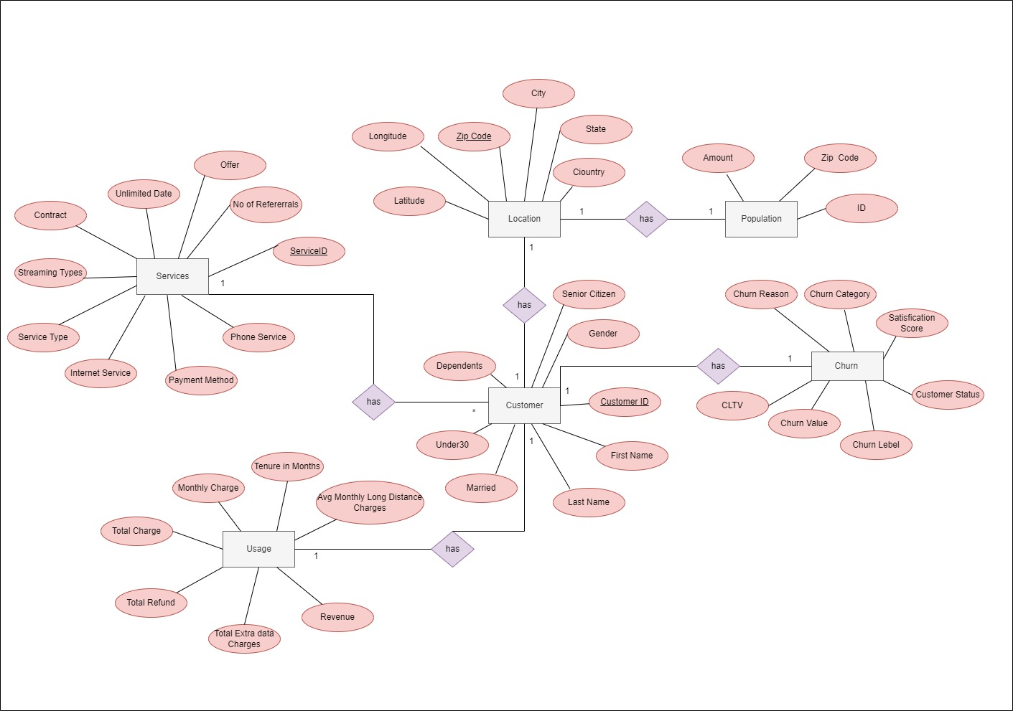

**Step 2: Preparation of data sources**

Initial dataset source had five files which include customer details with 9 columns, location details with 3 columns, population details with 3 columns, customer service details with 30 columns and customer churn status details with 11 columns. Modifications were done for separating service details as service details and usage details in order to having meaningful dataset. And also in order to have customer names I have used separated data source and removed some unnecessary details from the sources.

As a final data sources I have come up with Customer Details, Customer Names, Customer Service Details, Location Details, Population Details, Churn Status, Customer usage Details. And I have converted initial data sources into different files in order to having different data source types. Some of files extract and loaded into database which I have created as IT20139230DataSource in order to have a database source.

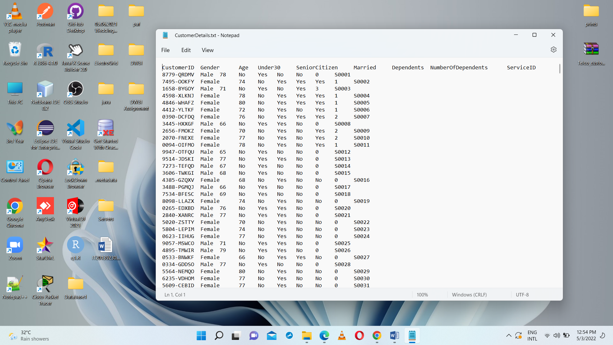

CustomerDetails.txt

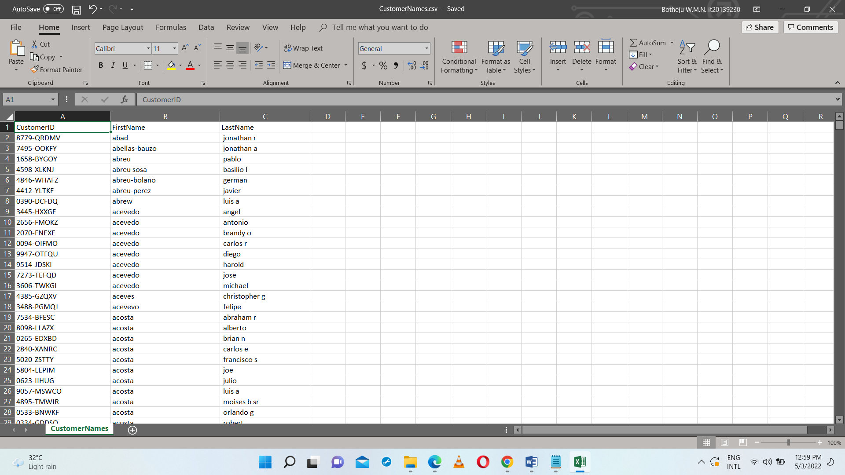

CustomerNames.csv

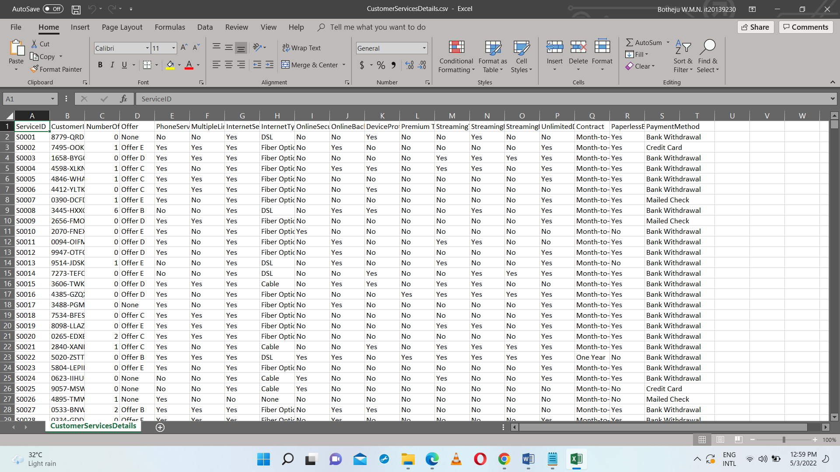

CustomerServiceDetails.csv

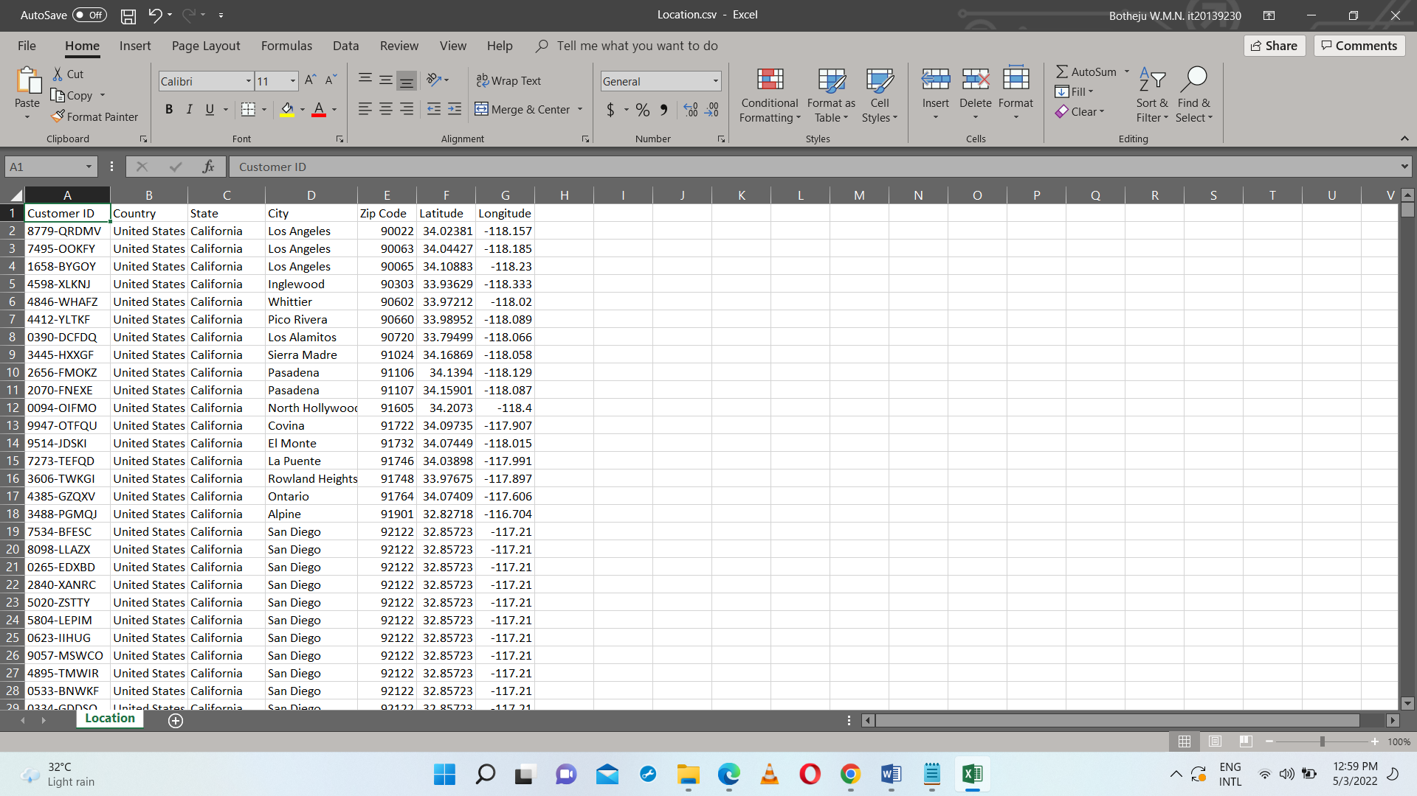

Location.csv

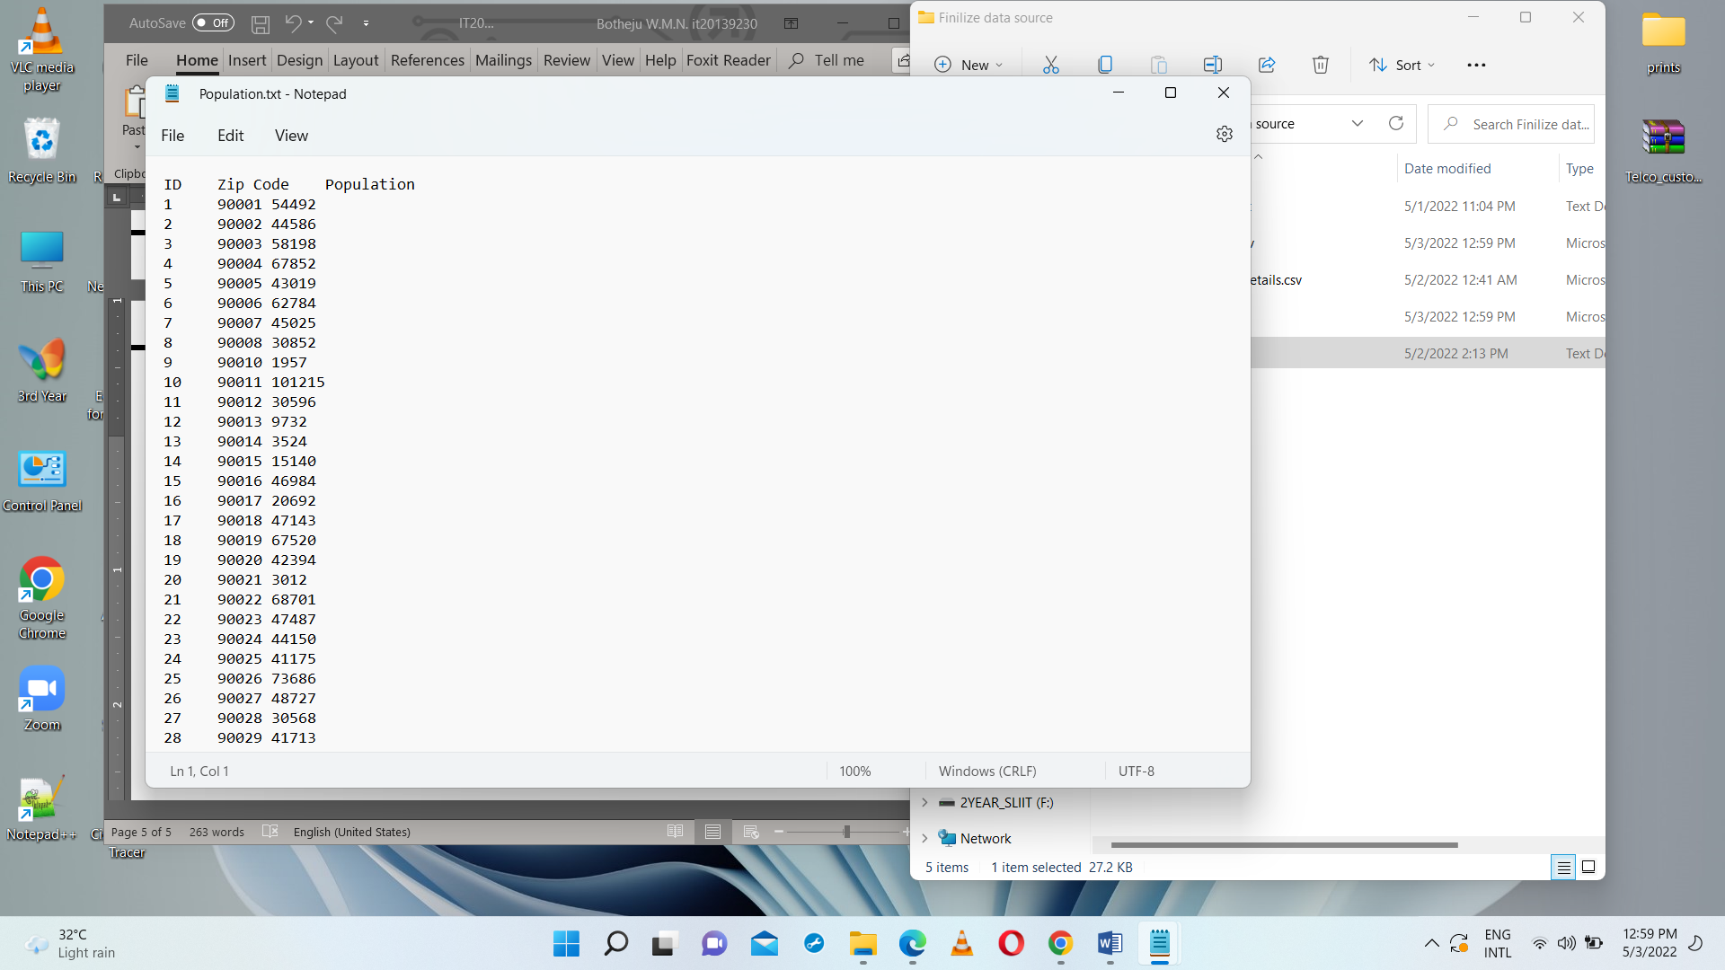

Population.txt

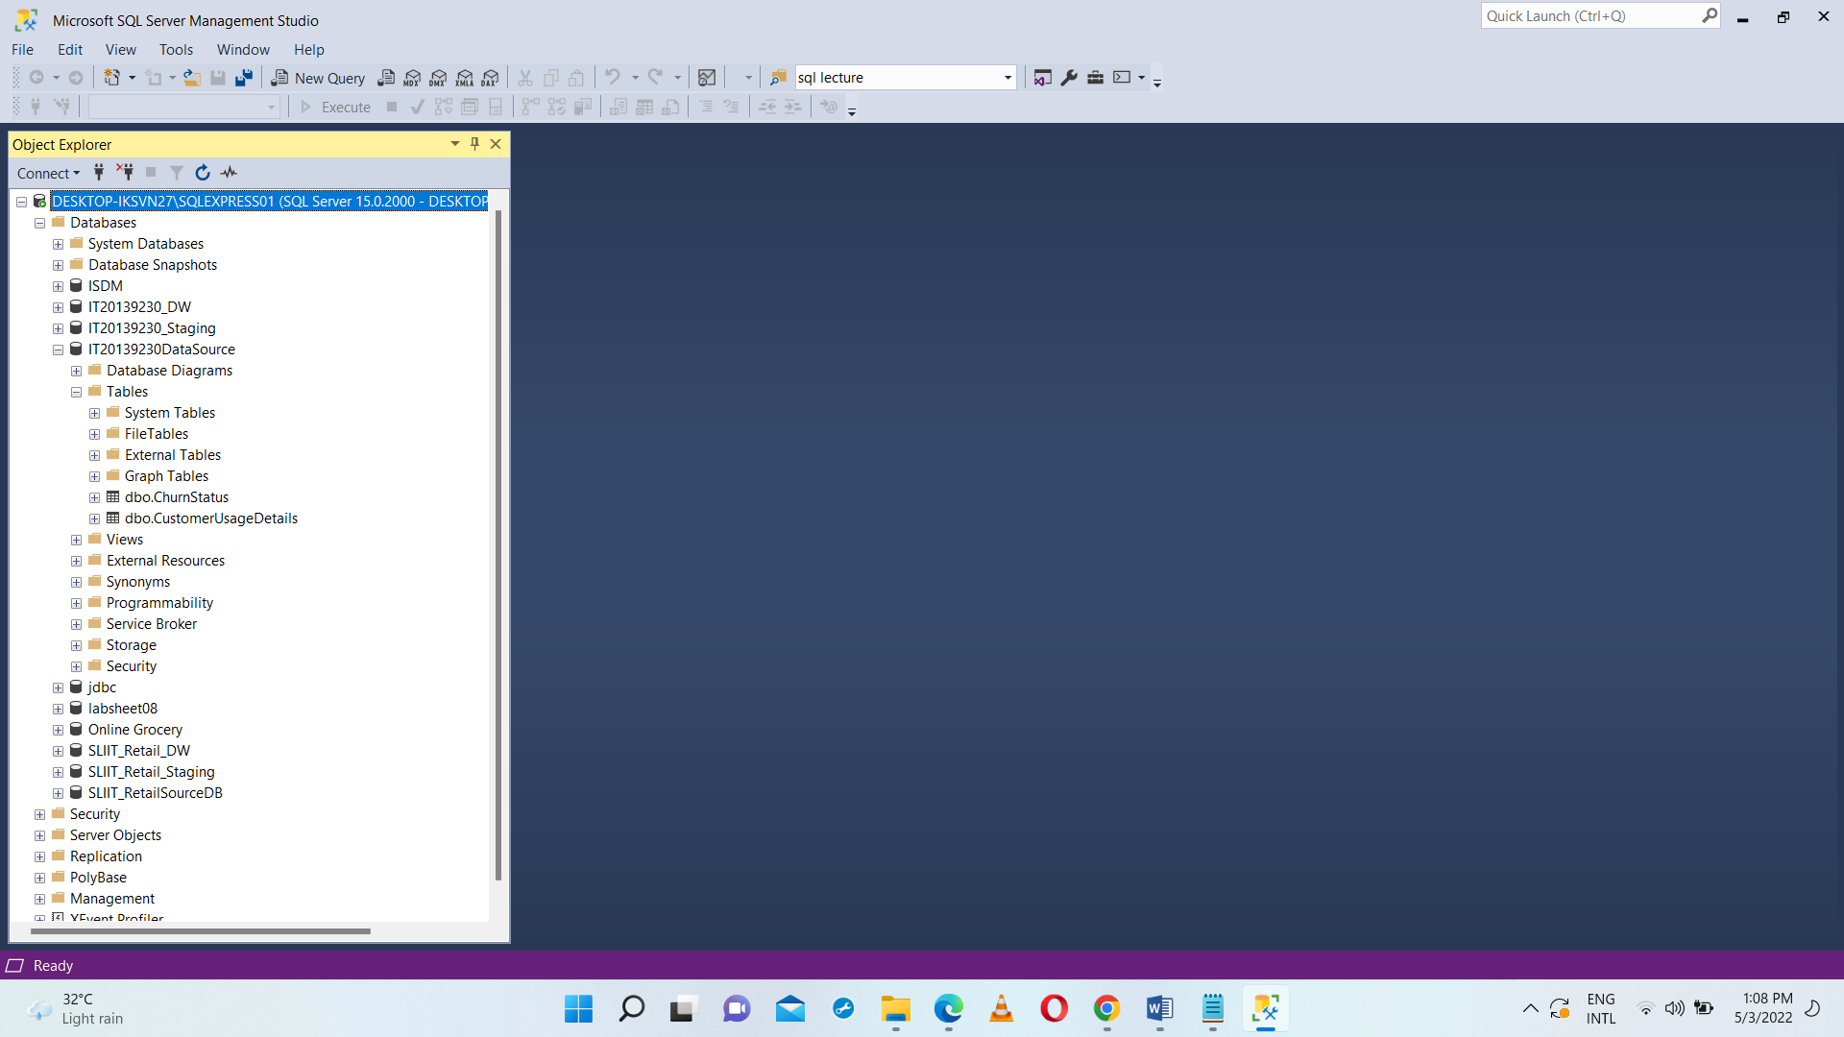

IT20139230DataSource

* **CustomerDetails-** Details about the Customer
* **CustomerNames-** Details of the first and last names of the customer
* **CustomerServiceDetails-** Details of the services for the customer
* **Location-** Details of the customer loction
* **Population-** Population details for the relavant zip Codes
* **ChurnStatus-** Churn status of the customer
* **CustomerUsageDetails-** Service usage details of the customer

**Step 3: Solution architecture**

Using different processes, architectures, and technologies we can manage data from various sources and convert them to business insights to make decisions, analysis data and report building.

In this solution, there are 3 main components up to the ETL process in the

process of Datawarehouse design.

• Source Files

• Staging DB

• Datawarehouse

**Source Files** : There are 7 source tables in three different format as the data sources.

**Staging DB :** Extracted all source details and change the data types of

the attributes that are in source file to relevant data type and loaded that

details into the staging database.

**Datawarehouse :** After the staging, the information in staging database will

become the sources to the transformation process. In this process data will

transformed & loaded in to the tables in Datawarehouse database.

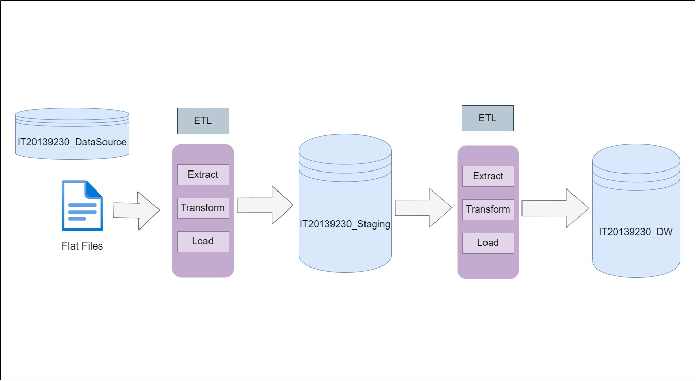

**Step 4: Data warehouse design & development**

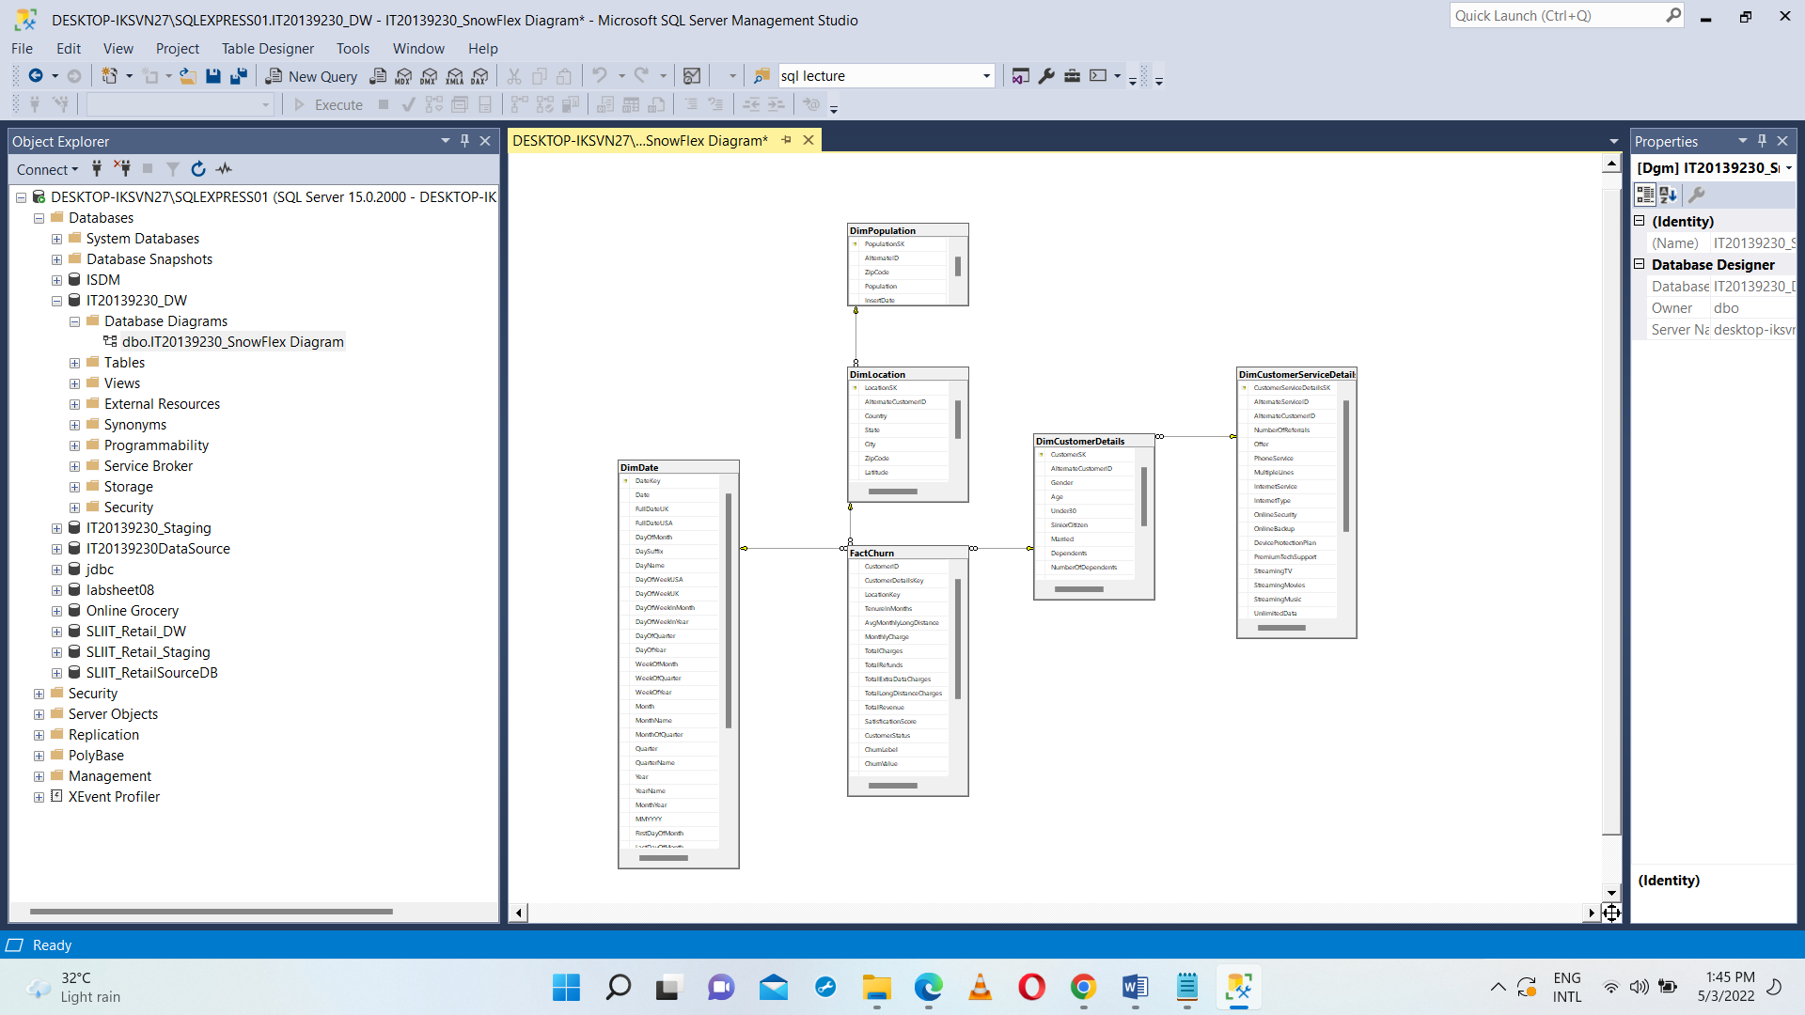

**Assumptions**

* Snowflake schema is used to design the Datawarehouse design. There is one fact table and 4 dimensions apart from the data dimension.
* DimCustomerServiceDetails were considered as a slowly changing dimension.

Before creating the FactChurn table & other dimensions, started by creating the Date dimension using ‘DateMaster.sql’ file code dimension using ‘DateMaster.sql’ file code.

* **DimCustomerDetails-** Extracting data from CustomerDetails and CustomerNames from the staging and loding them.
* **DimCustomerServiceDetails-** Extracting data from CustomerServiceDetails from the staging and loding. Ans also this is a slowly changing dimention.
* **DimLocation-** Extarct data from Location from the staging and loading.
* **DimPopulation-** Extract data from Population from then staging.
* **FactChurn-** Extract data from CustomerUsageDetails and CustomerChurnStatus

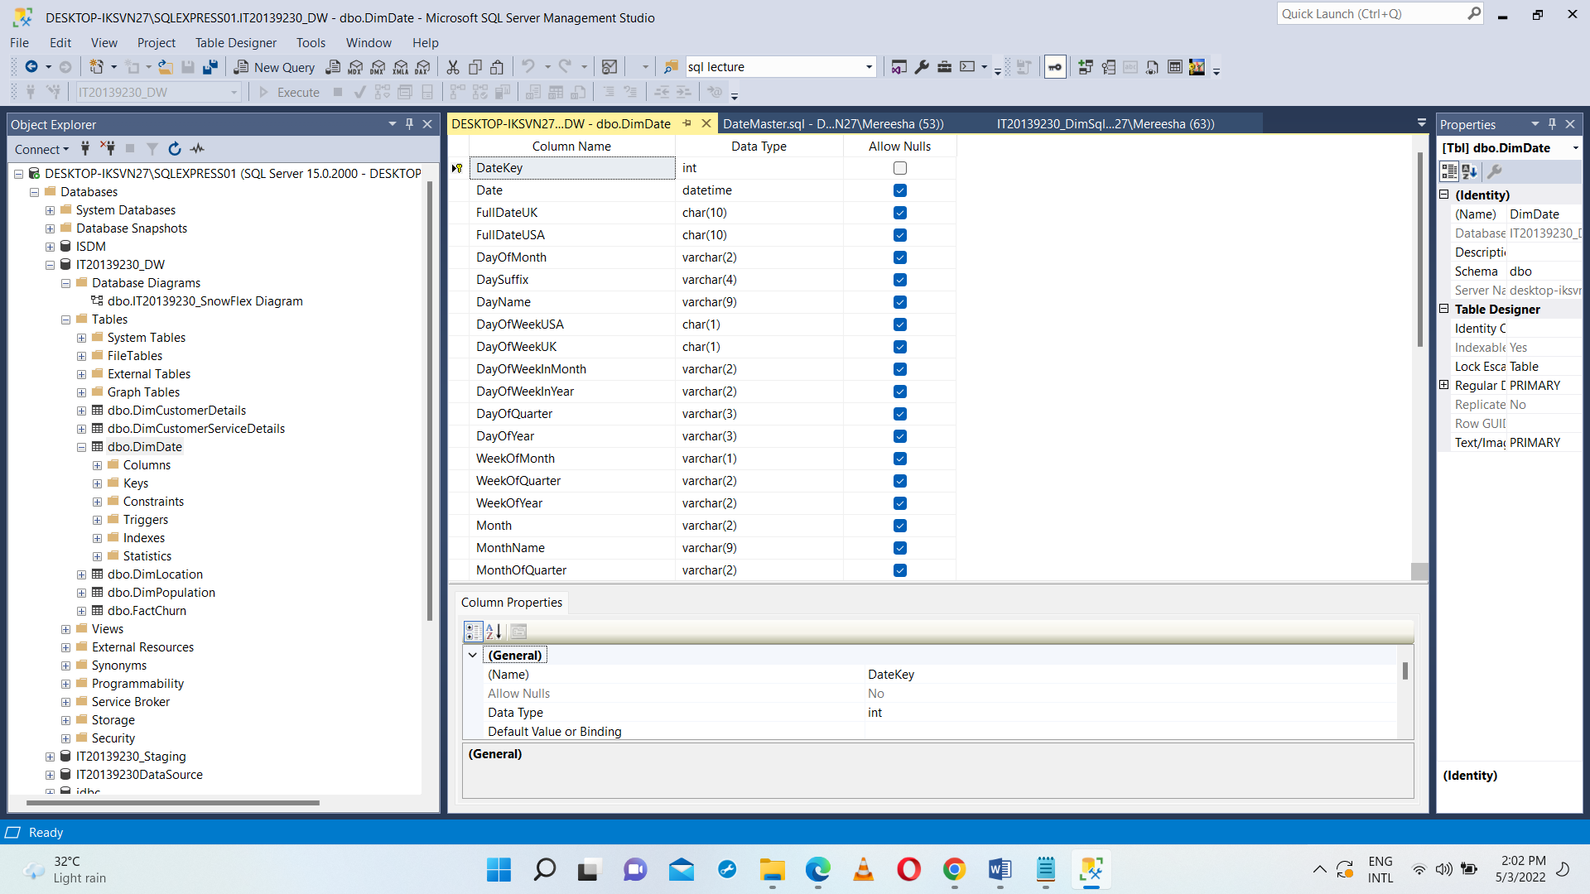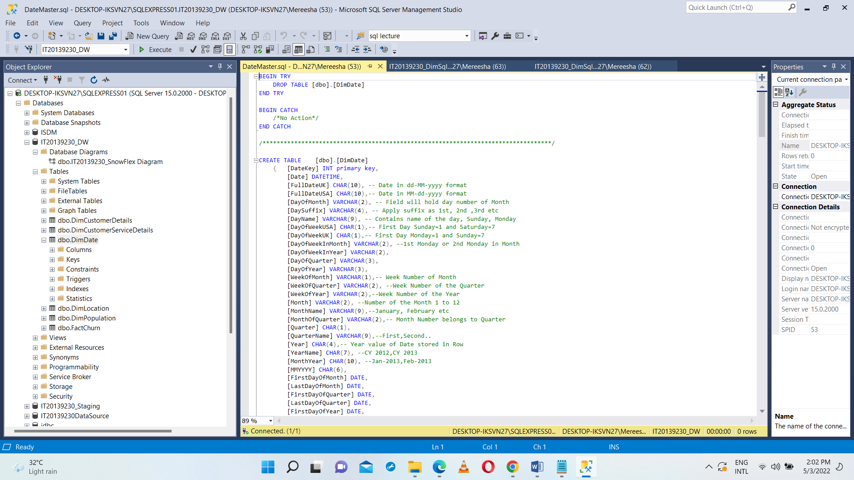

DimDate

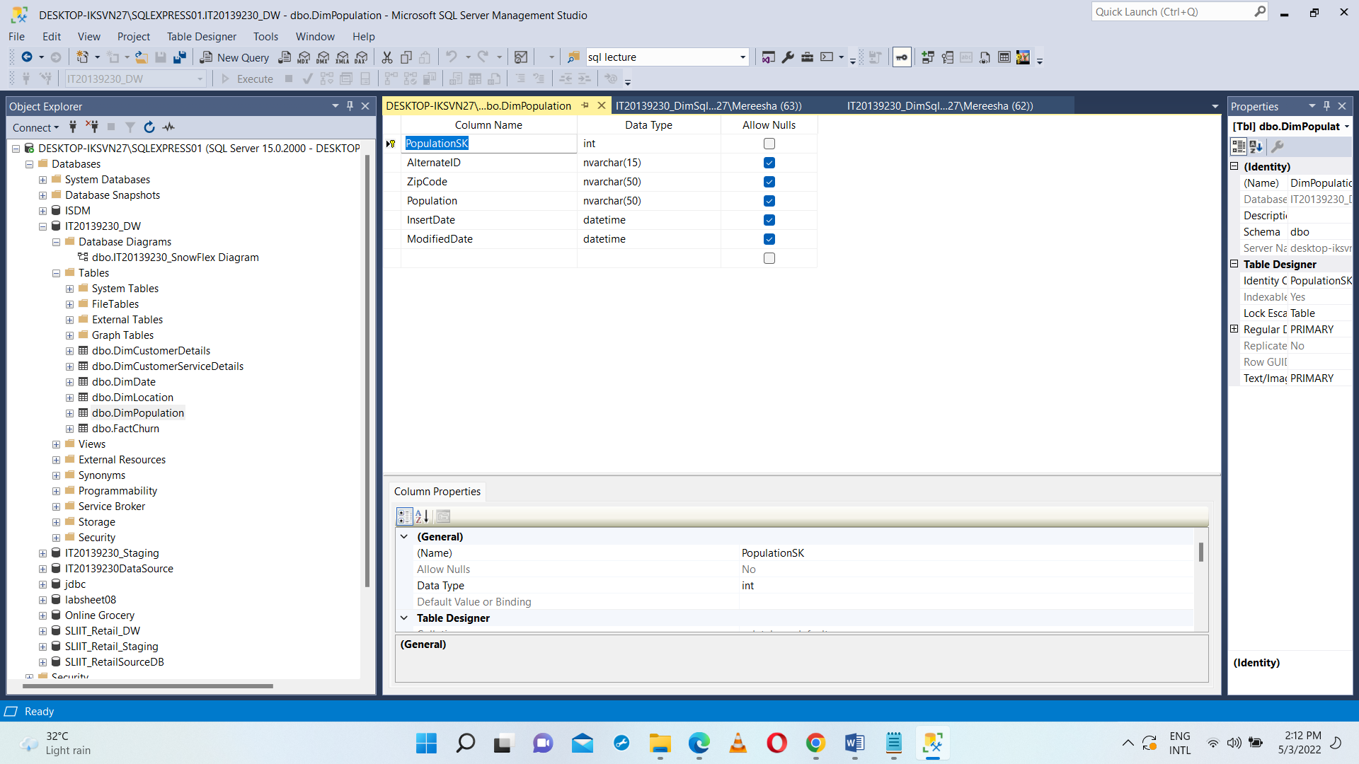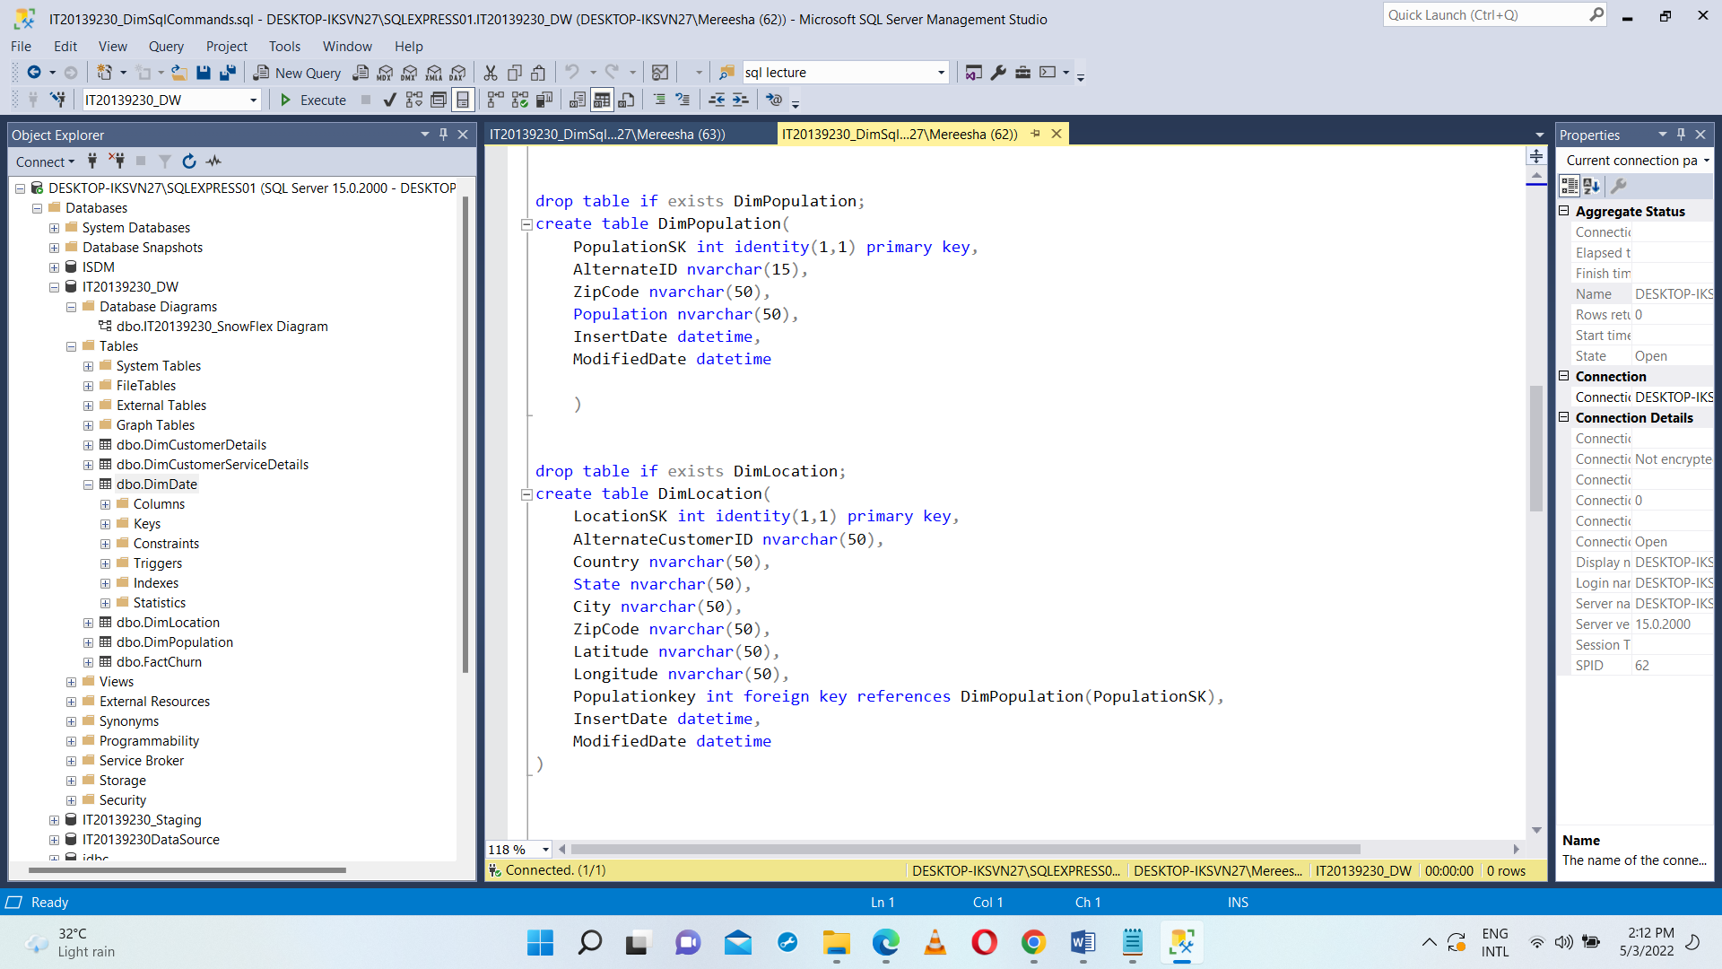

DimPopulation

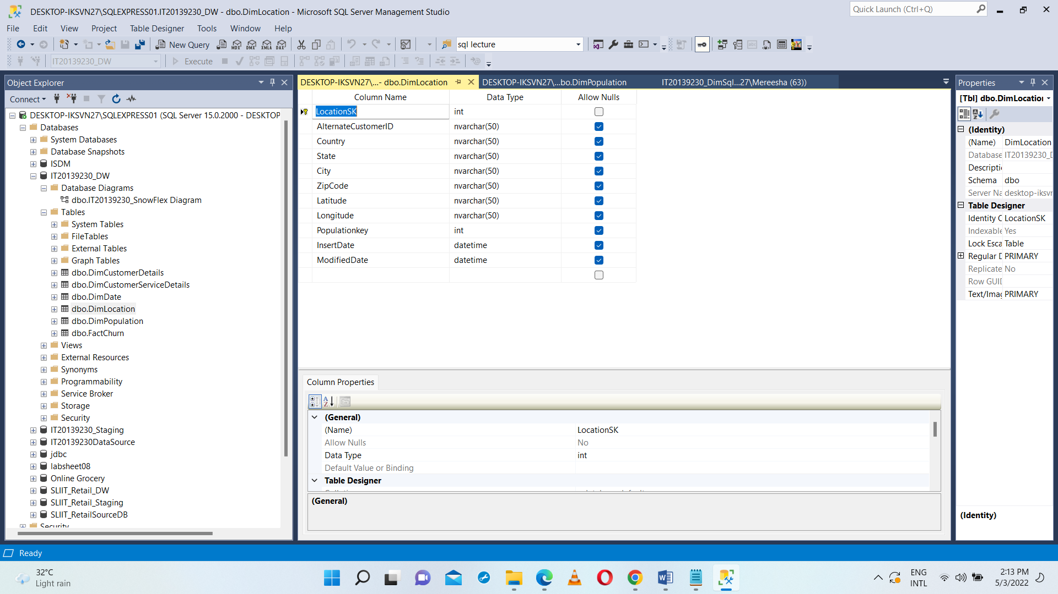

DimLocation

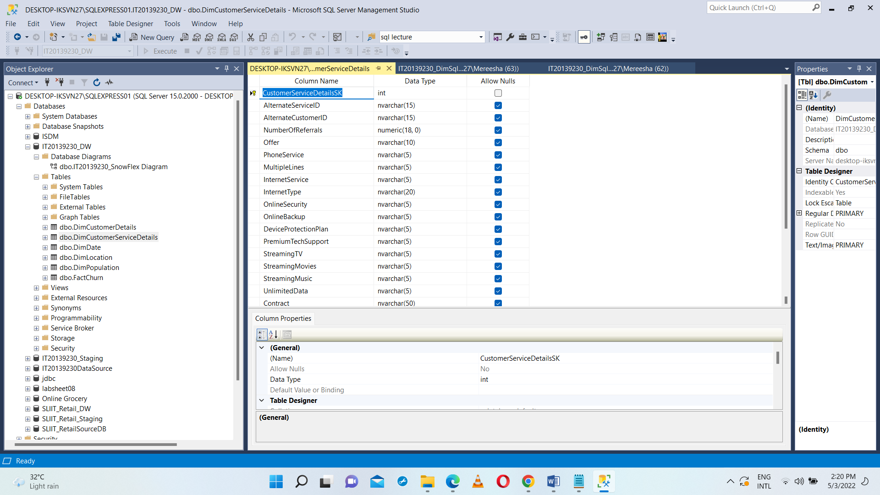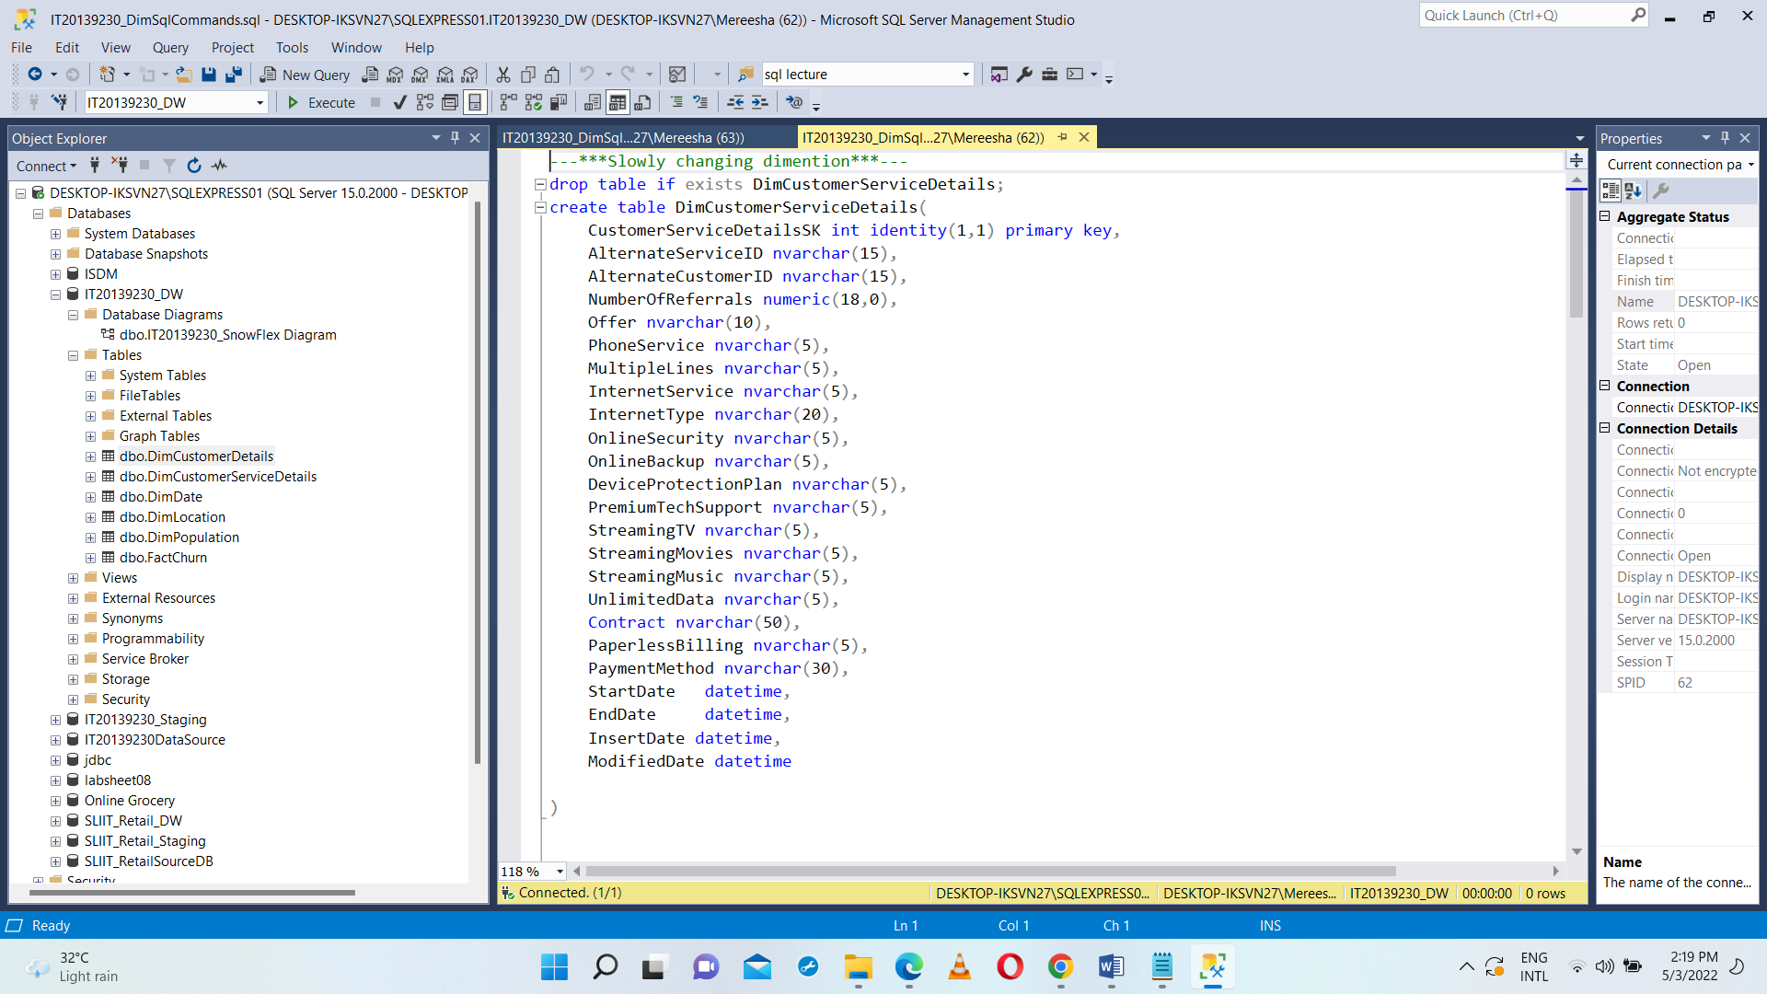

DimCustomerServiceDetails

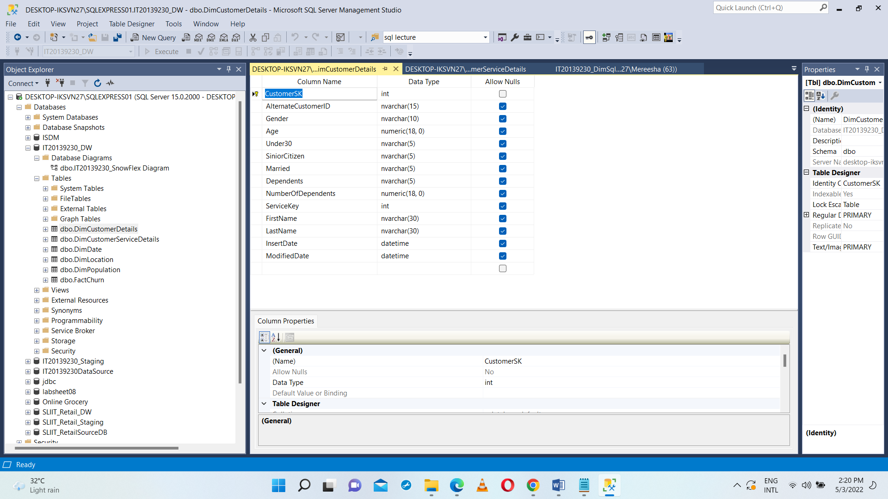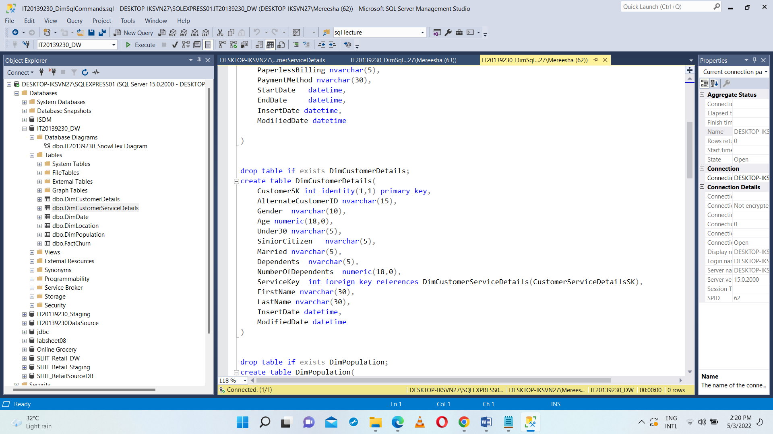

DimCustomerDetails

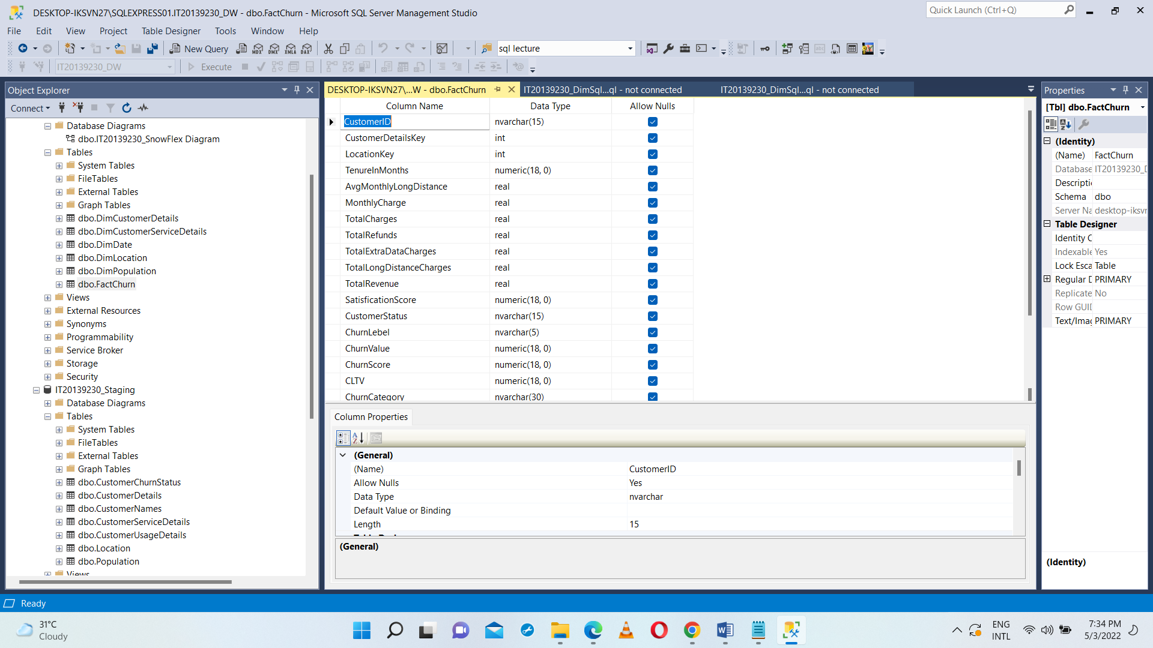

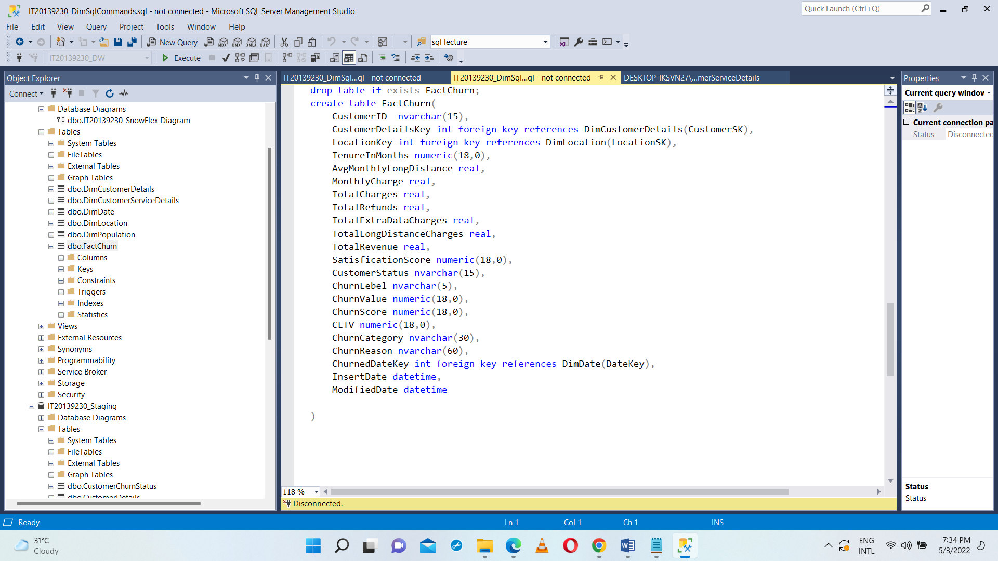

FactChurn

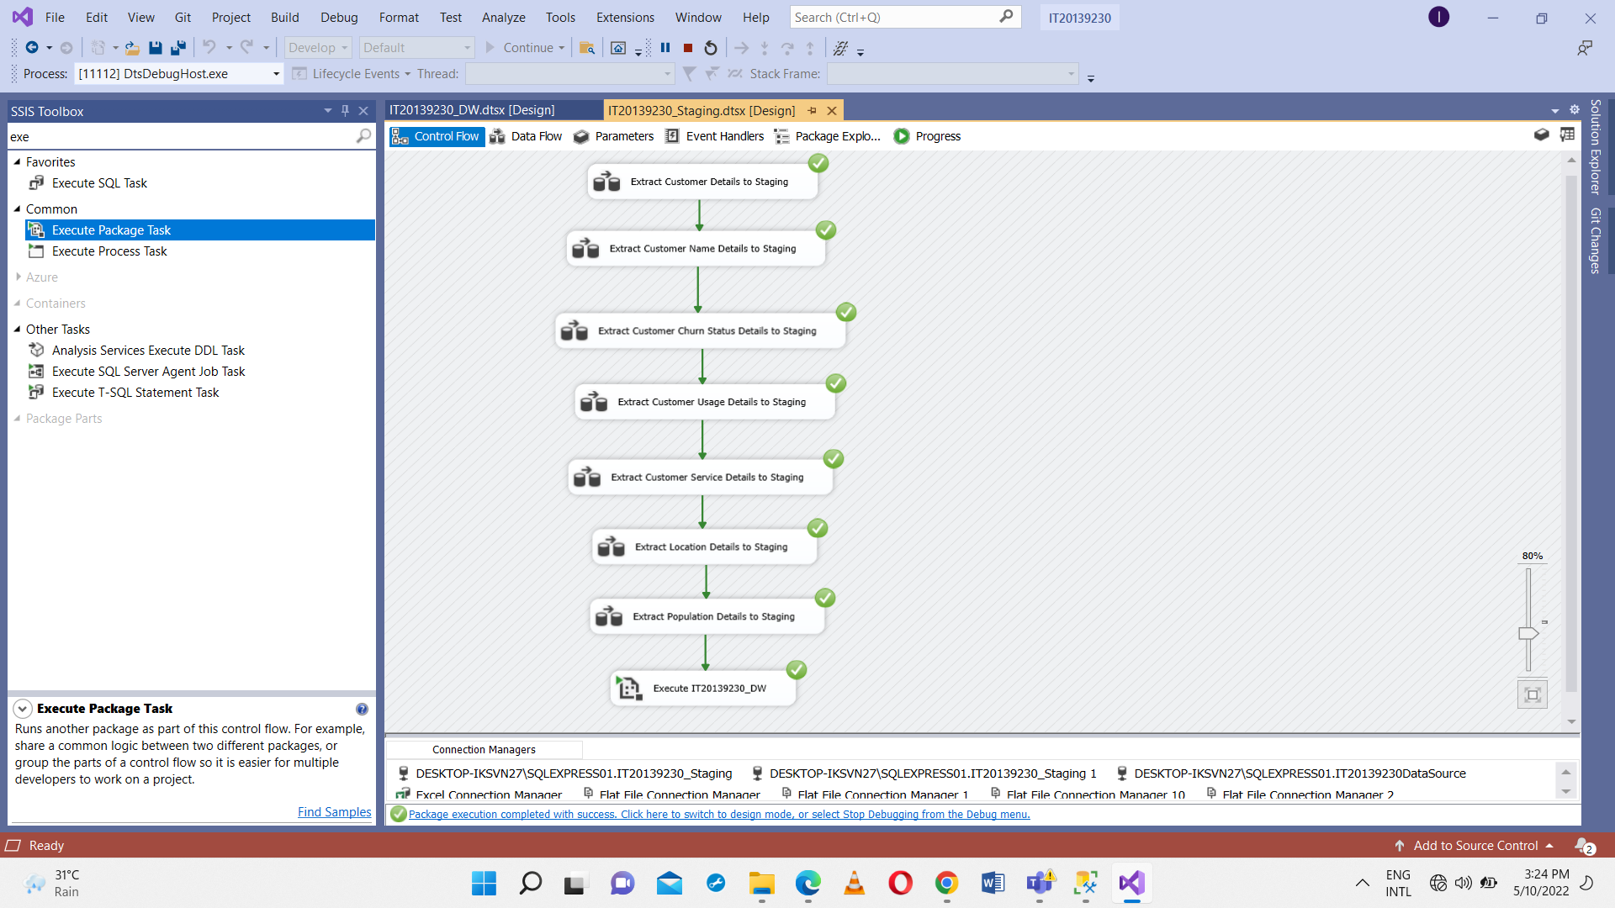**Step 5: ETL development**

First extracted all the data from tables which are in the IT20139230_DataSource, and flat files into separated staging DB called IT20139230_Staging as shown in the below using SQL Server Integration Service Software.

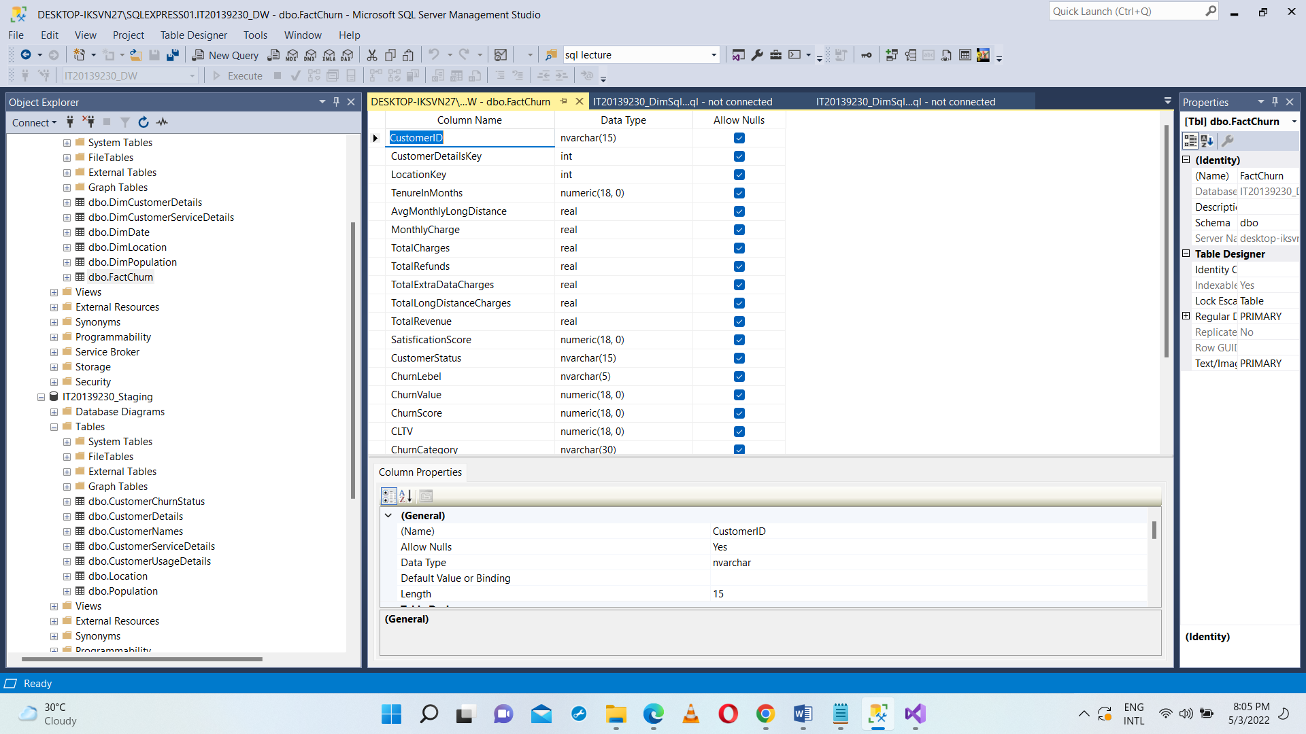

IT20139230_Staging

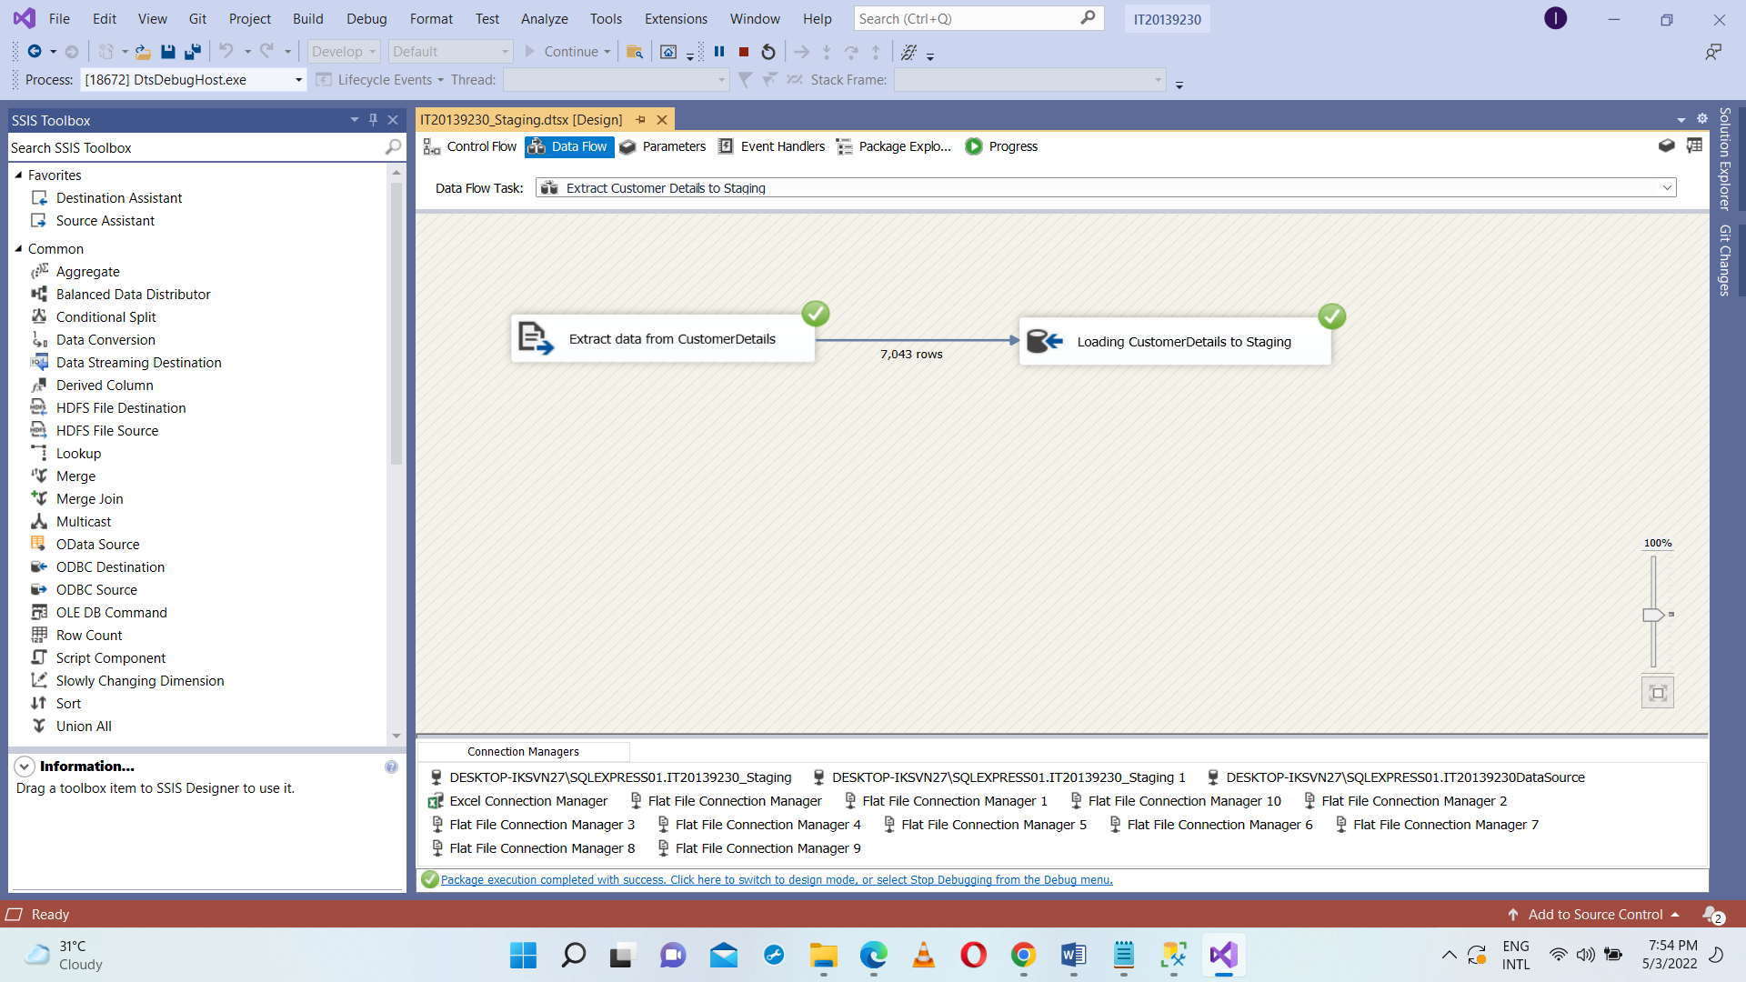Extract Customer Details from CustomerDetails.txt file and load into staging CustomerDetials table. Used Execute SQL Task SSIS tool Truncate table for SQL command as truncate table dbo.CustomerDetails in IT20139230_Staging Database

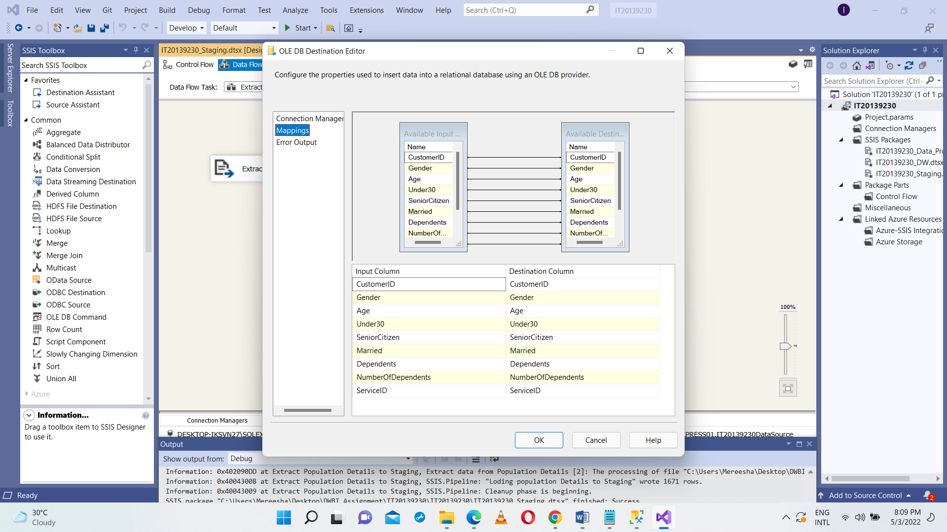

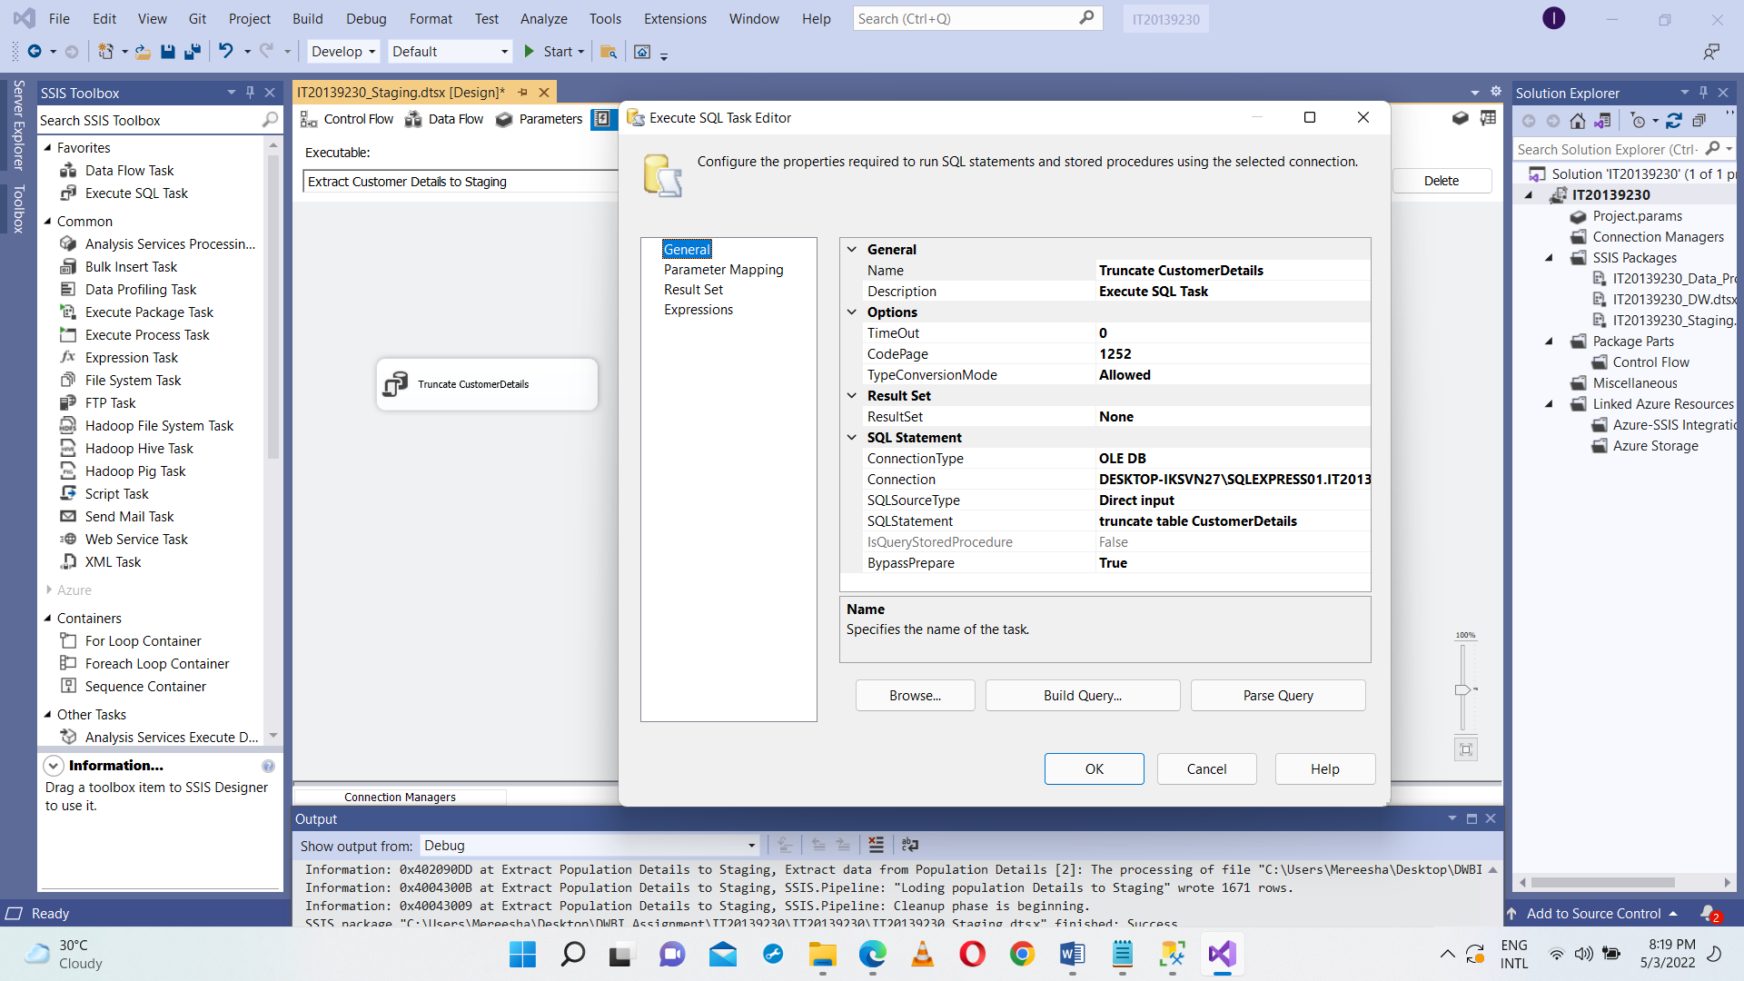

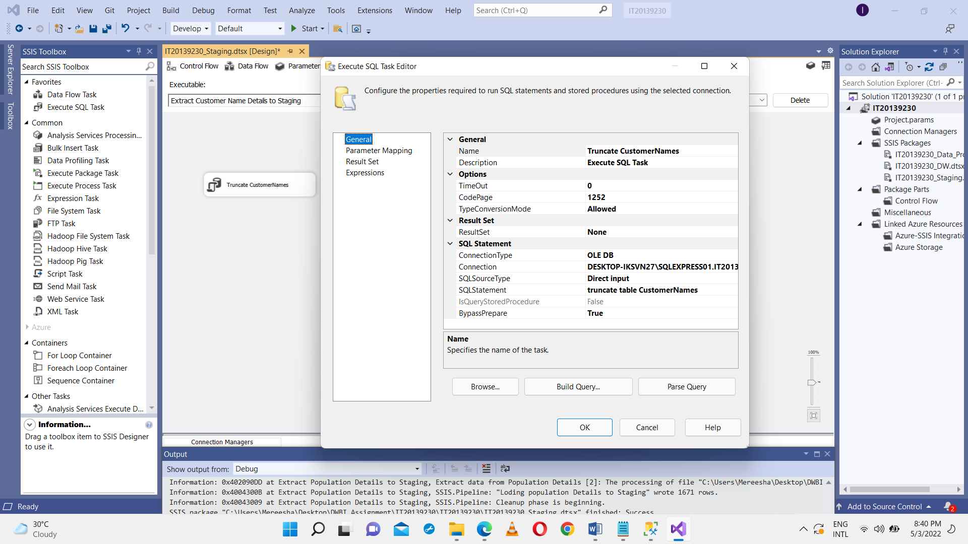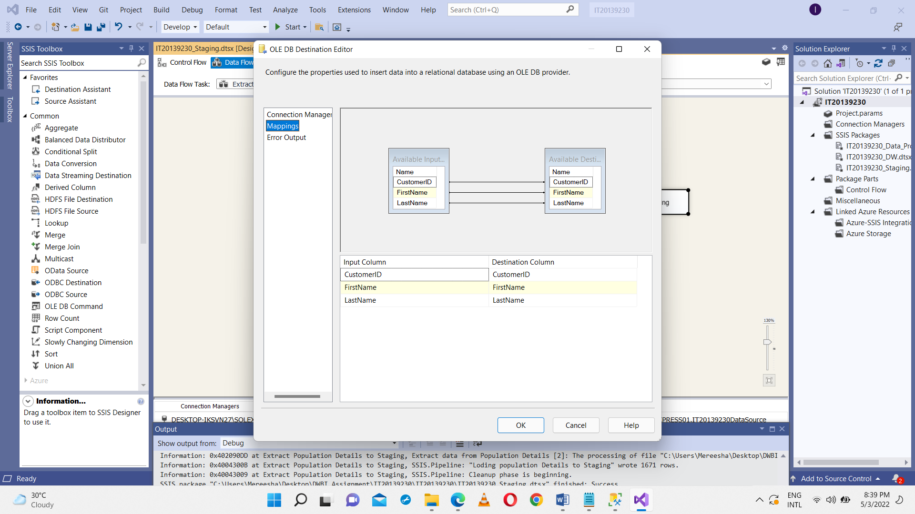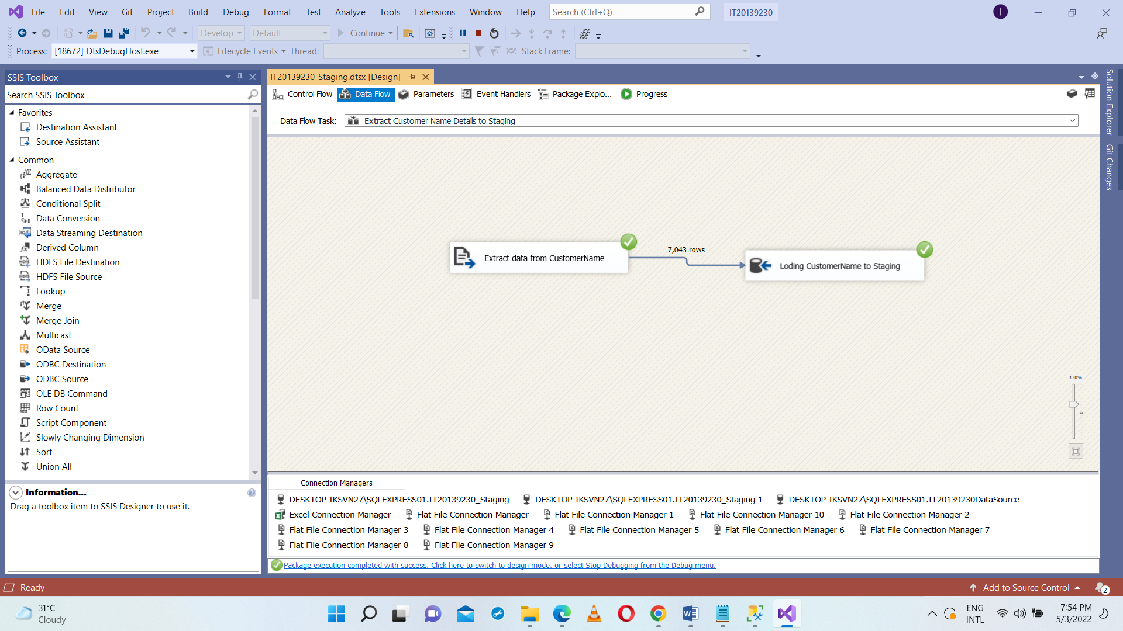Extract Customer Name Details from CustomerNames.csv file and load into staging CustomerNames table. Used Execute SQL Task SSIS tool Truncate table for SQL command as truncate table dbo.CustomerNames in IT20139230_Staging Database.

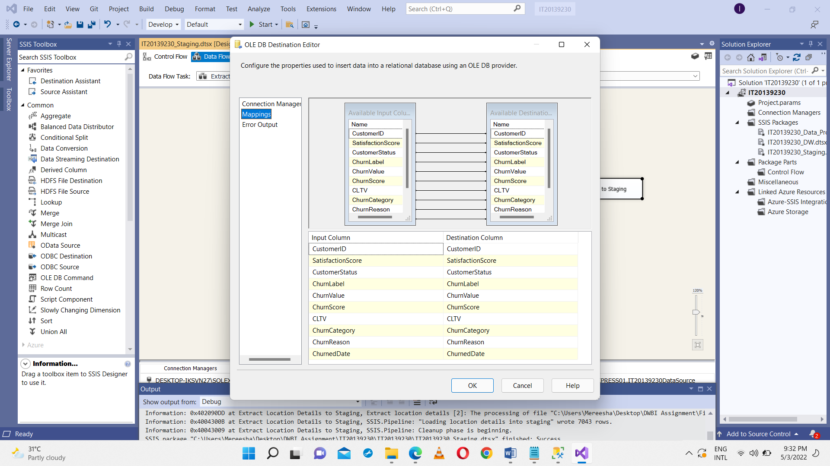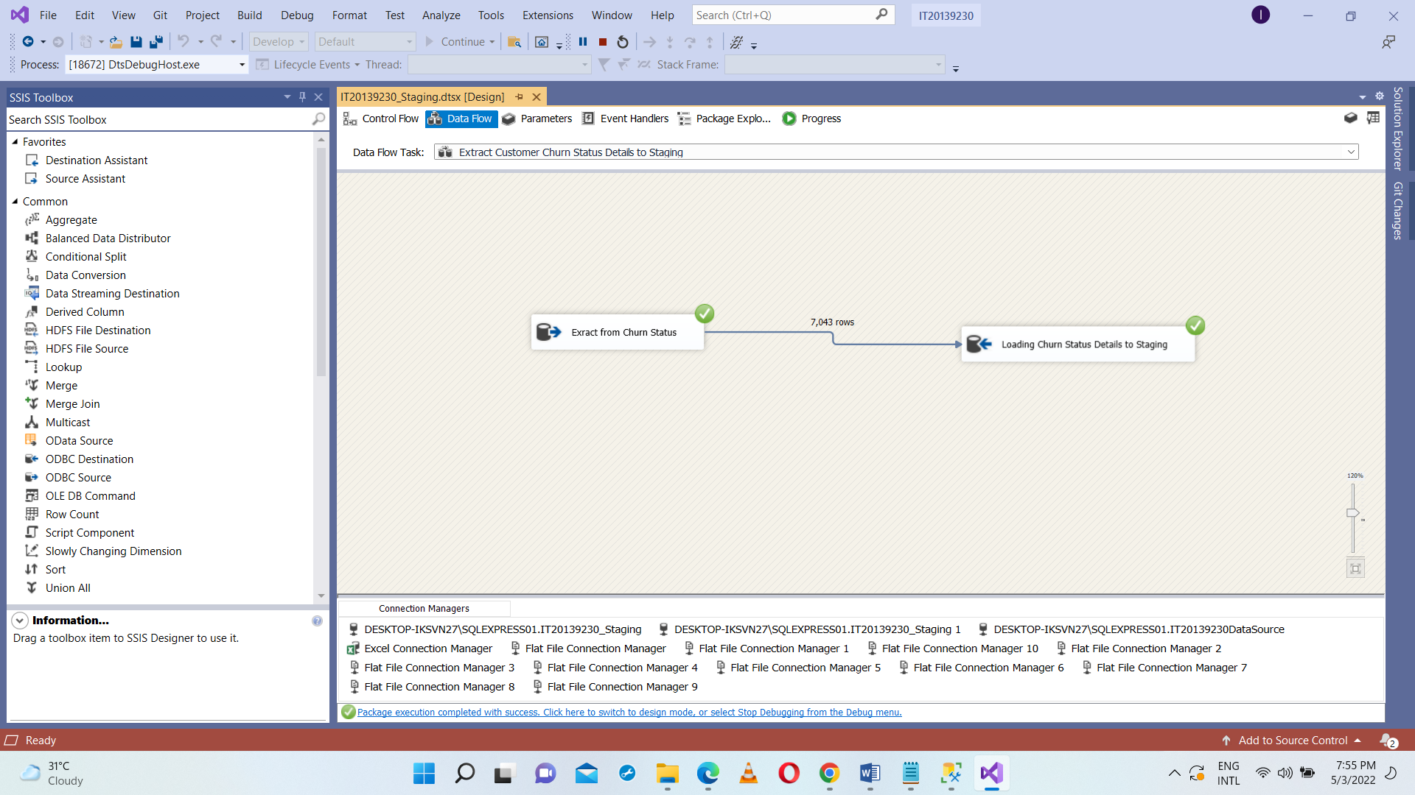Extract Customer Churn Details from IT20139230_DataSource database and load into staging CustomerChurnStatus table. Used Execute SQL Task SSIS tool Truncate table for SQL command as truncate table dbo.CustomerChurnStatus in IT20139230_Staging Database.

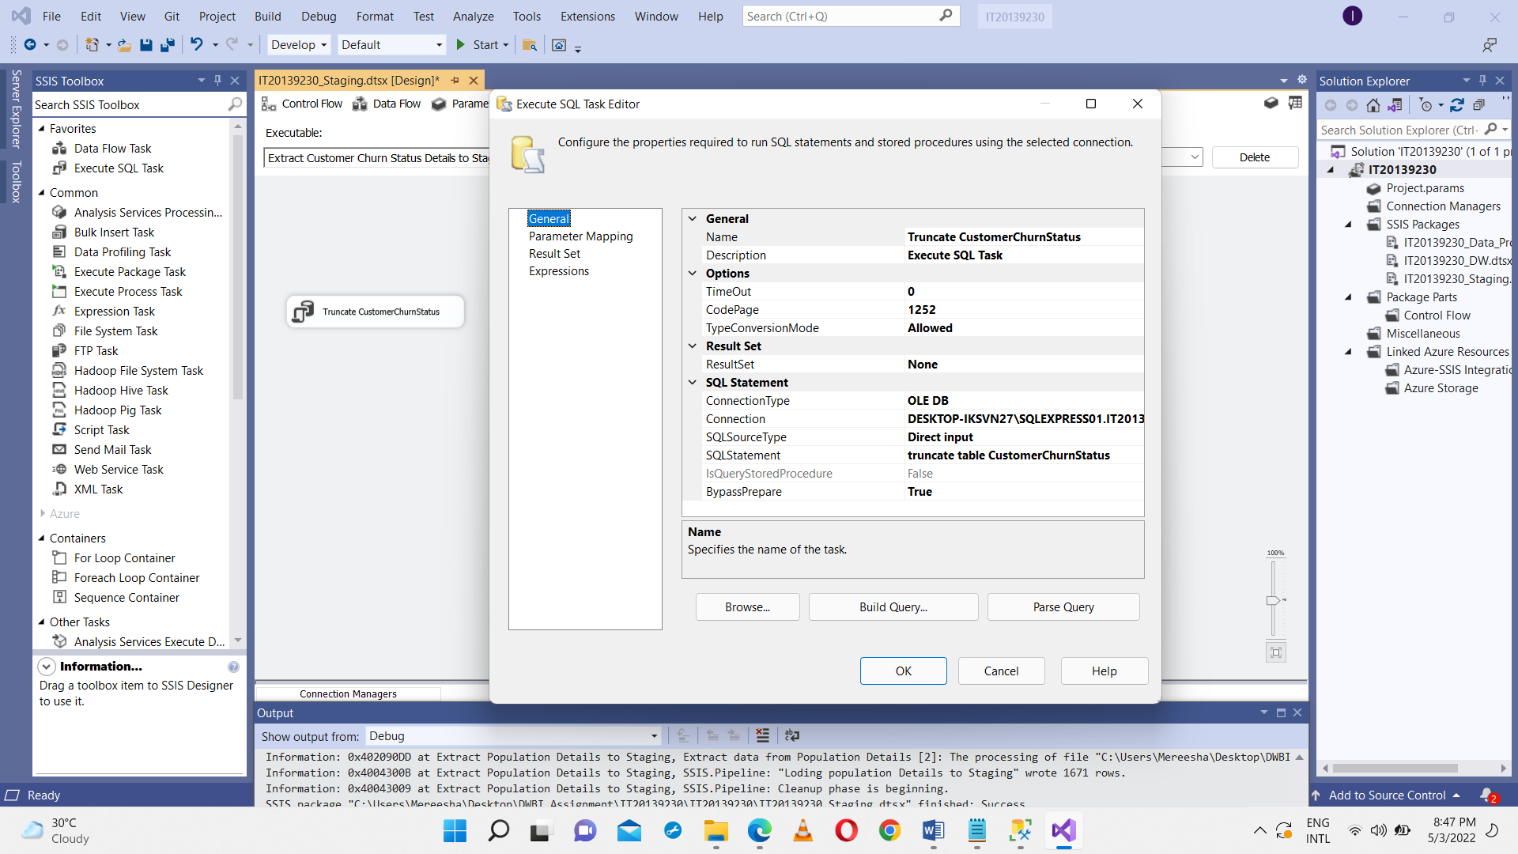

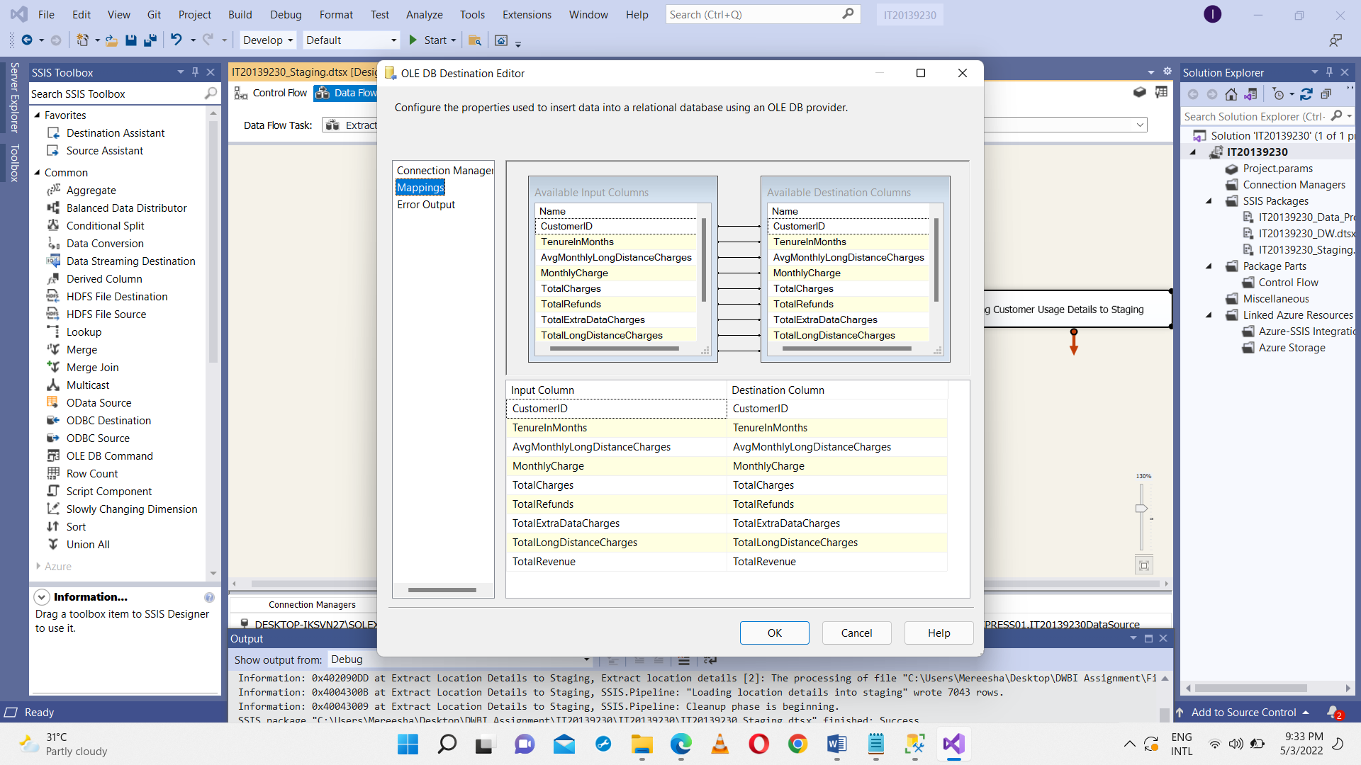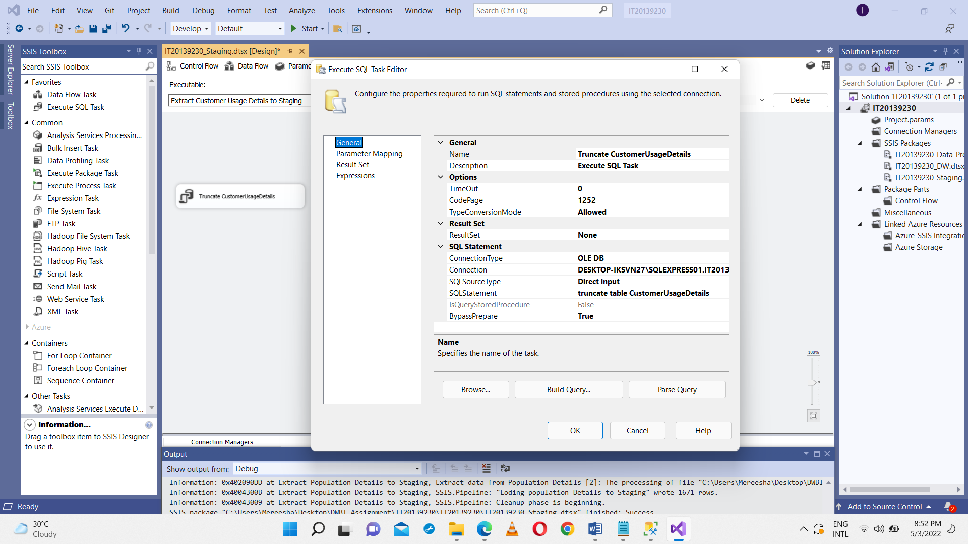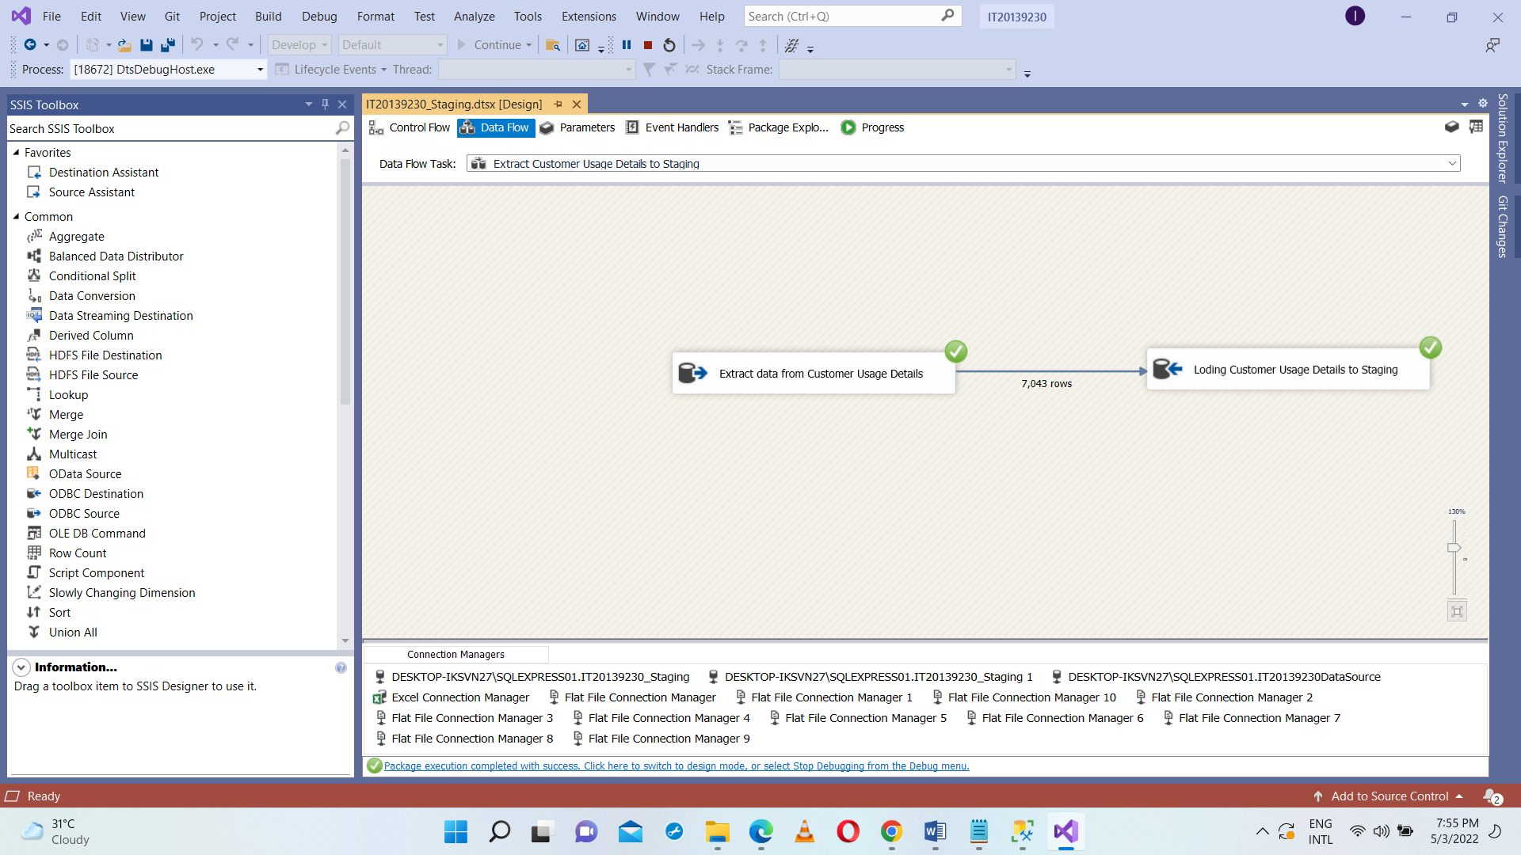Extract Customer Usage Details from IT20139230_DataSource database and load into staging CustomerUsageDetails table. Used Execute SQL Task SSIS tool Truncate table for SQL command as truncate table dbo.CustomerUsageDetails in IT20139230_Staging Database.

Extract Customer Service Details from CustomerServiceDetails.csv database and load into staging CustomerServiceDetails table. Used Execute SQL Task SSIS tool Truncate table for SQL command as truncate table dbo.CustomerServiceDetails in IT20139230_Staging Database.

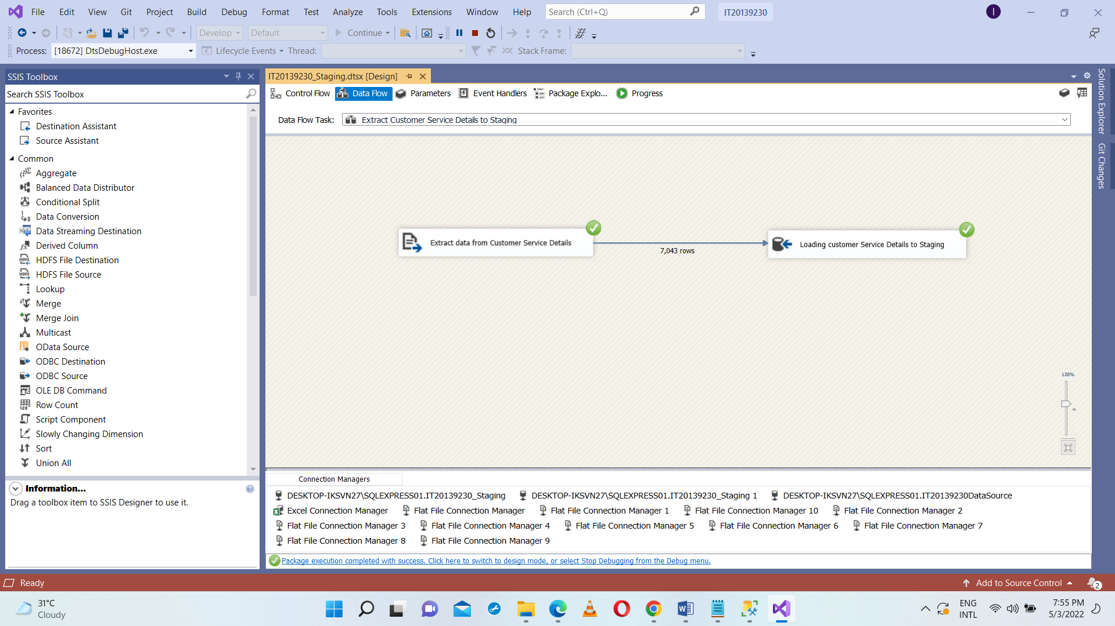

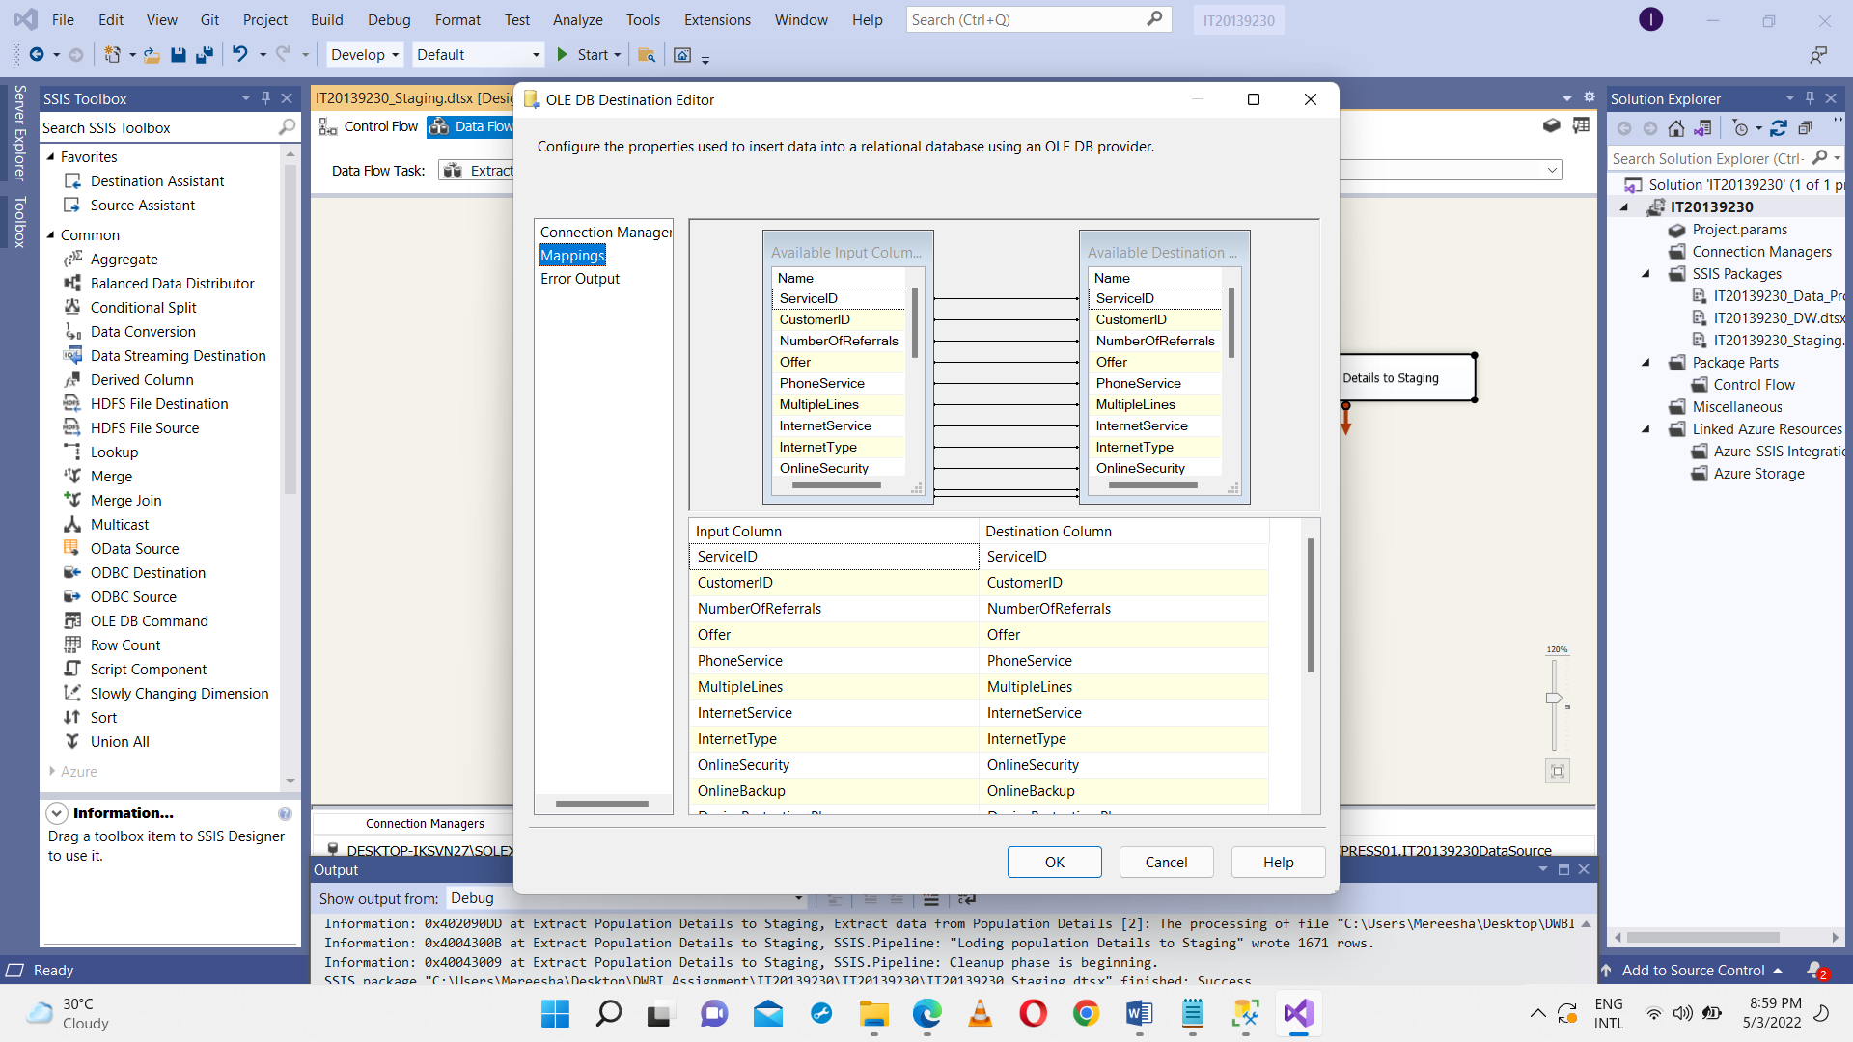

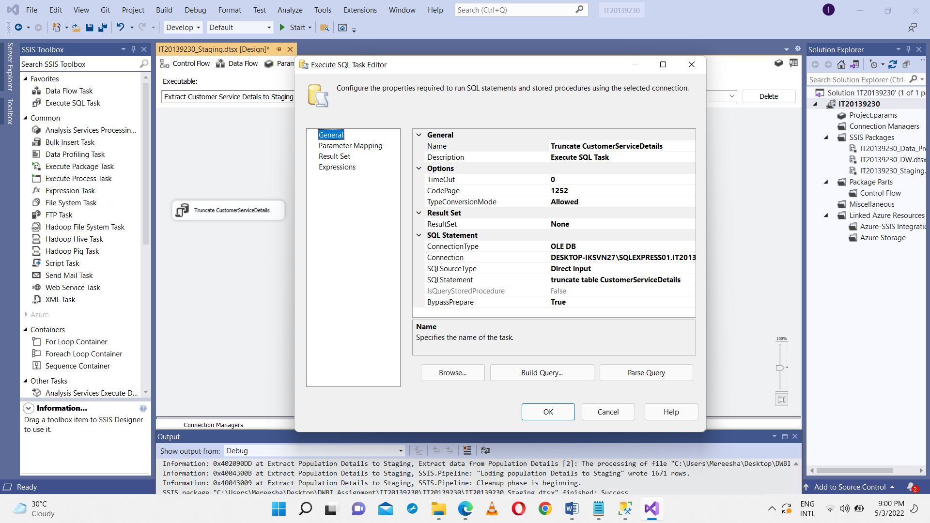

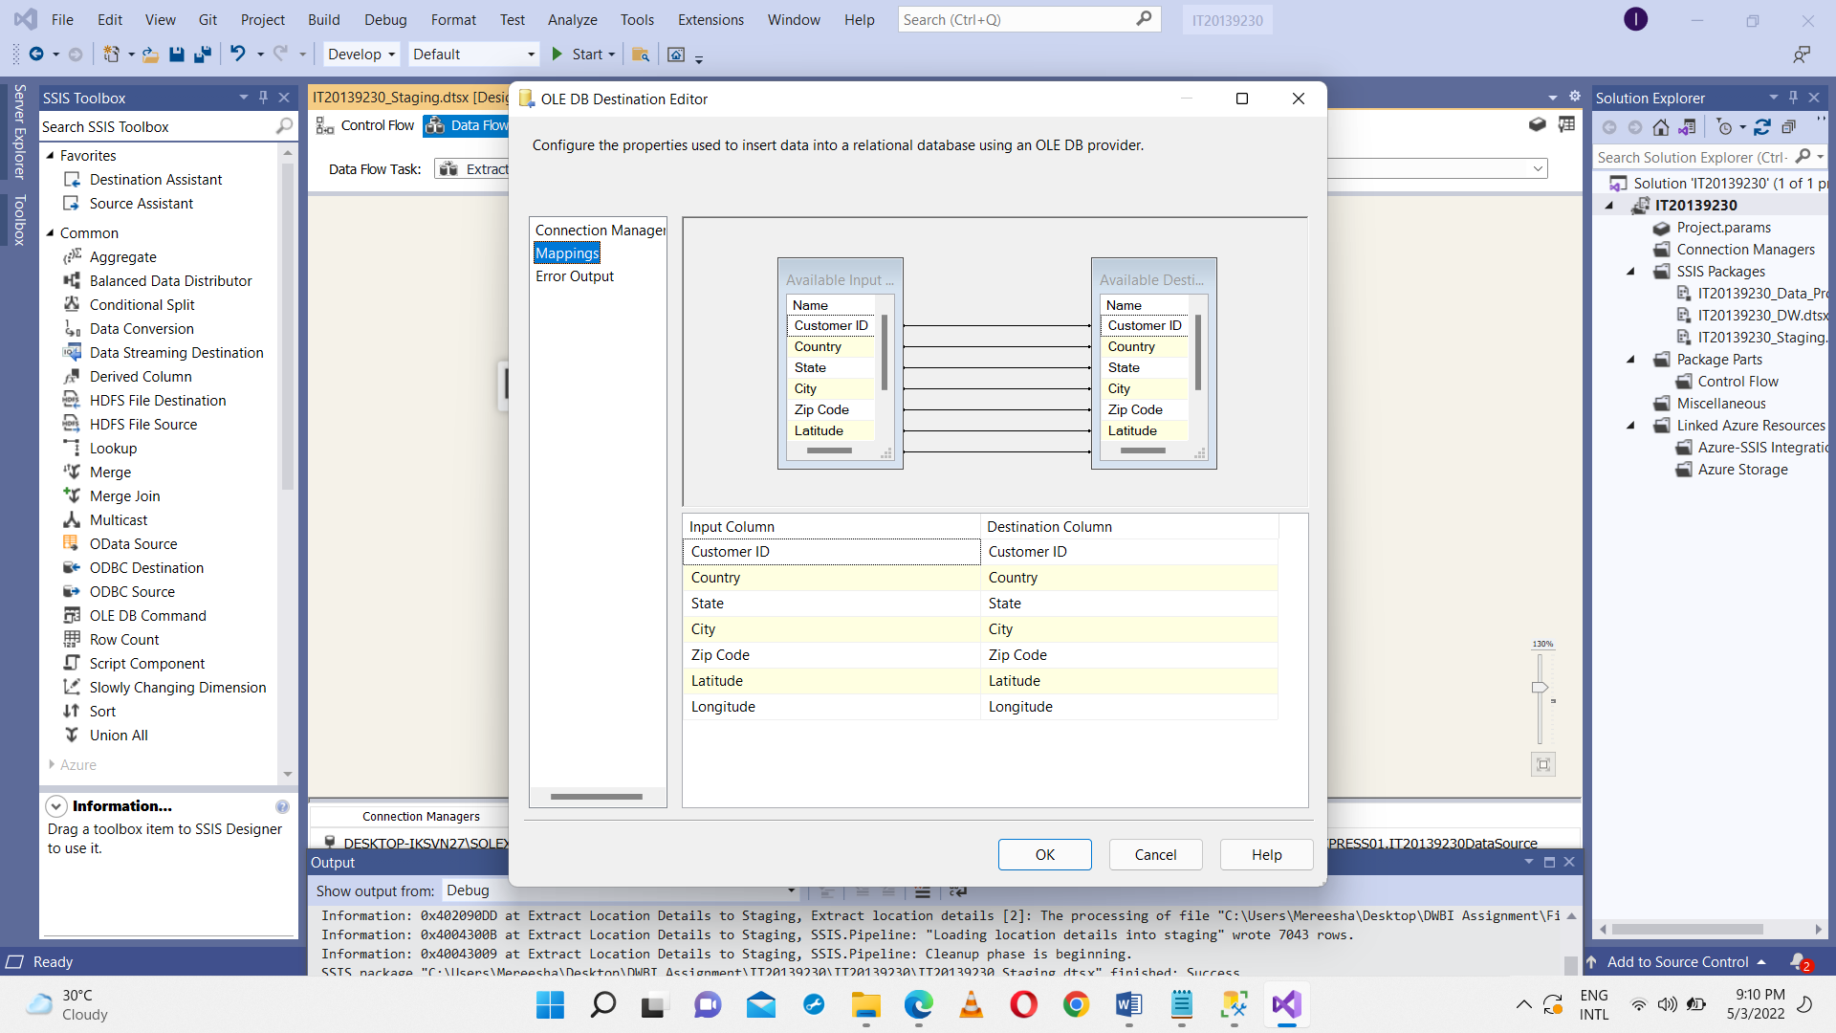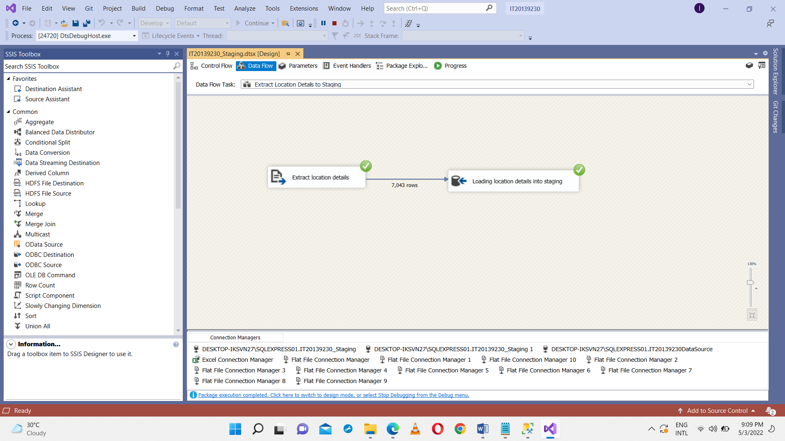Extract Location Details from Location.csv and load into staging Location table. Used Execute SQL Task SSIS tool Truncate table for SQL command as truncate table dbo.Location in IT20139230_Staging Database.

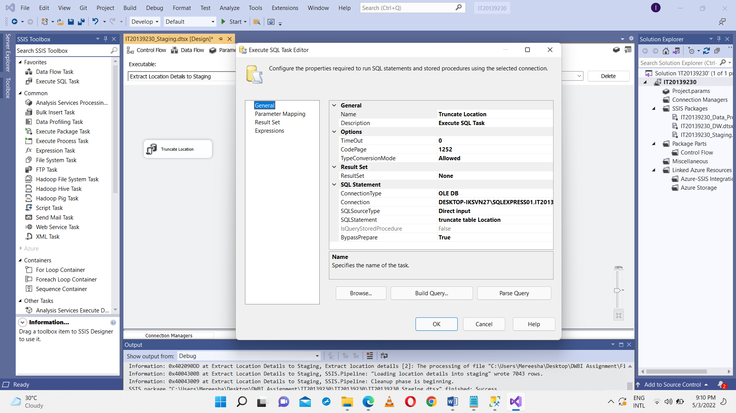

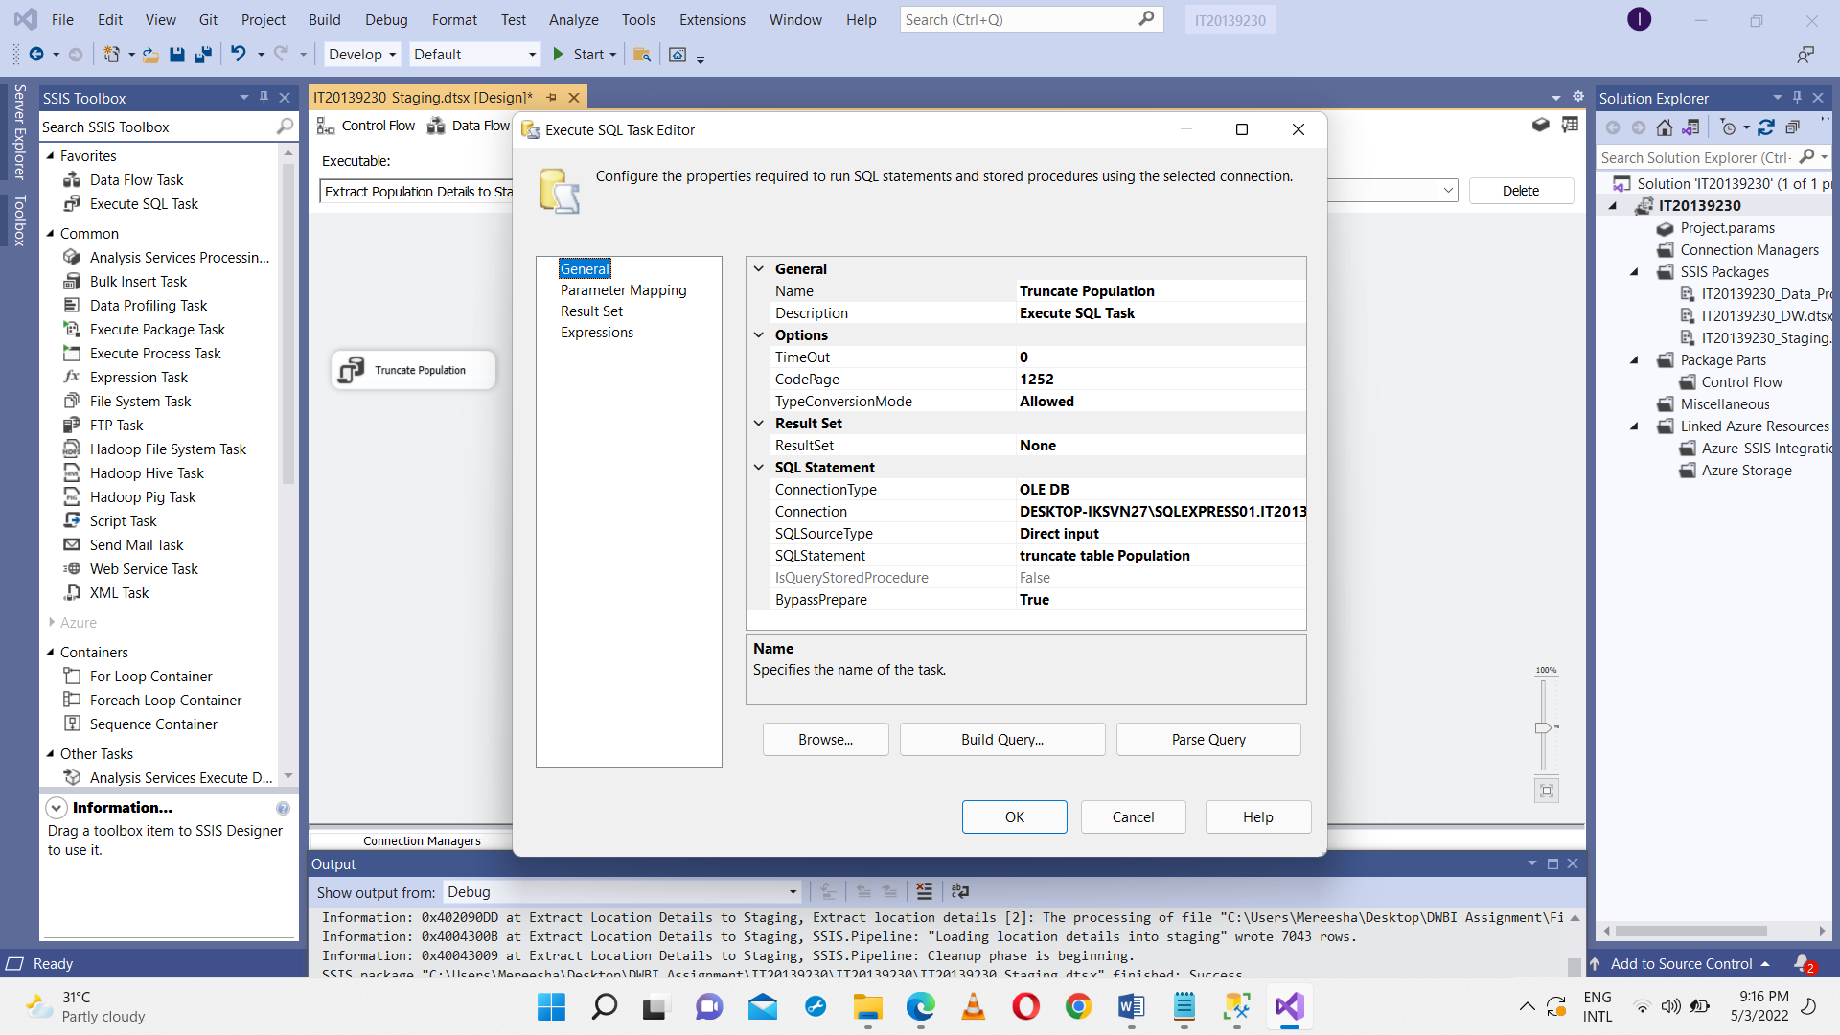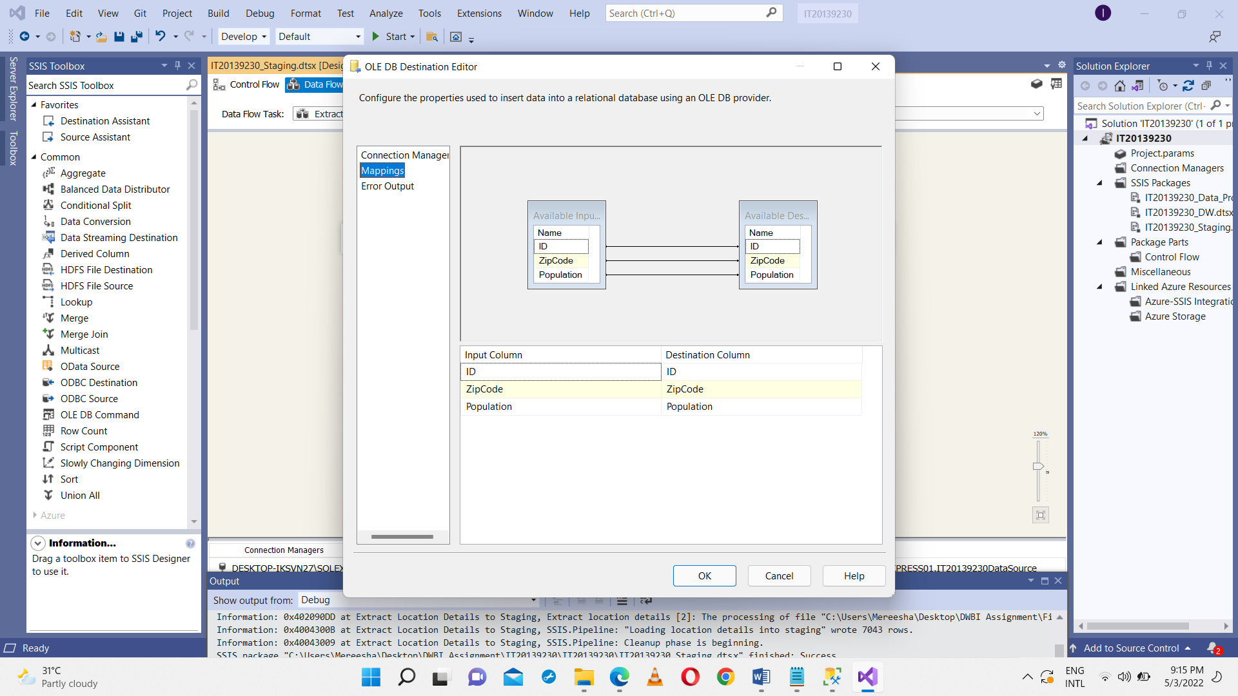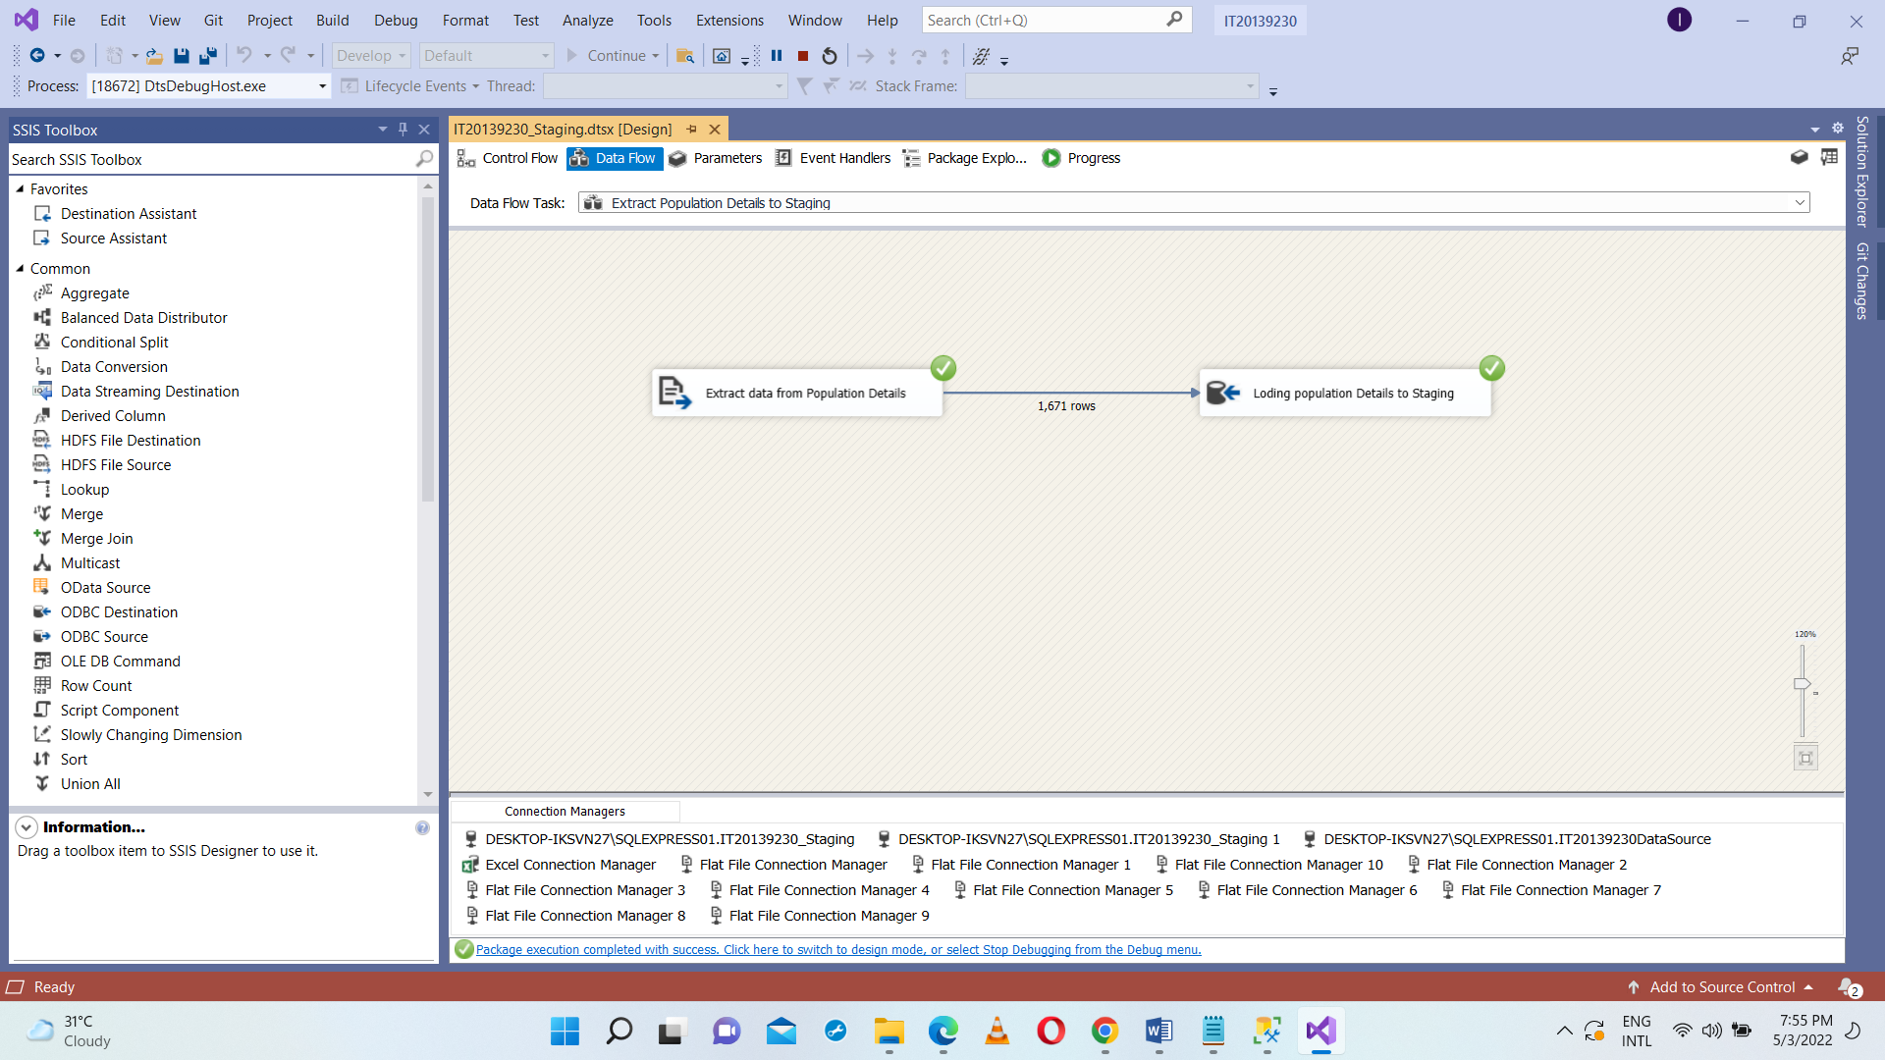Extract Location Details from Population.txt and load into staging Population table. Used Execute SQL Task SSIS tool Truncate table for SQL command as truncate table dbo. Population in IT20139230_Staging Database.

**Data Profiling**

Staging table data was used to analyzed and determined what types of transformation was needed to perform on the data.

• Right click on SSIS Packages and New SSIS Package selected.

• In the Control Flow of IT20139230_Data_Profiling.dtsx, drag and drop the Data Profiling Task and double click to open the configuration.

• Clicked on Quick Profile button to open Single Table Quick Profile Form.

• Clicked on New button and create the connection to IT20139230_Staging

• Once the green tick appeared, double click the Data Profiling Task and Click on the Open Profile Viewer to view the analyzed data

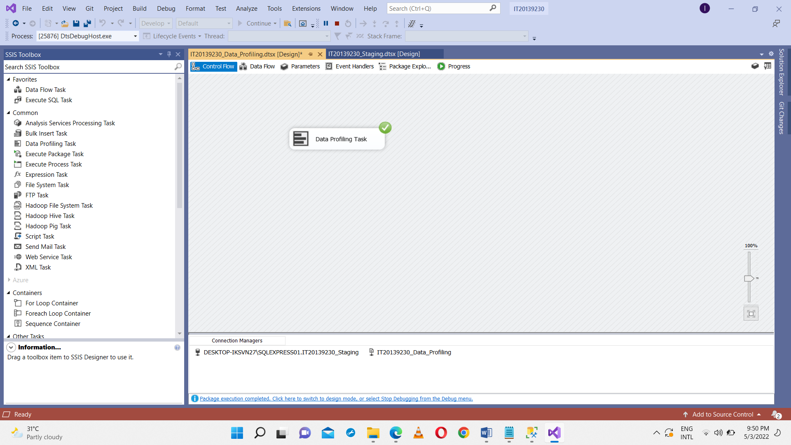

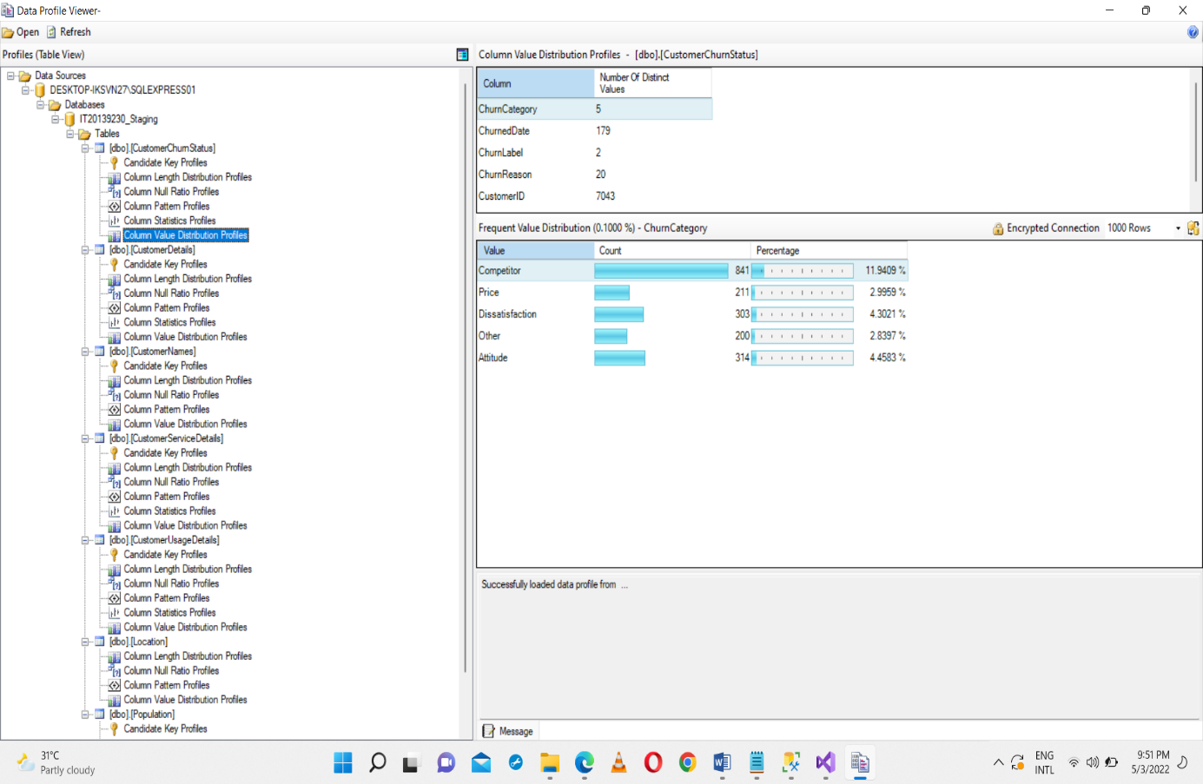

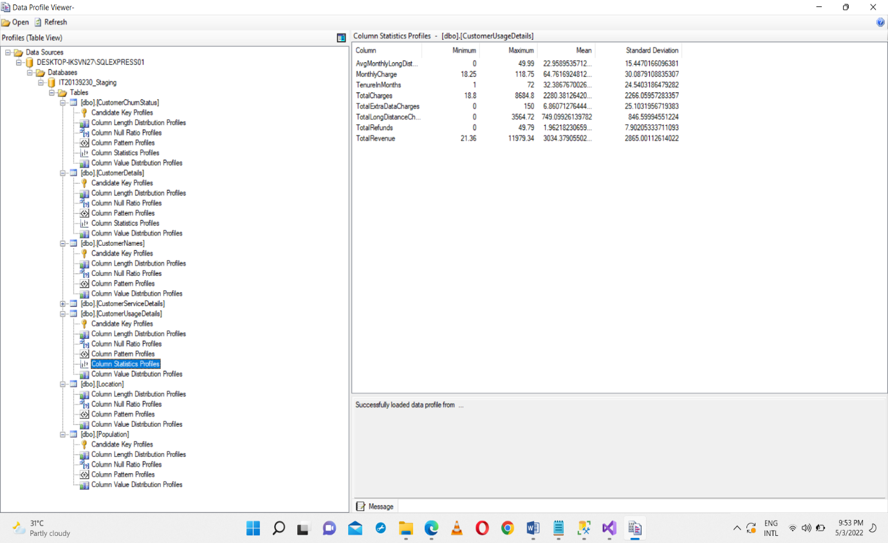

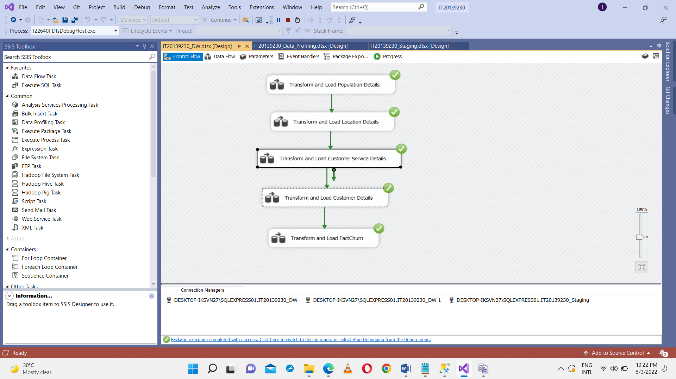**Data Transformation**

Finally extracted all the data from tables which are in the IT20139230_Staging into DB named IT20139230_DW database as shown in the below using SQL Server Integration Service Software.

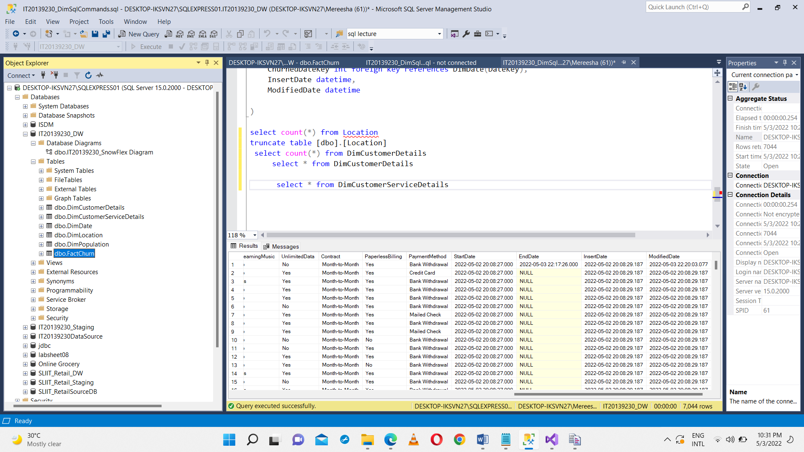

IT20139230_DW

**DimPopulation**

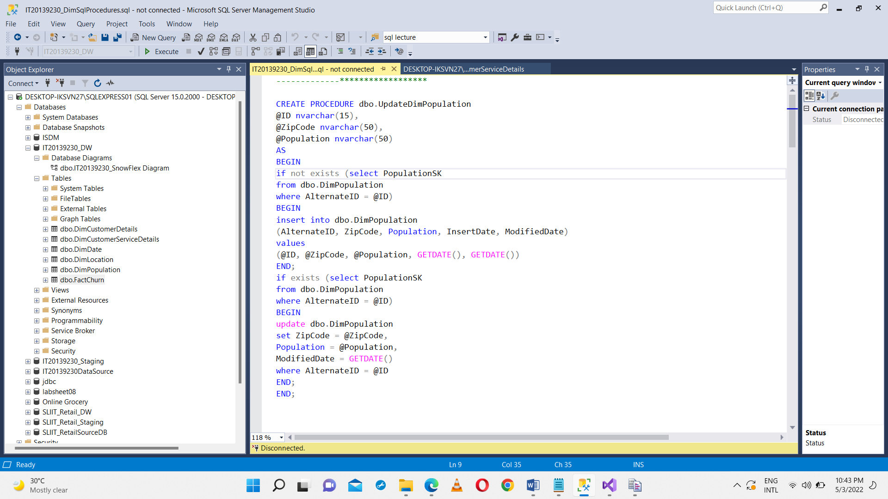First created a Procedure called UpdateDimPopulation and executed in the IT20139230_DW database

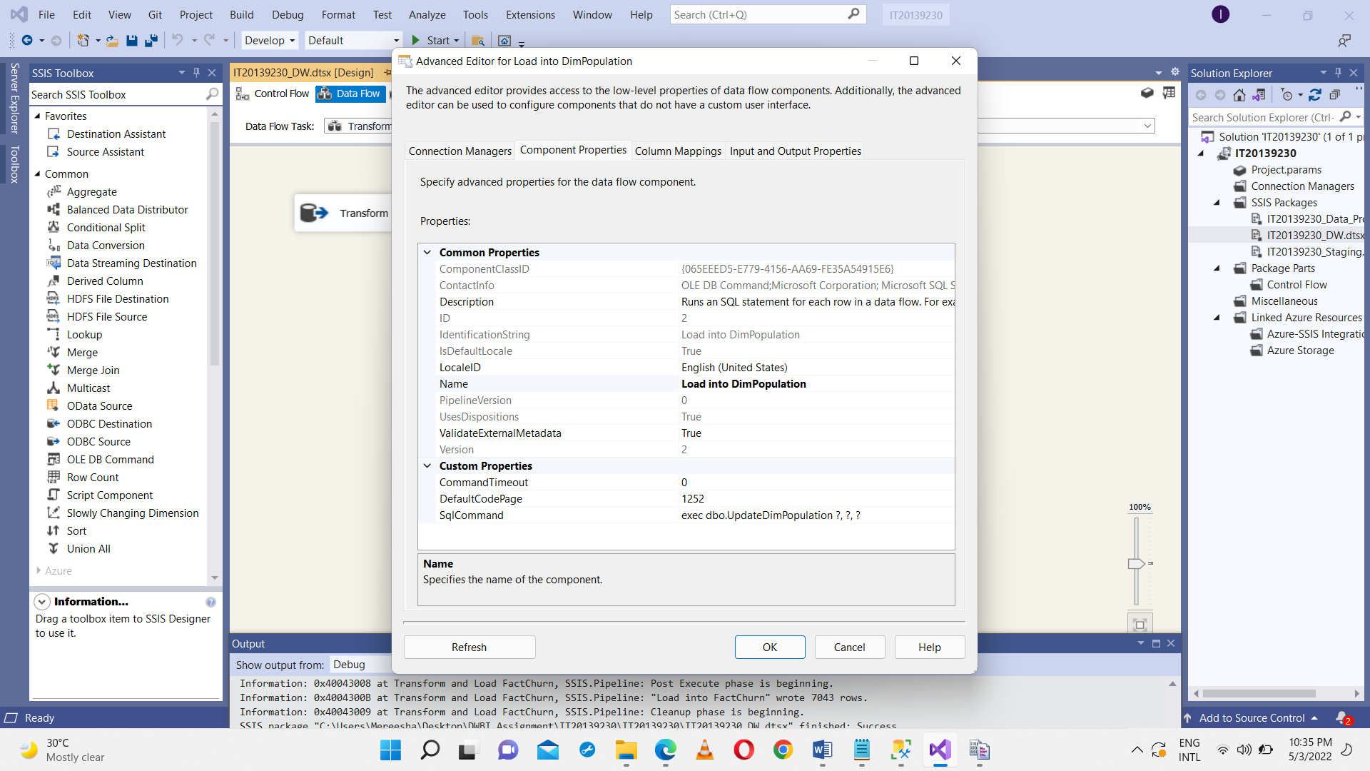OLE DB Command SSIS tool used to execute, UpdateDimPopulation procedure, it used to insert data from Population details which is in IT20129230_Staging to DimPopulation table which is in IT20139230_DW. Above Stored Procedure ensure no duplicates are entered into the data warehouse table ‘DimPopulation’. If there is an existing Population record, it will be updated with the latest record coming from staging table. Else, if it is a new record, it will be inserted into DimPopulation.

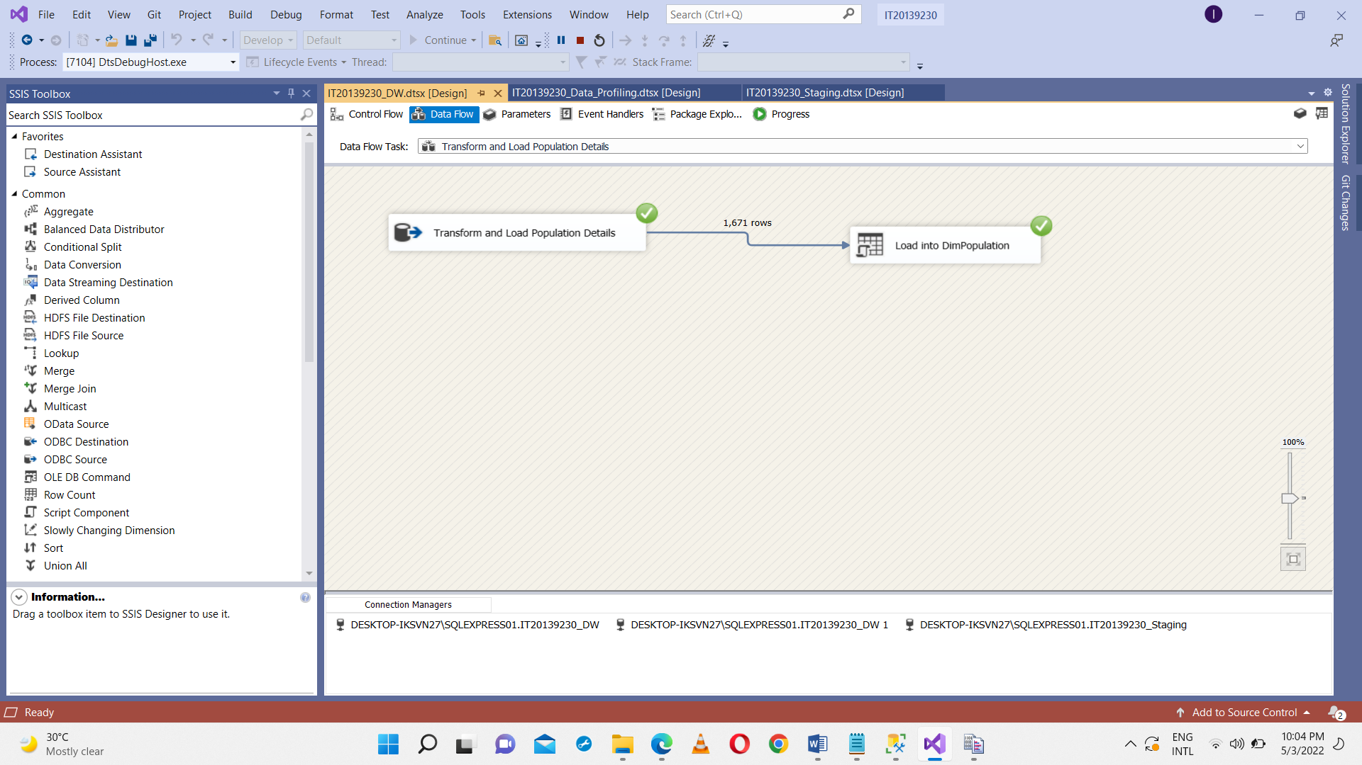

**DimLocation**

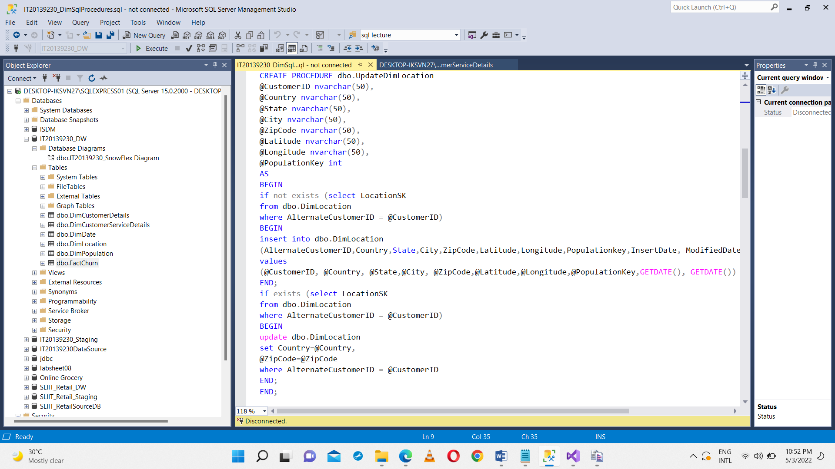Created a Procedure called UpdateDimLocation and executed in the IT20139230_DW database

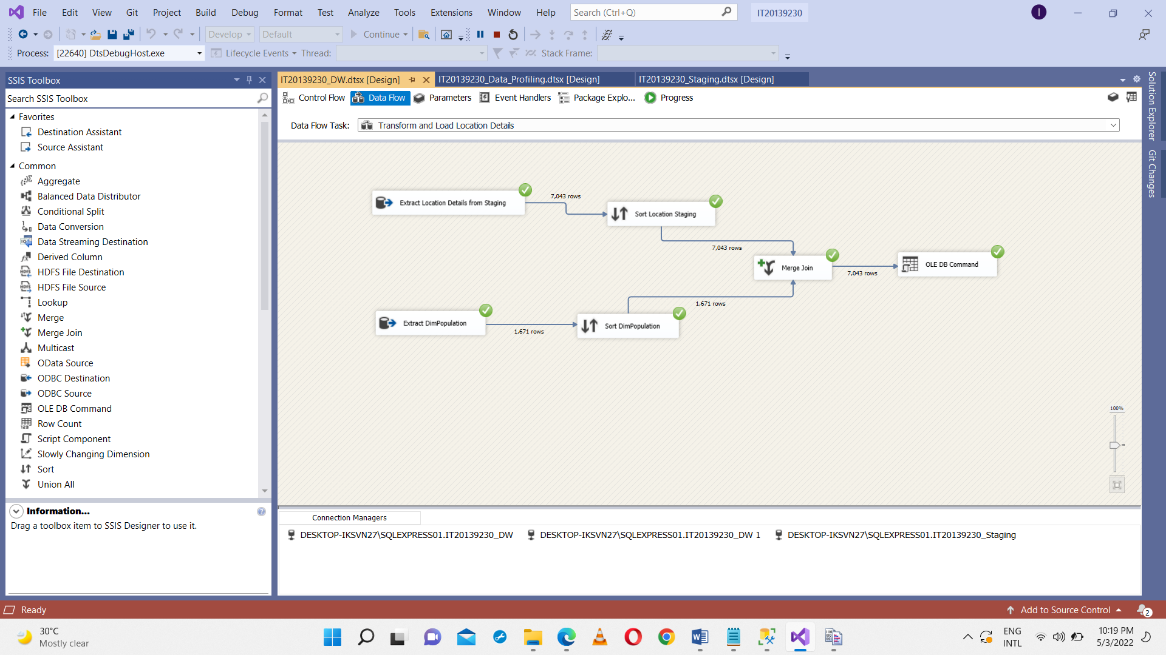Used sort to sort the details of the location details which are coming from staging and sorted DimPopulationSK wich is coming from DimPopulation and merge all the details in order to come up with foreign keys.

OLE DB Command SSIS tool used to execute, UpdateDimPopulation procedure, it used to insert data from Location details which is in IT20129230_Staging to DimLocation table which is in IT20139230_DW. Above Stored Procedure ensure no duplicates are entered into the data warehouse table ‘DimLocation’. If there is an existing Population record, it will be updated with the latest record coming from staging table. Else, if it is a new record, it will be inserted into DimLocation.

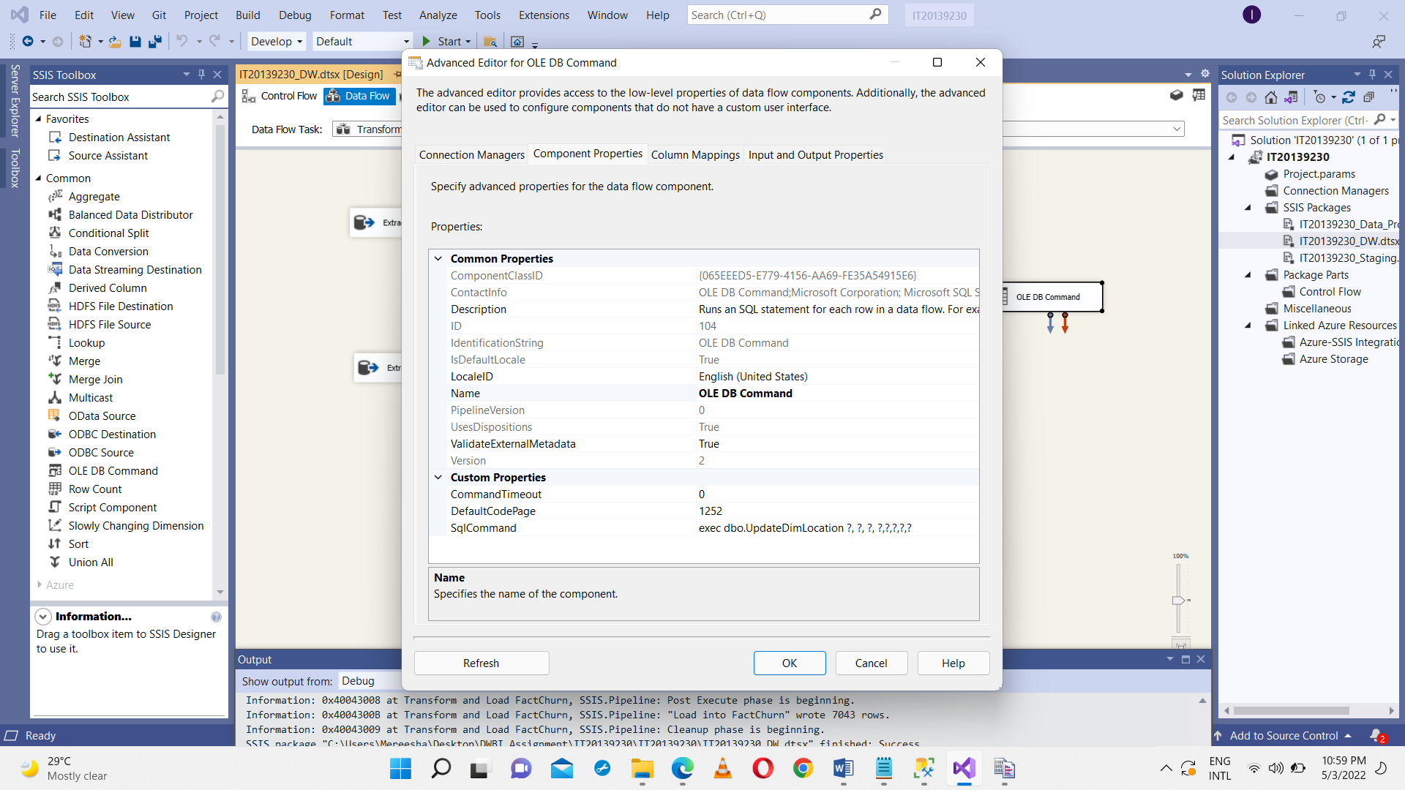

**DimCustomerServiceDetails**

Extract the customer service details from staging and consider DimCustomerServiceDetails as a slowly dimention

In the SCD Configuration Wizard I set the configurations as below

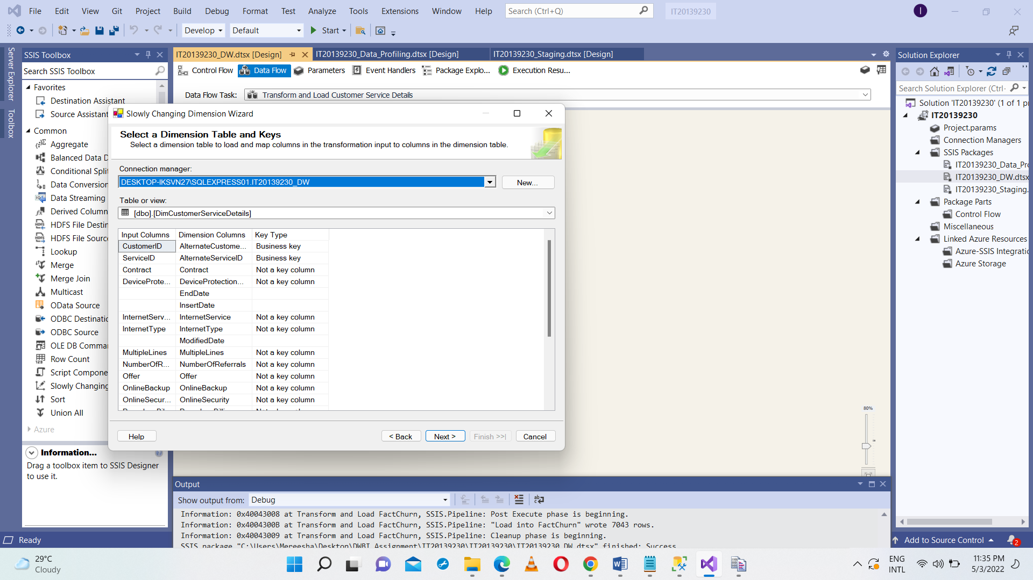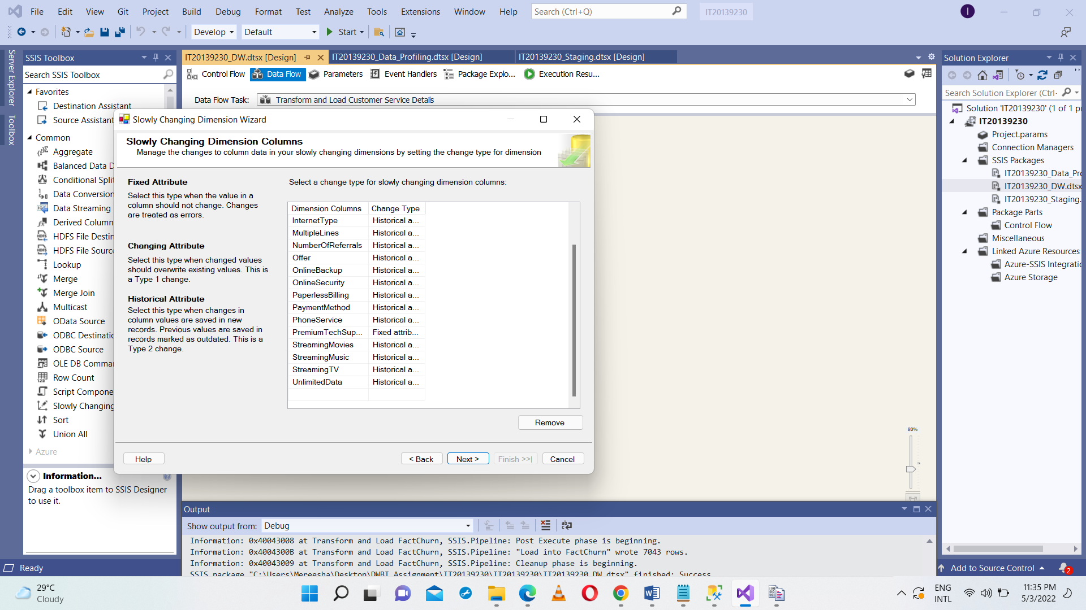

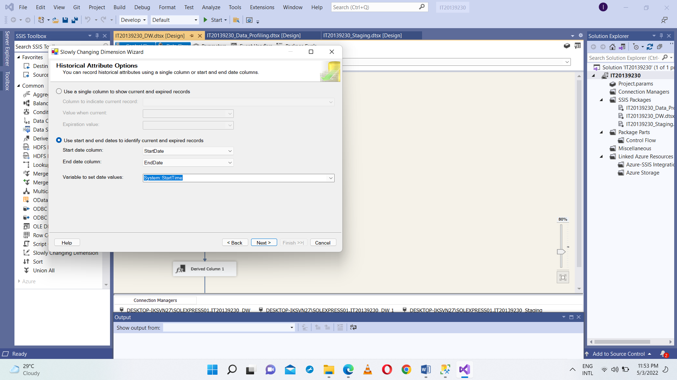

Once All Configurations done properly, it will automatically create the Slowly Changing Dimension as shown below.

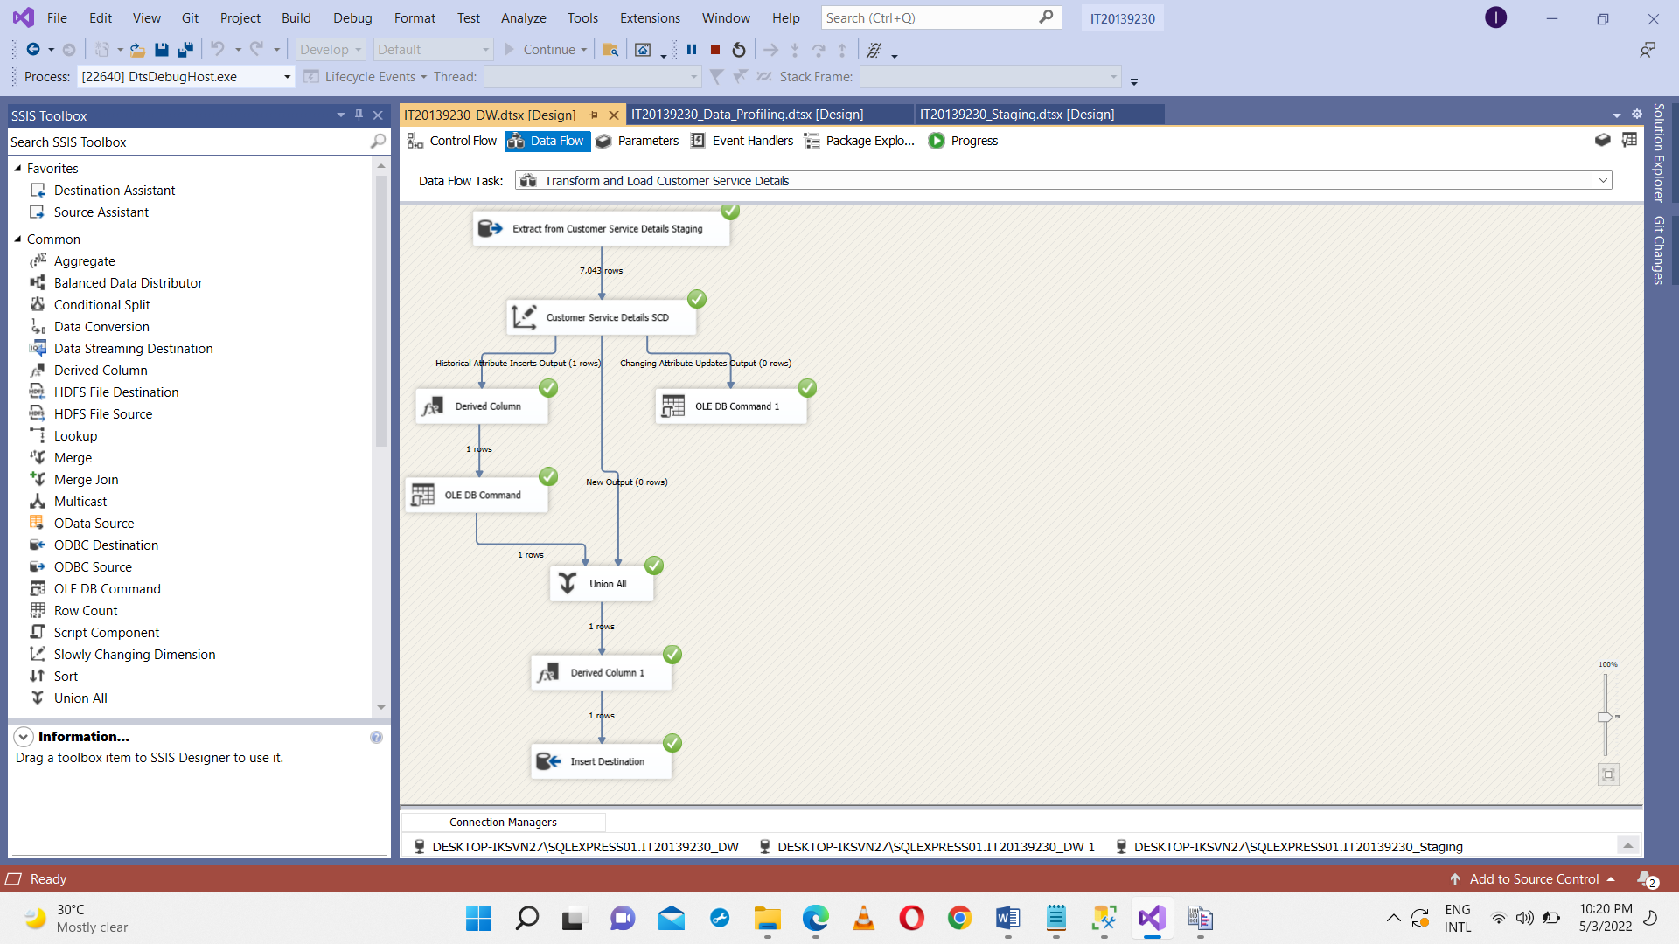

**DimCustomerDetails**

Created a Procedure called UpdateCustomerDetails and executed in the IT20139230_DW database.

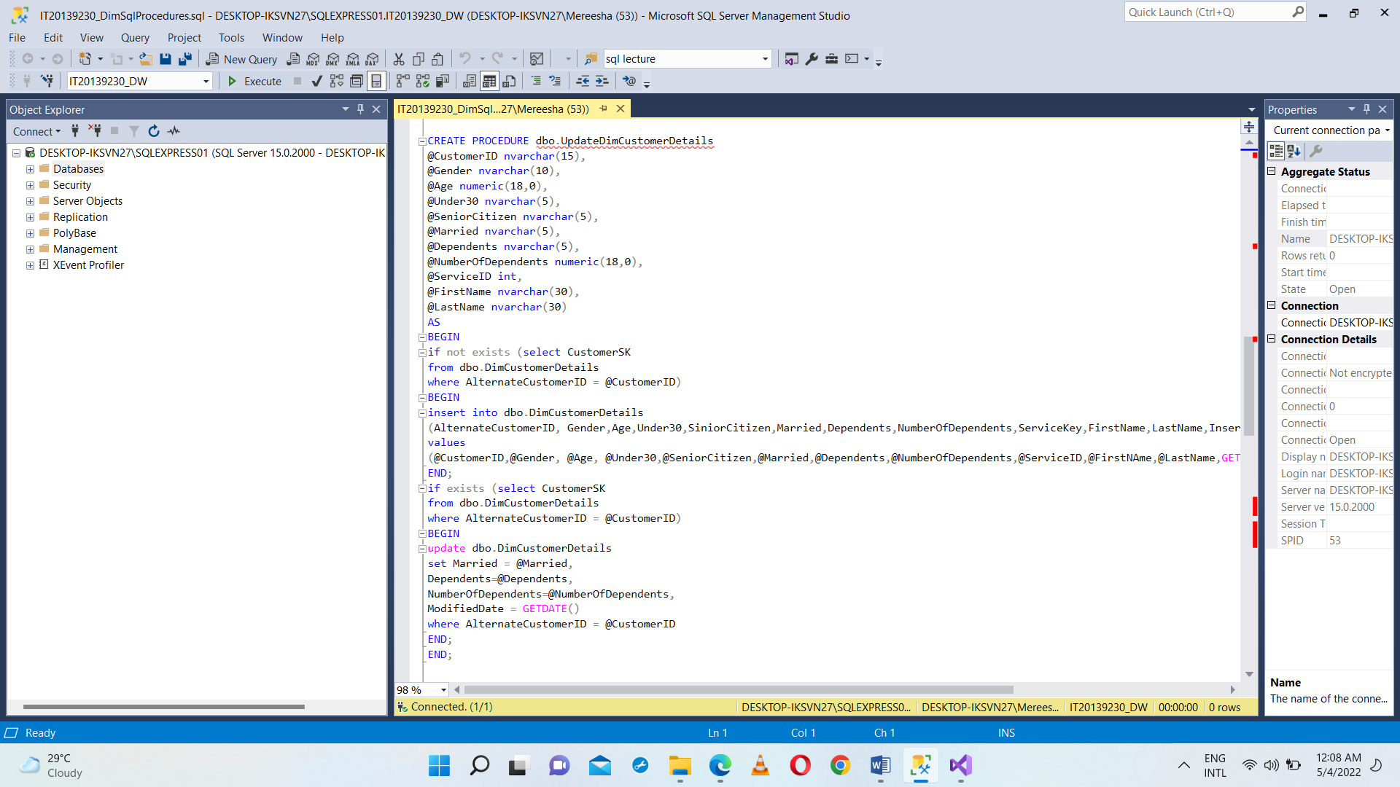

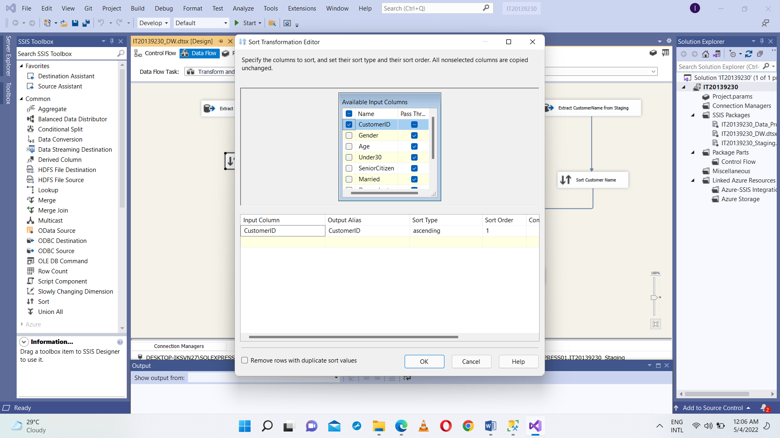Extract the customer details from staging and using Sort, sorted the details of the customer and also DimCustomerDetails references to CustomerServiceDetailsSk. In order to come up with CustomerServiceDetailsSk extract customer service details from DimCustomerServiceDetails and sorted it SK. There after merge those sorted details. Customer names were in different staging table in order to have those details extract CustomerName table from the staging and sorted the relevant details. After all merge those details and load into DimCustomerDetails.

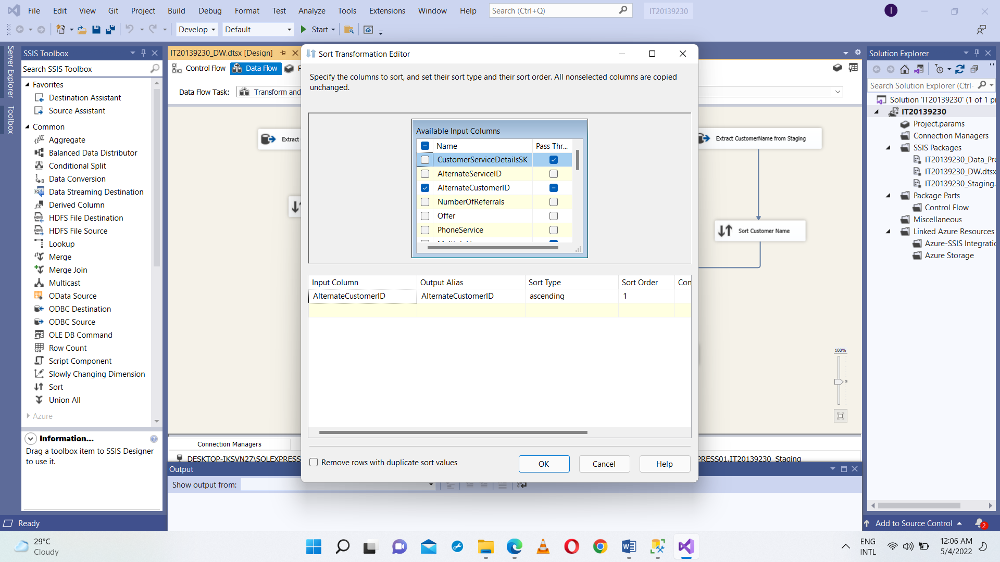

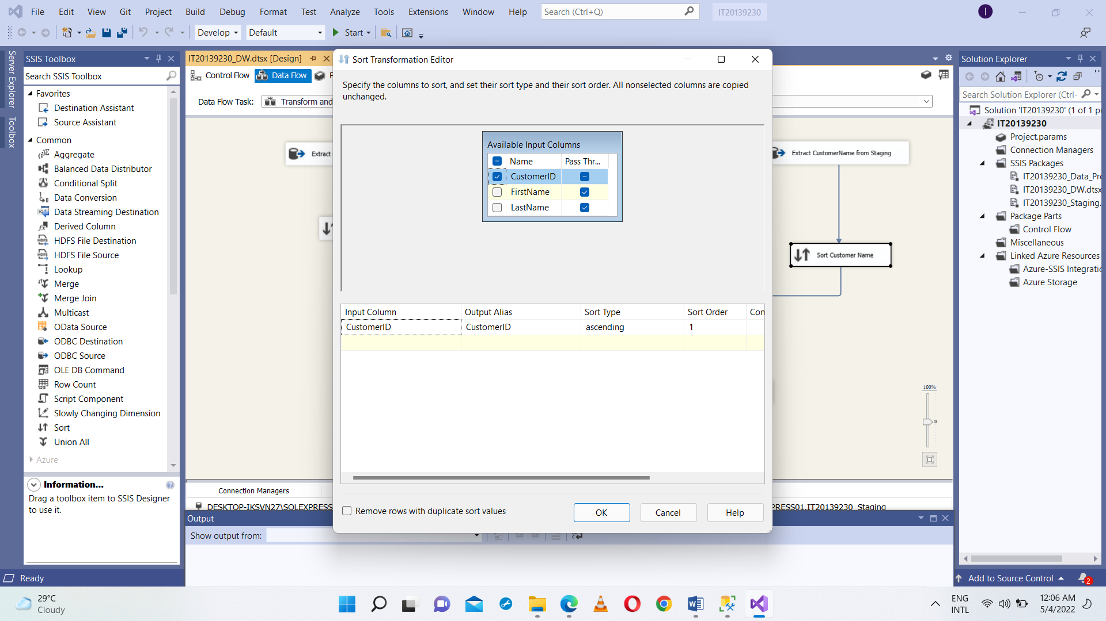

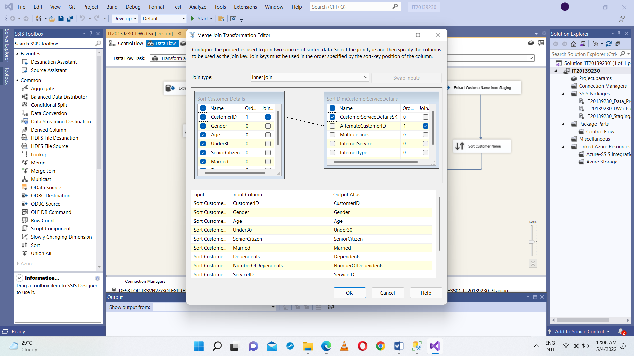

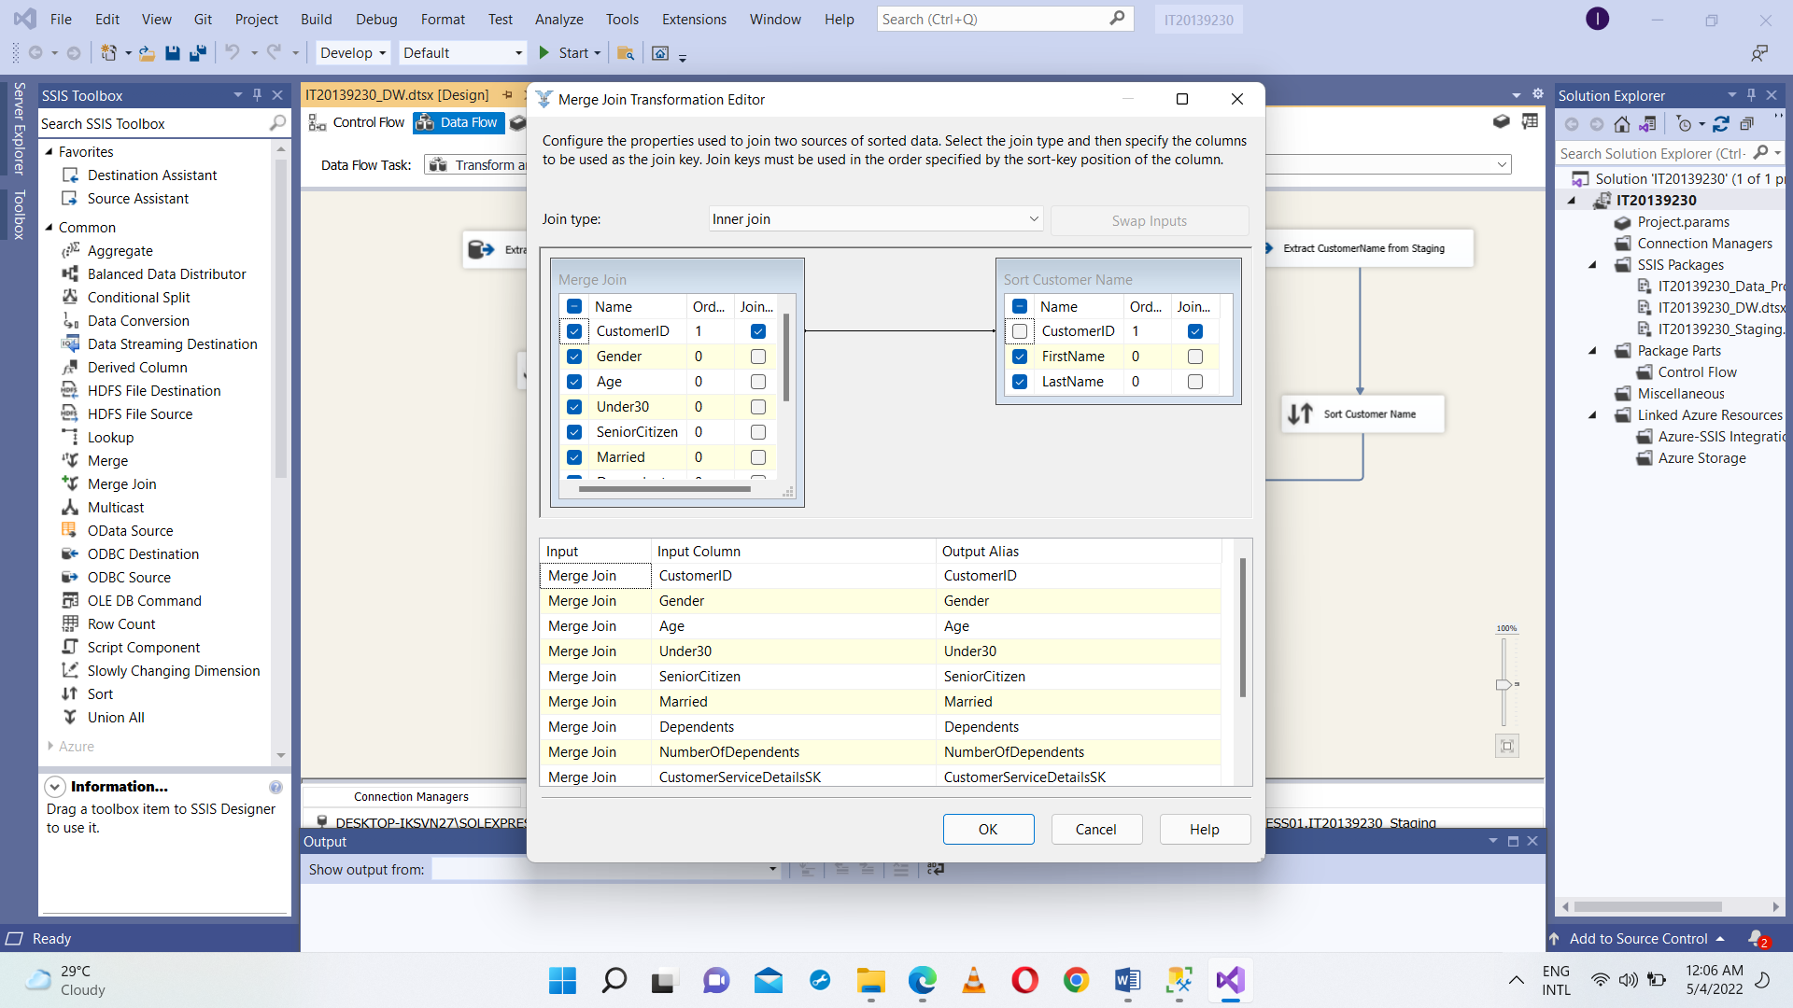

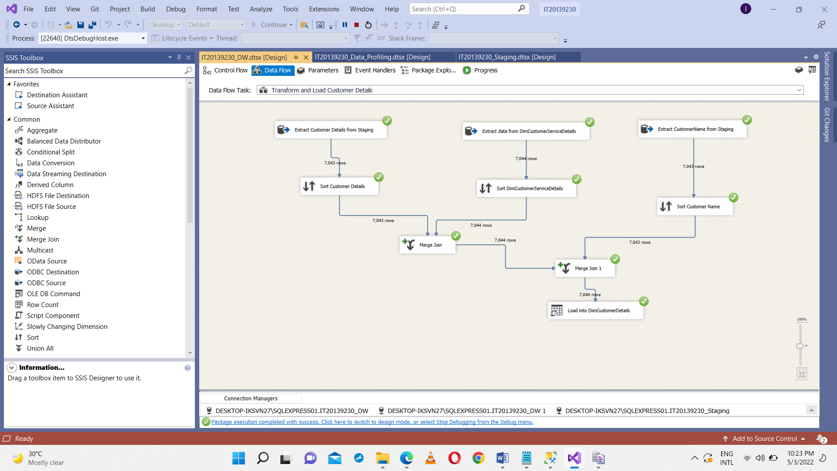

OLE DB Command SSIS tool used to execute, UpdateDimCustomerDetails procedure, it used to insert data from Population details which is in IT20129230_Staging to DimCustomerDetails table which is in IT20139230_DW. Stored Procedure ensure no duplicates are entered into the data warehouse table ‘DimCustomerDetails’. If there is an existing Population record, it will be updated with the latest record coming from staging table. Else, if it is a new record, it will be inserted into DimCustomerDetails.

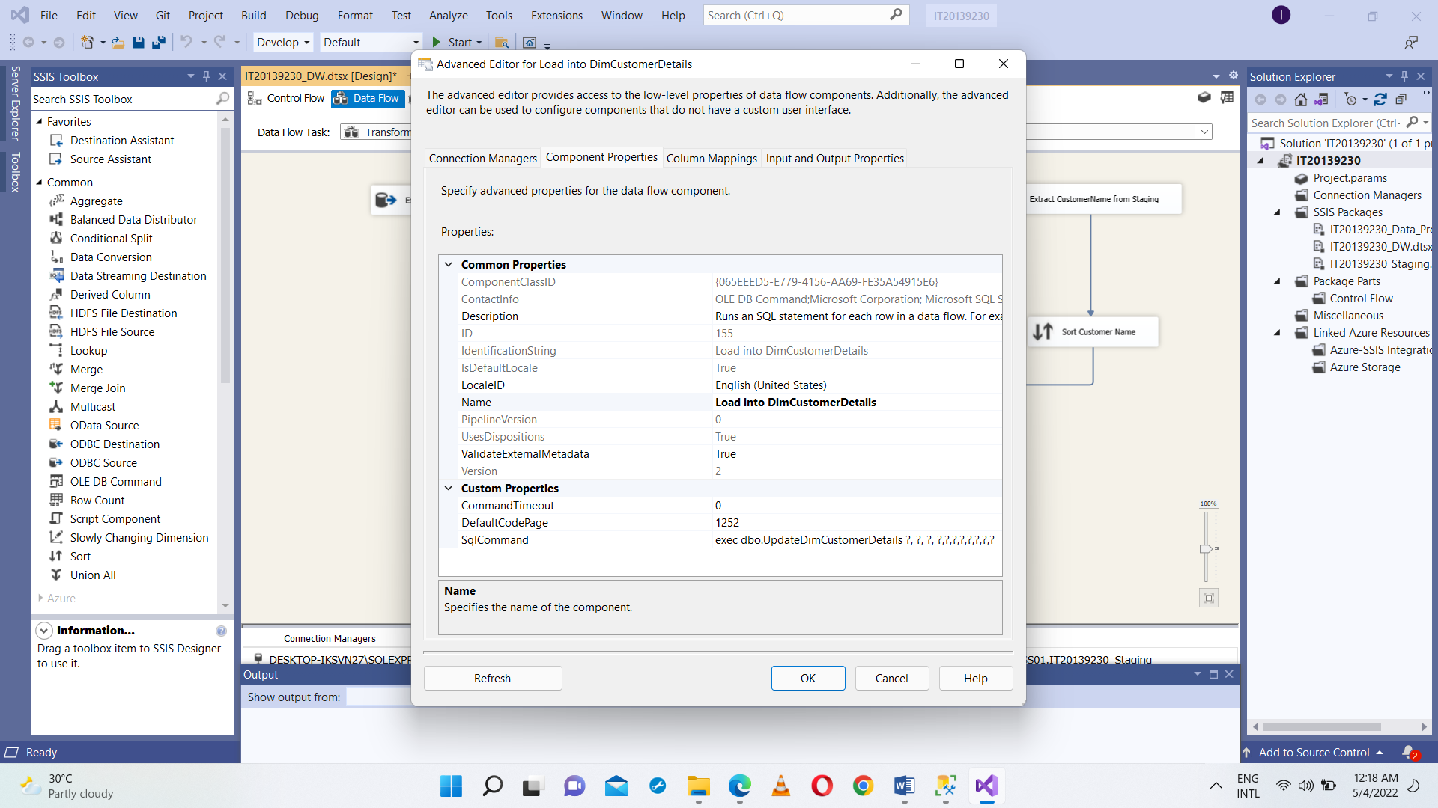

**FactChurn**

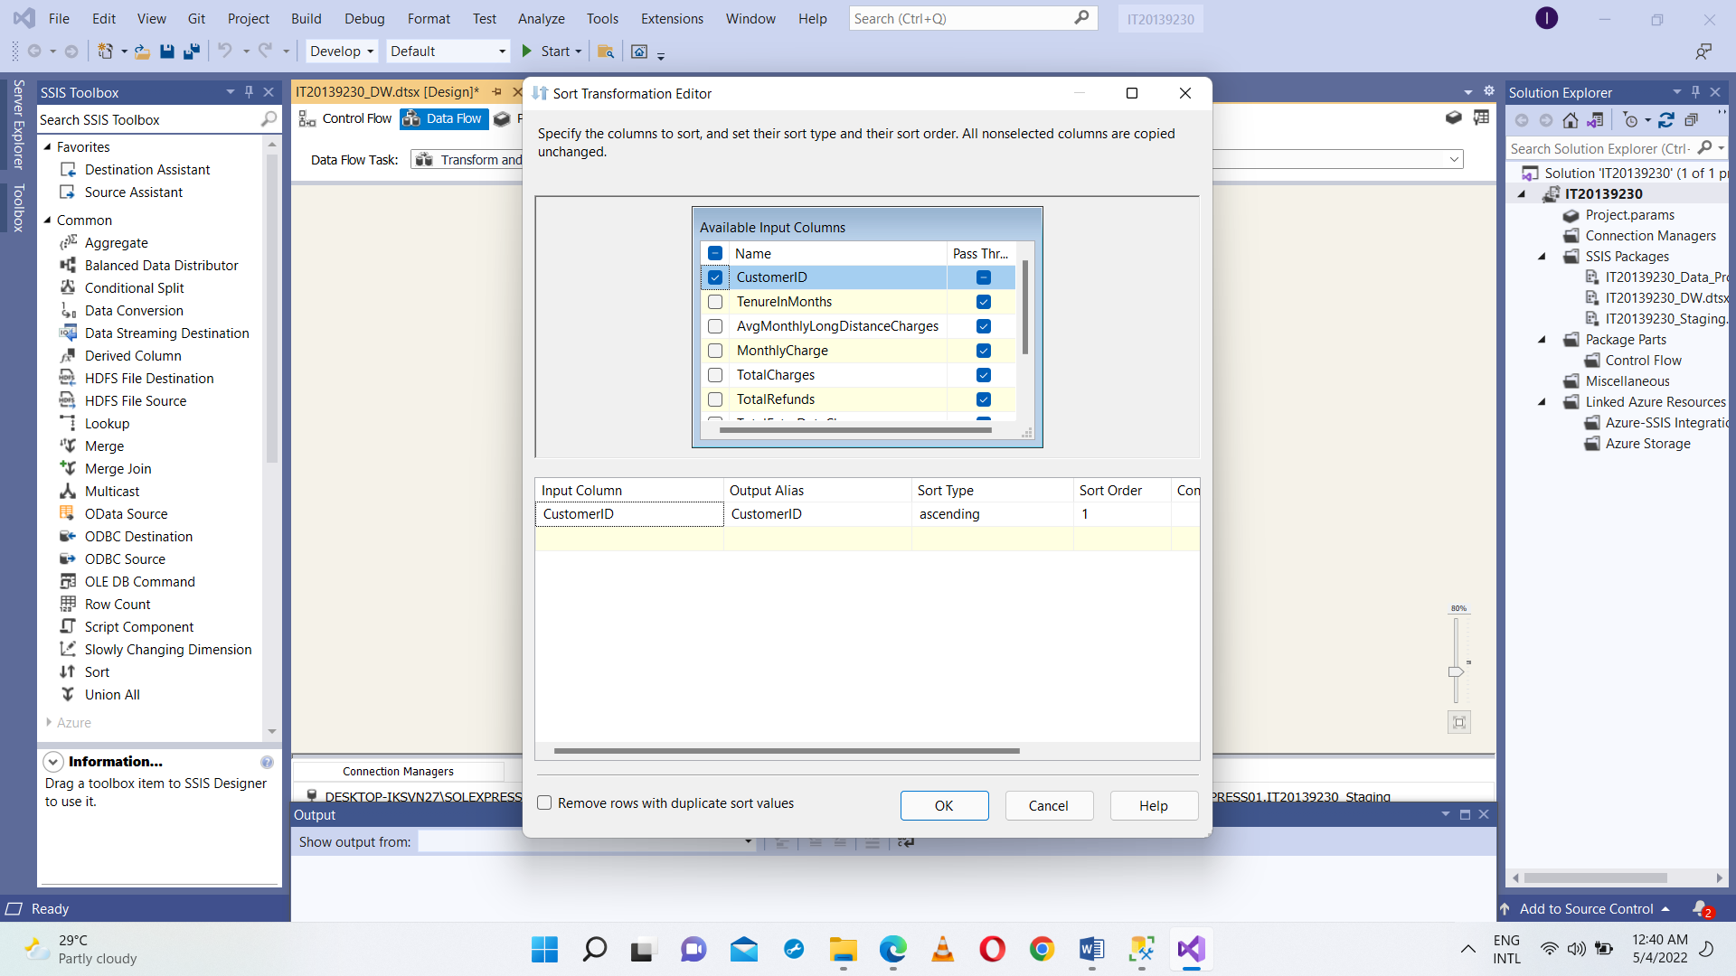Extract the customer usage details and customer churn status details from staging then sort the customer usage details and customer churn status details using Sort. Using Merge join join those details. There after use Lookup for Churn Date in order to having a references to DimDate dimention. Again used Lookup for DimCustomerDetails to having it Sk as a references in FactChurn table. Samething was done to comeup with LocationSK as a references. There after derived 2 columns as Insert and Modified date. After all loading transformed data into FactChurn.

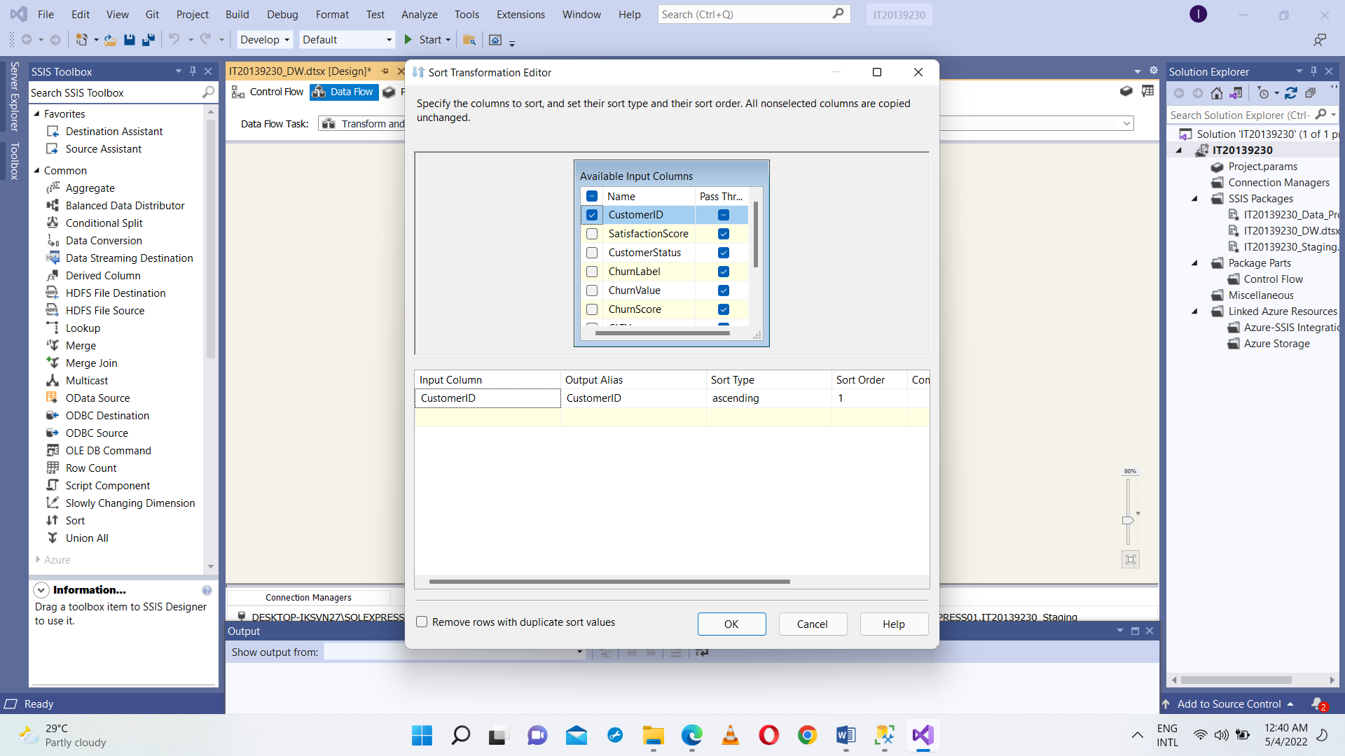

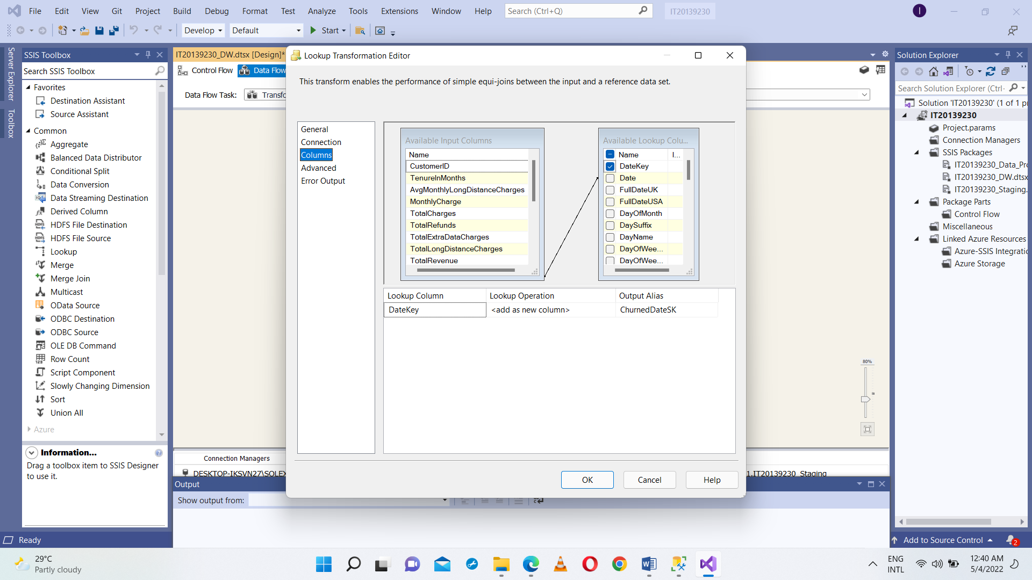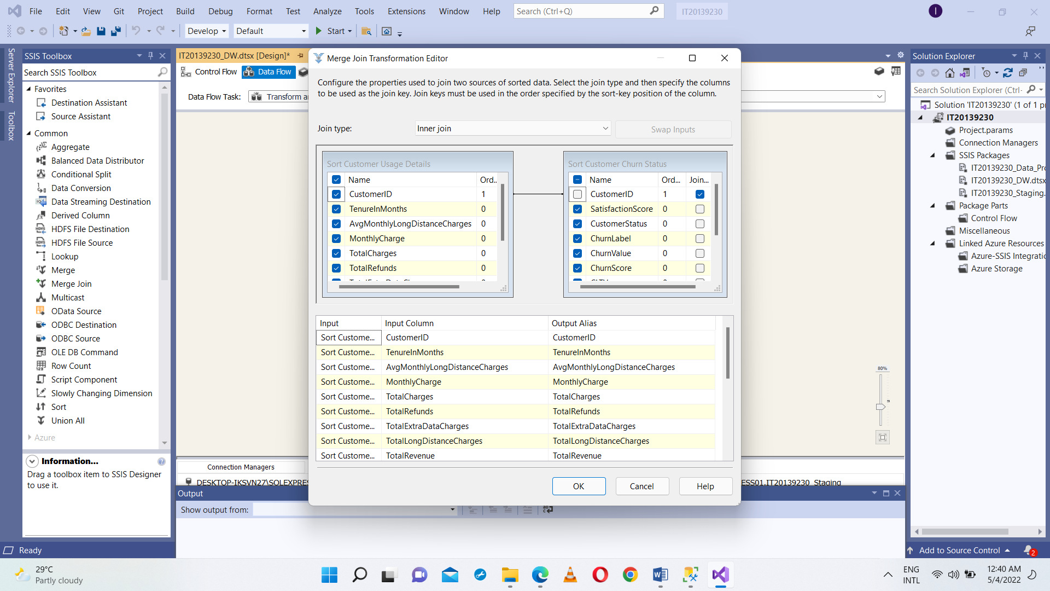

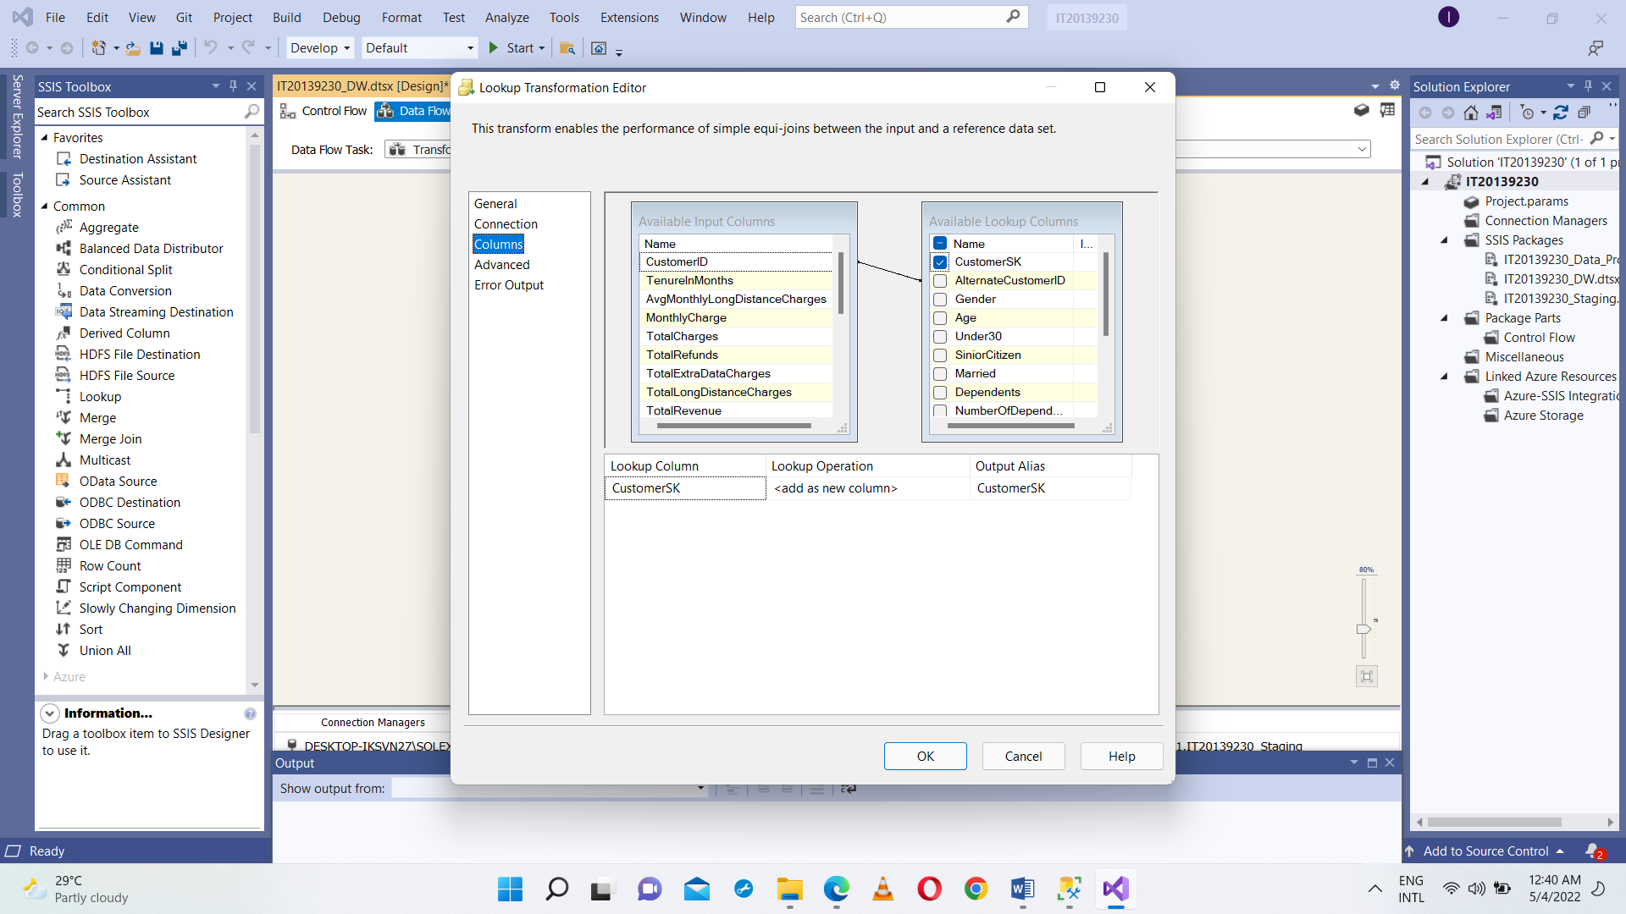

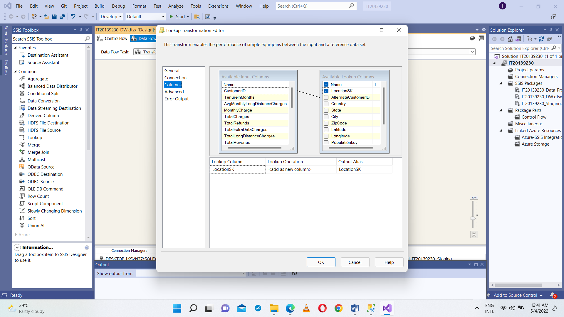

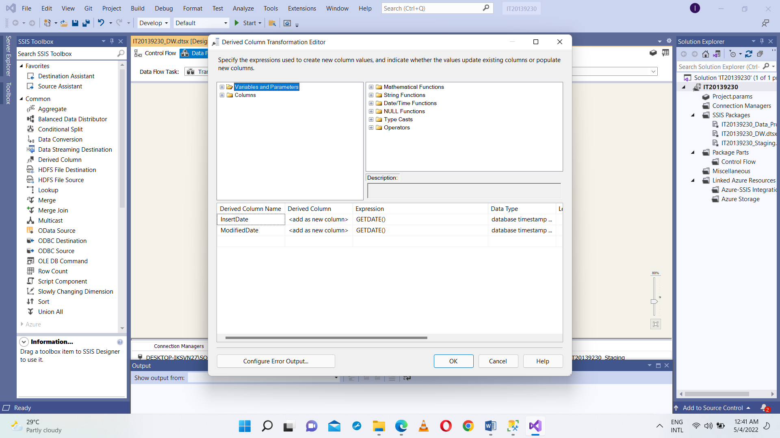

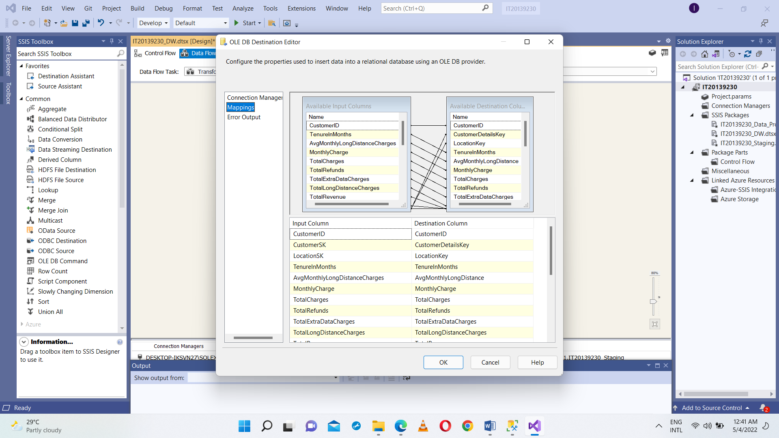

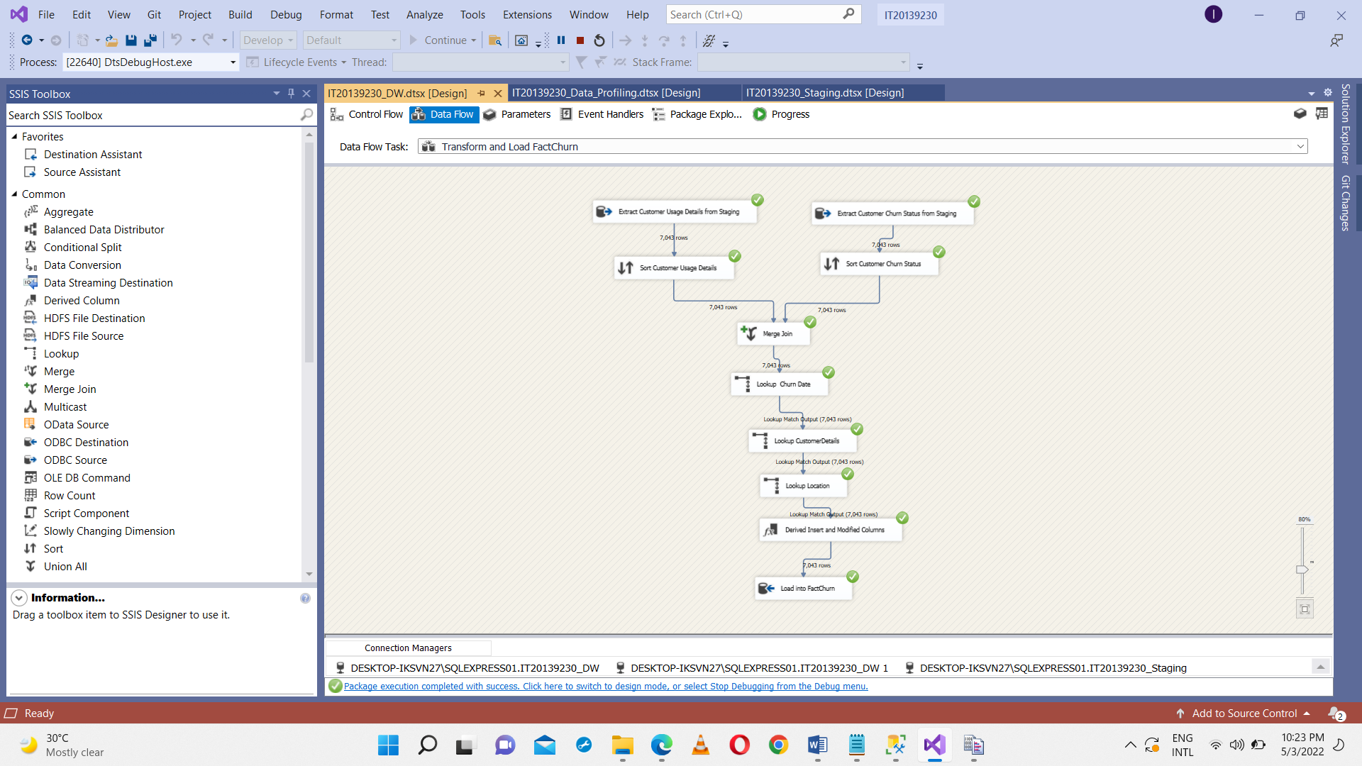

**Step 6:ETL development – Accumulating fact tables**

I have extended my FactChurn table with adding accm_txn_create_time, accm_txn_complete_time and txn_process_time_hours new columns.

Stetted accm_txn_create_time to be equal to the current system date when load data to FactChurn table.

Prepared a separate csv file which contains CustomerID and accm_txn_complete_time and put it into the IT20139230_Stagging Database.

Designed a separate ETL ssis package which names as IT20139230_DW_Update which reads data from accm_txn_complete_time which is in IT20139230_Staging Database and update the FactChurn accm_txn_complete_time in FactChurn table which is in IT20139230_DW.

Updated txn_process_time_hours as well.

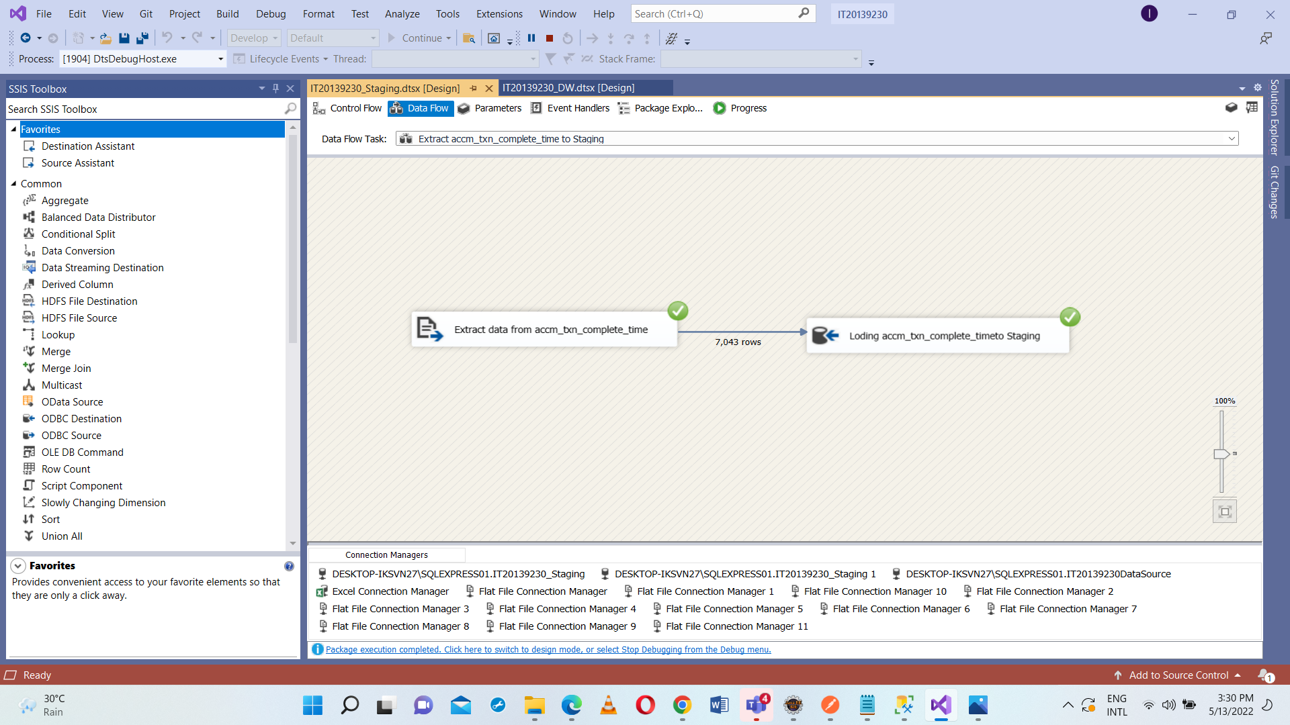

Configurations were done to add new derived columns to accm_txn_create_time to get current system date when load data to FactChurn table.

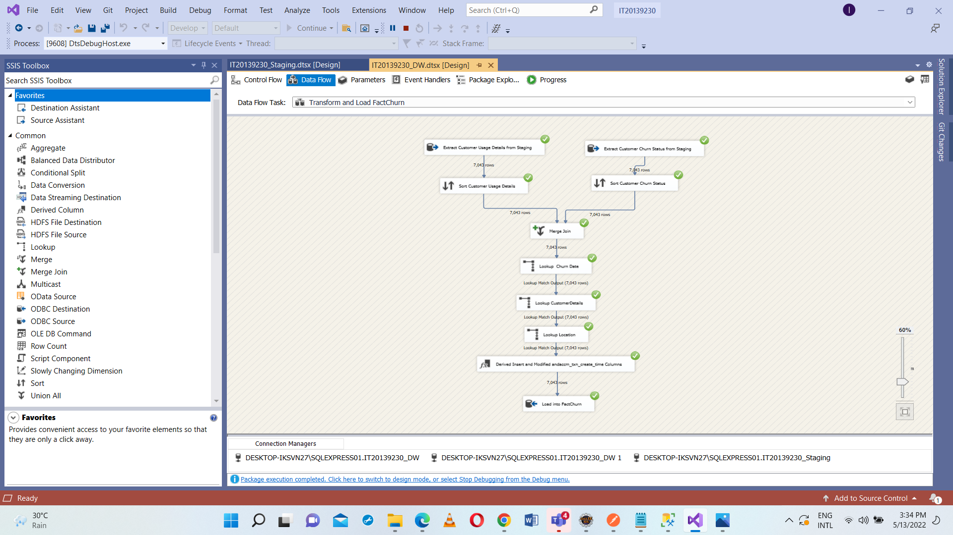

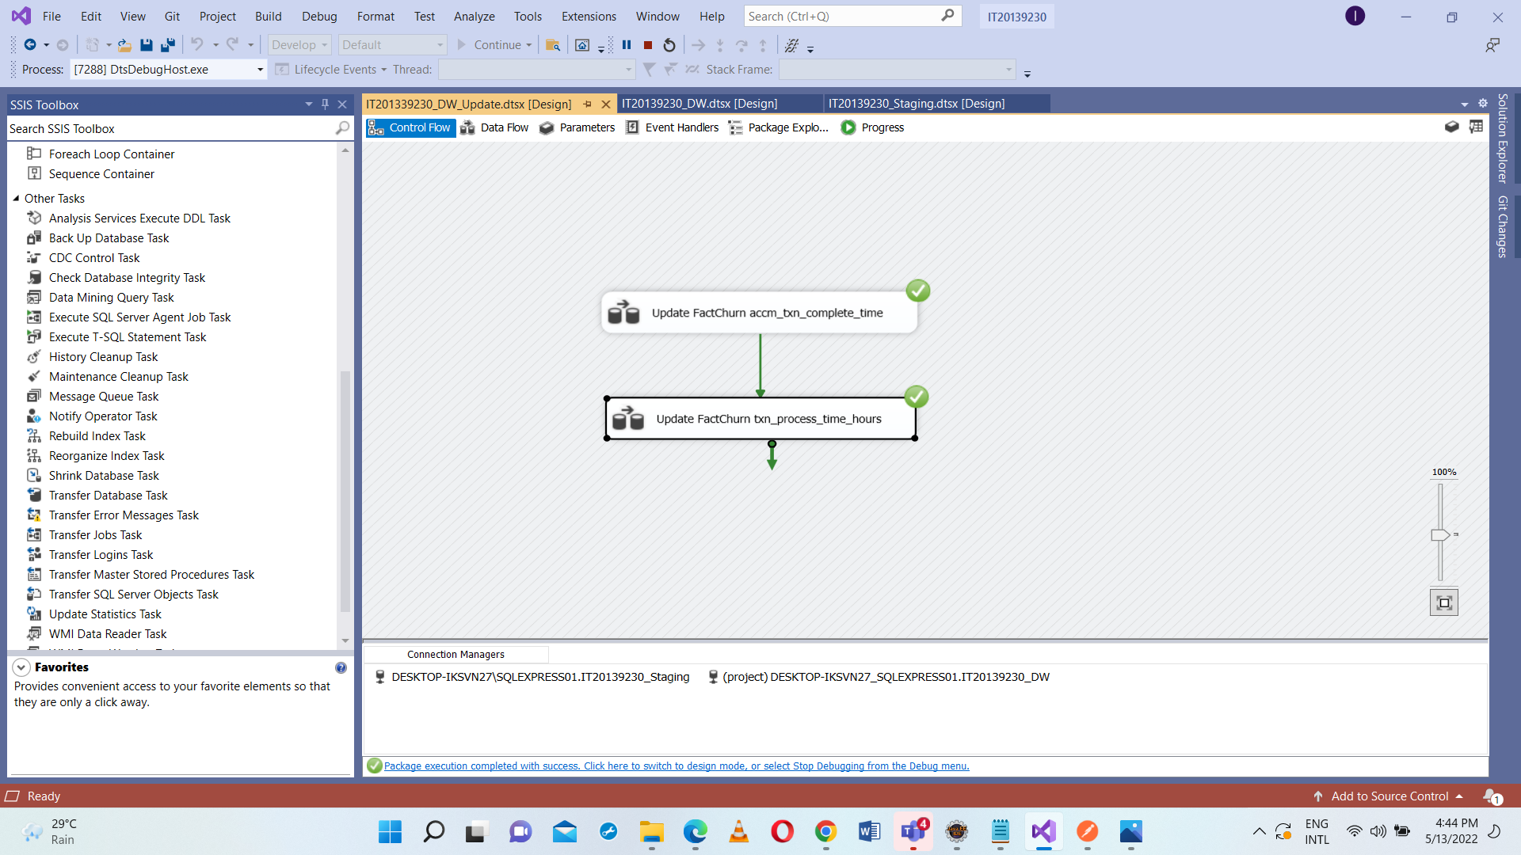

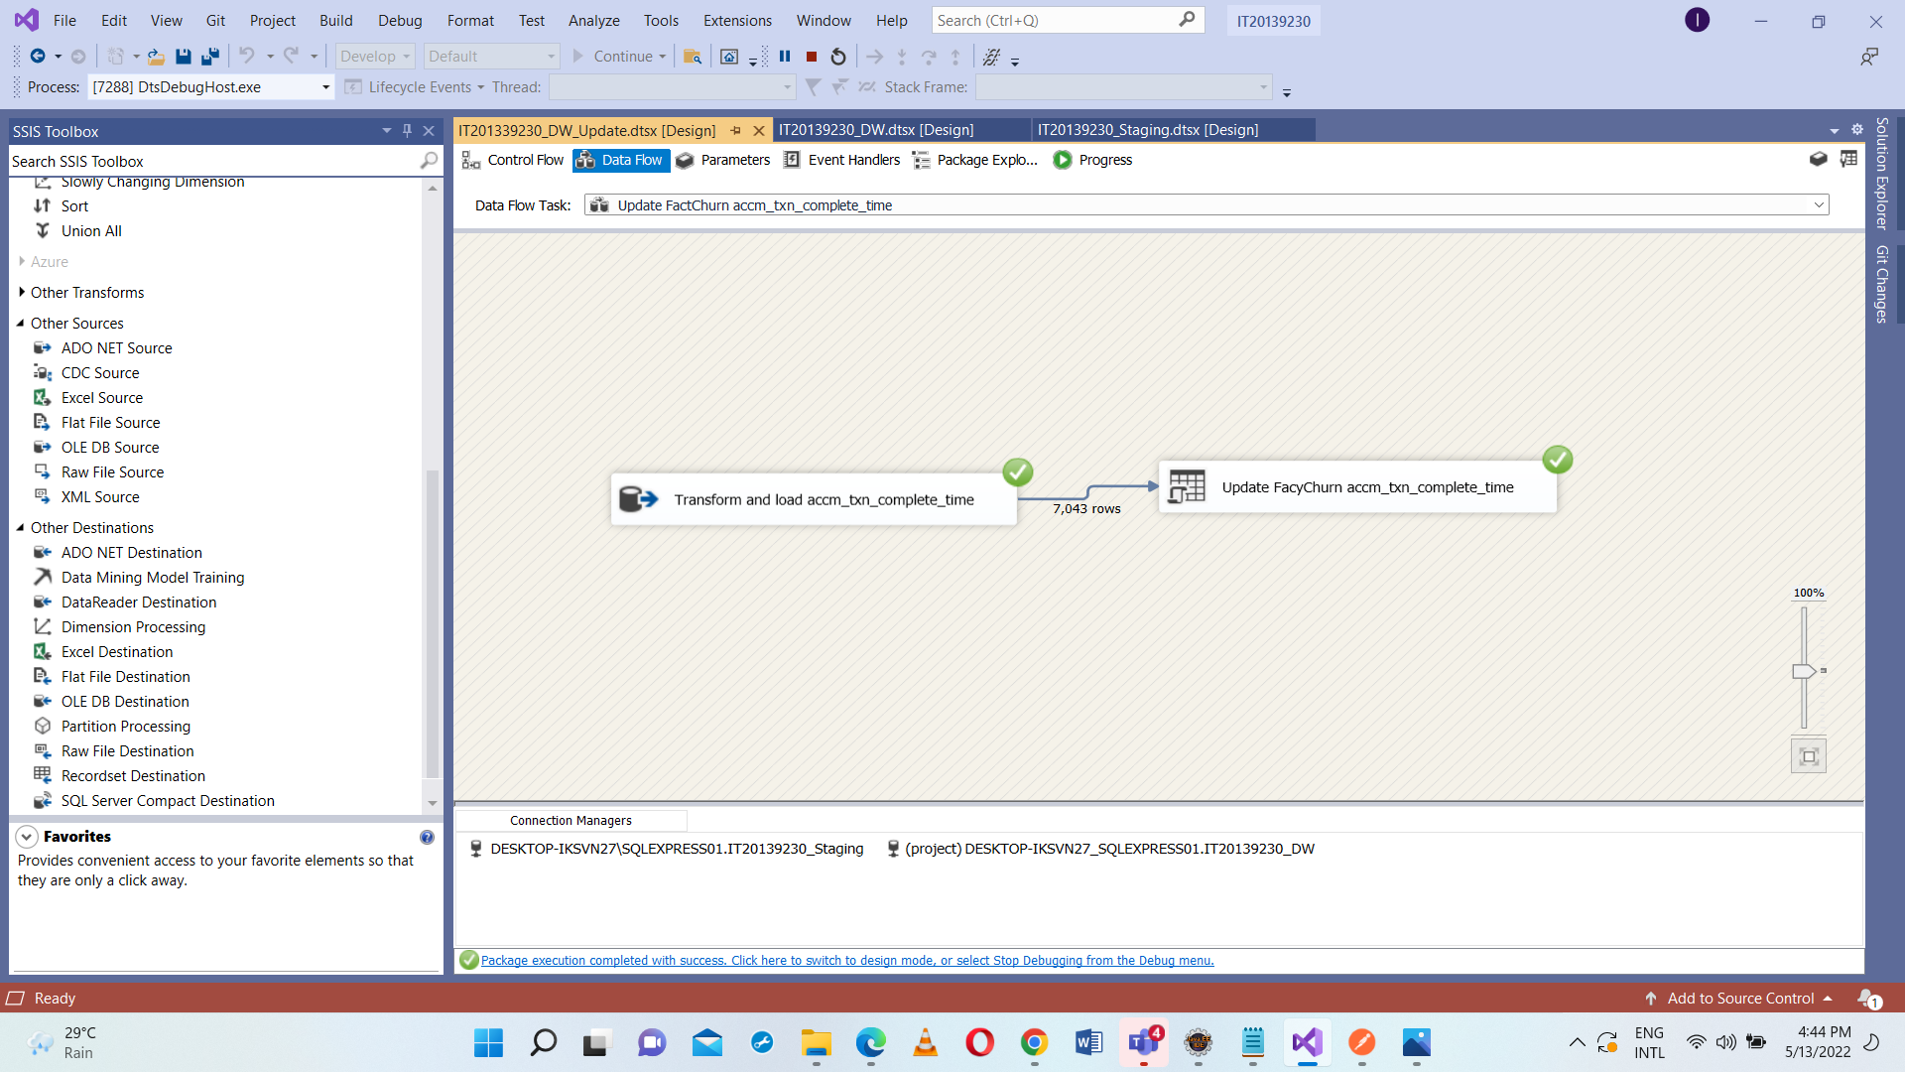

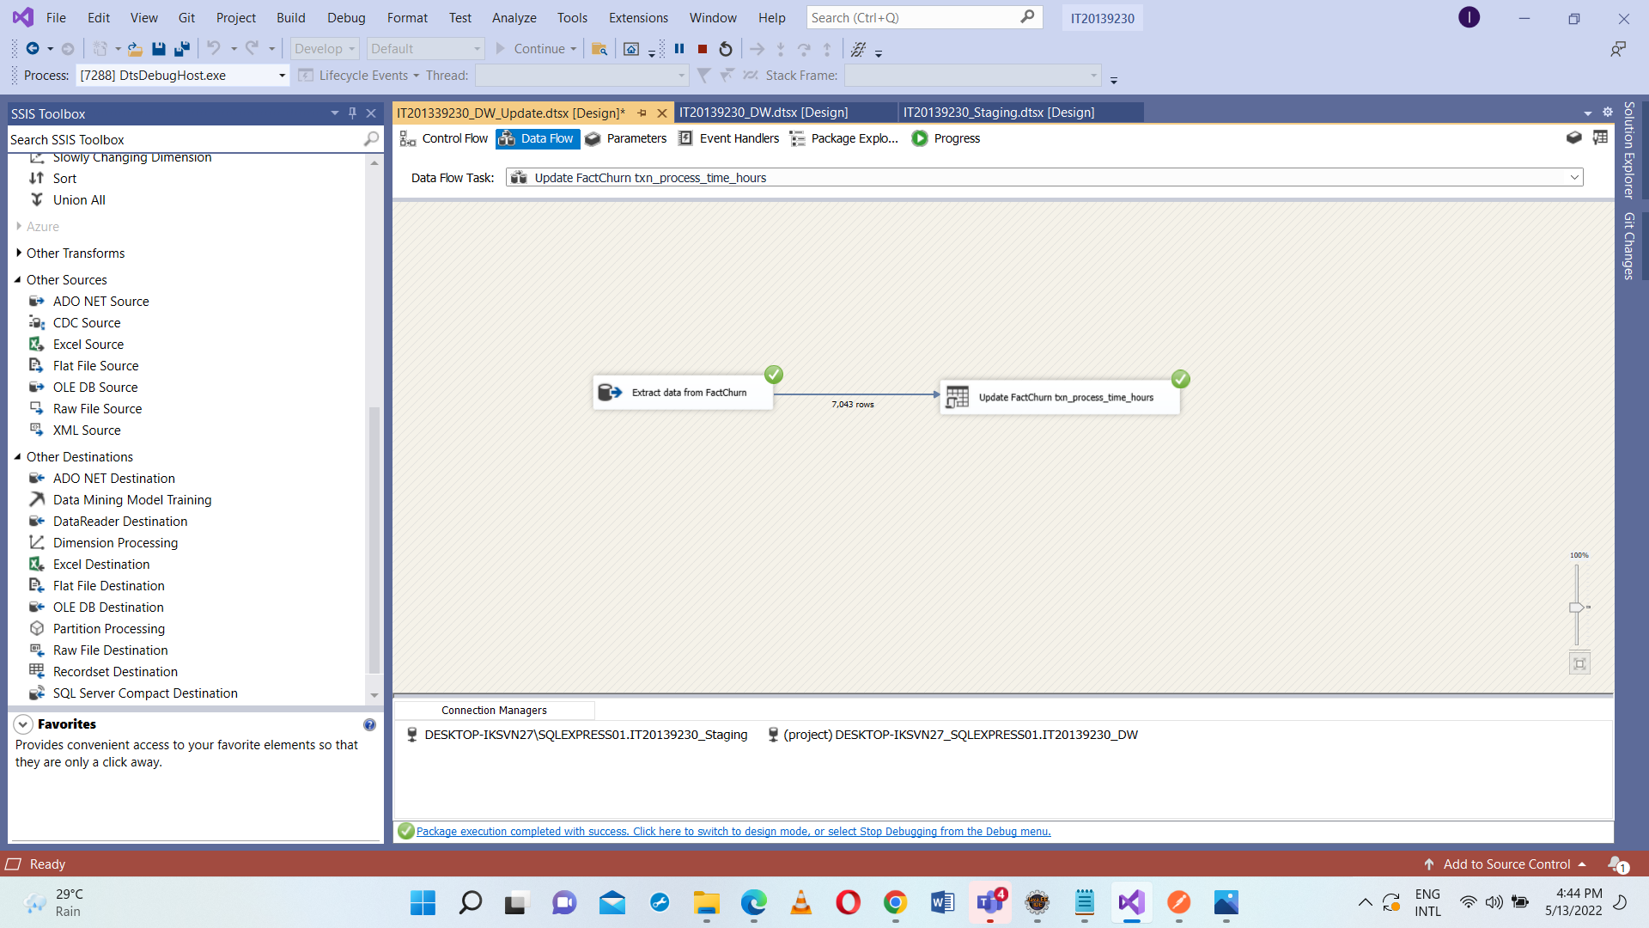

**References:**

<https://courseweb.sliit.lk/course/view.php?id=4696>

<https://www.geeksforgeeks.org/etl-process-in-data-warehouse/>

<https://www.javatpoint.com/etl-process-in-data-warehouse>

<https://www.youtube.com/watch?v=oF_2uDb7DvQ>